SPORTraits 2020

SPORTraits by Kevin Hurley Photography

1360 Maple Ave SW Roanoke VA 24016 540.345.3055
www.kevinhurleyphotography.com hurleyphoto@cox.net

*Please complete this order form, select a package, attach your payment (cash or check only, please!) and return to KHP on your picture day. All packages must be paid for on picture day.
*Please complete one order form for each child, unless you’d like to have your children photographed together.
*Please make checks payable to Kevin Hurley Photography.

Player’s Name ___________________________________________________________________

Team Name _____________________________________________________________________

Parent’s Name _________________________________________________________________________________

Mailing Address ___________________________________________________________________

City/St/Zip __________________________________ Phone________________________________

Email ____________________________________________________________________________
(you will be added to our email list, from which you can unsubscribe at any time)

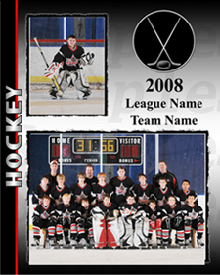
Step 1. Select your package:

_____ Pkg A: $35 1 8x10 Memory Mate; 1 8x10, 2 5x7. 4 3x5 & 8 Wallets Individual

_____ Pkg B: $25 1 8x10 Memory Mate; 2 5x7, 2 3x5 & 4 Wallets Individual

_____ Pkg C: $15 1 8x10 Memory Mate

_____ Pkg D: $10 1 5x7 Team Only

Step 2. Select your add-ons (available only with the purchase of a package):

Additional Units, $24 each Fun Stuff

1 8x10 ____qty. 8 Trading Cards $19 _____ qty
(please attach trading card player info form!)
2 5x7 ____qty.
Hockey Puck $29 _____ qty
4 3x5 ____qty.
Bag Tag $12 _____ qty
8 Wallets ____qty.
Standout Statues $32 _____ qty

1 3x5 Magnet $10 _____ qty

Total $__________________ (All packages must be paid for on picture day)
Studio use only: Paid________ Initial________ File #_____________________

