Meeting Time: |  | Monday, April 15th at 6:05pm ended at 7:55pm
Attendees
Status | Name |  | Title
 | Chris Lott |  | President
 | Jim Frazee |  | Scheduler (Treasurer in Training)
 | Kristina Rodriguez |  | Registrar
 | Rob Hameline |  | Youth Hockey Director (blue line)
 | Linda Scholl |  | Tournament Director (traveling for work)
 | Steve Maggio |  | Fundraiser
 | Kelly Leinbach |  | Secretary (Tournament Dir. in Training)
 | Heather Howard |  | Communications
 | Matt White (no vote) |  | Referee Scheduler
 | Jorge Rodriguez |  | Treasurer
 | Chad Koresc (no vote) |  | Webmaster (PT appointment)
 | Chip Roman (no vote) |  | Snowbelt
 | Kate Ducey (no vote) |  | (Scheduler in Training)
 | Jessica Clark (no vote) |  | (Secretary in Training)
Guests
Todd Leinbach (Peewee parent) assist Chad with graphics

Introductions for Kate Ducey and Jessica Clark.
- Reading of minutes of the last meeting for information and approval.
  - Secretary to requested approval for minutes from 3/16/2019 meeting. Approved by Chris.

- Treasurer’s Report. Kristina provided treasurer’s report. Spreadsheet hand out received.
Kristina made motion to keep registration fees the same as last year: All members in favor - approved.
Releases reviewed. No impact to 2019/2020 rosters.

- Reports of the Office
3.1 Has Chris received any news or reports from Central Section? Chris reached out to central section to inquire about dual rostering for Squirts if needed. Permission required from Snowbelt to.

- Reports of the Board of Directors

- President – Chris – nothing new
- Vice-President – VACANT
- Secretary – Kelly (transitioning to Jessica Clark) – nothing new
- Treasurer – Jorge (transitioning to Jim Frazee) – nothing new
- Director of Officials – Matt – no email received.
- Communications Director – Heather. Informational posting on website. Chad maintaining schedule/registration.
- Director of Fundraising – Steve: Letter drafted to Galisano Childrens Hospital. He is sending out this week. Spoke with Ryan regarding ice time, the best rink time would be Christmas-New Years for Skate-a-thon. Waivers for insurance would be required.
- Registrar – Kristina – nothing new
- Tournament Director – Linda (transitioning to Kelly Leinbach) – not present
- Scheduler – Jim (transitioning to Kate Ducey) Tentatively put in schedule for practices. Peewee with Midgets will share half hour of ice time. Start of season date decided, the puck drops September 30th. Clinics 4 Sundays in September. Season End date March 15th.
- Director of Youth Hockey – Rob – asked if 16U is it on the website. Evaluators not needed. Clinton, New Hartford & Whitestown are combining for 16U team. Release required for CSYHA evaluation. No charge to players for try out.
- Webmaster – Chad – is reading minutes and following up, has appointment tonight and can not be present.
- Snowbelt Coordinator – Chip. Not present. Position discussed: Snowbelt has 12 meetings per year. Begin thinking of plan for when Chip’s kids are done with hockey.
- ACES Coordinator – Jim Frazee interested and accepted role.
- Reports of the Committees
5.1 Bylaw Committee: Kelly to send out vote to entire organization on Survey Monkey. No response counts as “in agreement”. Survey complete on Survey Monkey. Kelly can not figure out how to attach or link bylaws to survey. – Update to reflect need to change bylaws by vote if needed. Prior to season start.
- Suggestion: Update the Bylaws for the Vice President role. Vice President role is responsible for identifying and fulfilling the ACES Coordinator if role can not be fulfilled by Vice President.

- Unfinished Business

  - Solidifying Fundraising goals for 2019/2020 season
- Galisano Childrens Hospital, 12 hour skate-a-thon update (discussed in 4.7)
- Decide on line apparel company – did not cover – discuss next meeting

  - Jerseys:
    - Prices and findings for Jerseys (Mites through Midgets) Cost findings and color options presented. Cost is $58 per jersey, $11.50 per socks. Total per player $139. Chris made motion to keep to purchase jerseys through HockeyTron/Whole Sale Sports. All members in favor - approved.
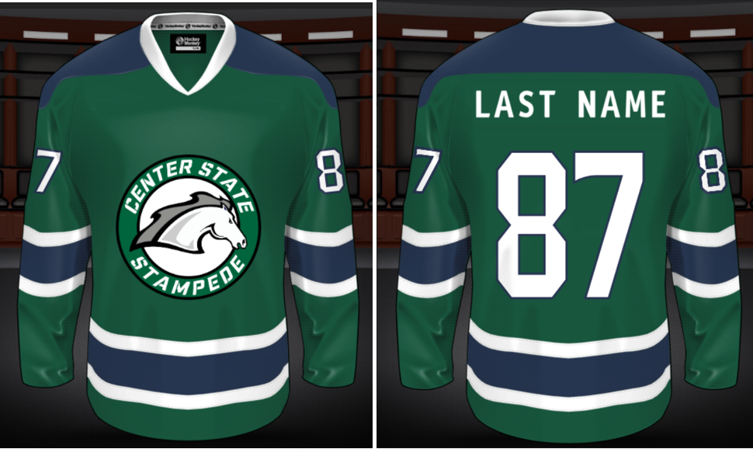

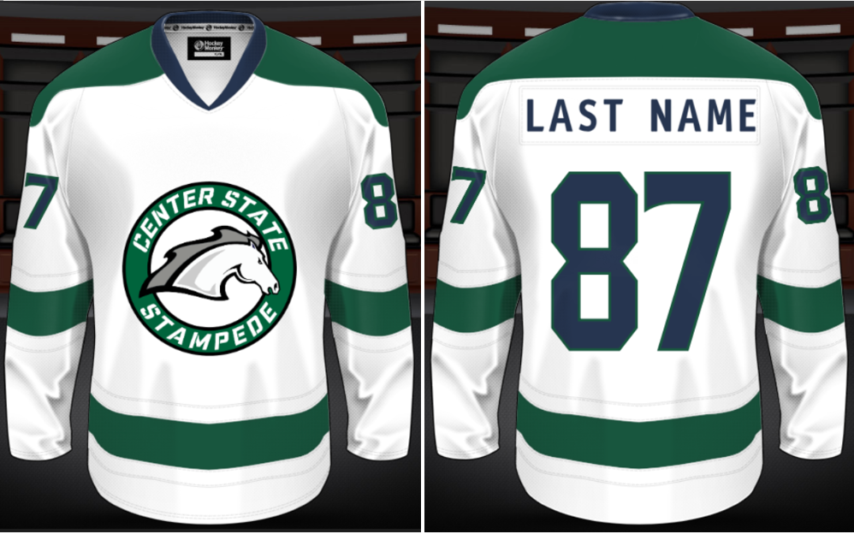
    - Prices and findings for inexpensive LTP jerseys. HockeyTron can supply 1 color jerseys with screen print logo for $12 each.
    - Logo. Concerns being close to other organizations. Todd presented new option that is similar to current logo but made 100% from scratch (see below). Discussion surrounding exploring Morrisville’s logo occurred. Decision to keep CSYHA log separate from Morrisville’s was made. Kristina made motion to use new horse logo presented. All members in favor - approved.

Heather looked up Trademark cost online: $275-$375.
Todd looking into cost to Register the logo.

Rob asked if the 16UWrap team use current jerseys? Kristina made motion for the organization to absorb the cost of 1 jersey per player for the 16U Wrap team pending roster number. All members in favor – Will not approve until we revisit after tryout dates and know numbers.

  - Schedule end of year coaches meeting. Set date of meeting and location. Schedule a meeting 1 month prior to try outs (April 2nd). Chris is going to call each coach. Personal feedback.

  - Discuss tuition costs. IMPORTANT (discussed in item 2)
- Factor in the 2019/2020 ice rates are going up to $125 per hour (from $110). Kristina aware.

  - Jim to check ice hours for mites, squirts and midgets for Kristina. Not yet, Jim will confirm for next meeting. In the future the ice bills should go to scheduler. Done.

  - Raffle Recap – Heather. Did not discuss – next meeting

  - Try out coverage: 16U wrap Team – State Bound. Try outs April 27/28 April / May 4/5. No help needed per Hamline.

  - Board Terms/ Transitions: (Board Appointments for 1 year. Then voting must take place.)
- Vice President - Vacant
- Jorge – will stay on for 1 more year and train Jim for position.
- Kristina – confirmed staying on 1 more year.
- Linda – has decided to step down due to new job. Has agreed to train Kelly for position.
- Hamm – not present at last meeting. Confirm at this meeting. Did not do – next meeting
- Jim – has agreed to stay on 1 more year and train Kate Ducey for position.
- Kelly (term not up but morphing into Tournament position) will train Jessica Clark on position.
- Matt (non issue)

  - Kelly contacted families of kids aging up to squirts to see if they plan on participating in squirts next year:
- Cyril Sheehan (2010) LTP 1 & 2 – Yes Interested in Squirts.
- Logan Tournear (2010) LTP 1 – No response
- Keagan McDermott (2010) LTP 1 – Yes, interested in Squirts.
Offer these players to skate with the mites for additional ice time.

  - 2019/2020 Center State Tournaments: Select Dates NOW. Table until May.
- Morrisville is open minded to earlier tournaments. (season starter)
- Morrisville Men’s team is traveling first 2 weeks in November.
- Morrisville Women’s team schedule soon to be released. Not yet.
- Cazenovia High School will have a lot of home games next season.
- Johnny Haynes: photographer update.

  - Board meeting Minutes – update site with approved meeting minuted. Complete.

- New Business Section
7.1 Chad has created ability to do registration ourselves. Discussed.
7.2 Credit card purchases? A card would be very useful for tournament preparation as well. Issue through checking account. Kristina to ask Community Bank. Discuss next meeting.
7.3 When we get non-profit status we should consider looking at google as a place to get organizational accounts, they do this for free. We can apply and get emails that are position@centerstatehockey.com addresses and include storage for shared files at no cost, but I need to be able to show non-profit status. The beauty here is that the gmail accounts can be managed by the admins and transition from one person to the next board member. All present members agreed this is the way to go. More professional, better option. Follow up with Chad about moving forward.

7.4 Recruiting. We need to get more players.
- Advertising options. Is it worth paying someone to help us get our numbers back up? Did not discuss.
- Kelly got rink permission to have a Center State Board member at a table in the lobby during Blue Line. Hand outs with information. Kelly to update with registration costs and hand out.
7.5 Coach Nellis would like to know if the Board would consider financing a few slabs of synthetic ice and designate an off ice area for shooting practice. Practice times are limited and it would be nice to have an off ice area for all players to be able to practice on before practice begins. Open to all age players. Inquire to Morrisville about space.
7.6 Sherburne Earlville Carnival. Shoot to Score game (3 responsible teens). May 16th, 4-7pm. Ask Linda, Dan.
7.7 Noted: Clinton wants ice time at Morrisville.
8) Next meeting – Chris wants Monday’s during the summer.
May 20^{th.} 6pm.
June 17th 6pm
July 15th 6pm
August 19th 6pm
September 16th 6pm.

