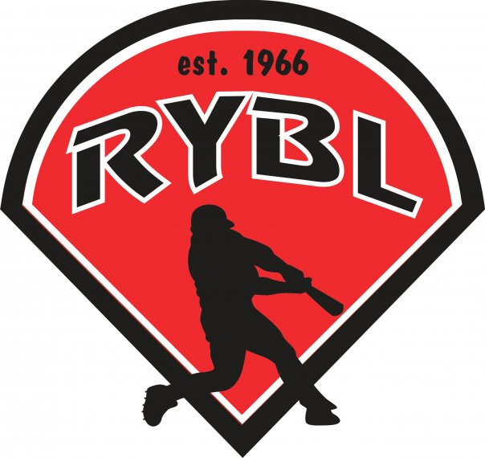
RYBL December 2022
Board Meeting
12/8/2022 7:30 PM
- Call to Order 7:31pm
- Opening Prayer
- Previous Board Minutes Approval – Andy Keogh approved
  - November 2022 Minutes – Approval
- Treasurer’s Report – DJ Butcher
  - Current Bank Balance: 28,055.84 pox 261 approved
    - Outstanding Bills: 7,561.76
    - Accounts Receivable: 2,700.00
- Office and Committee Reports – maybe a new tax man for free -
- Secretary – Andy Keogh– looking into a Saturday Union Hall for mother son party – needs to be end of Feb or beginning of March – do we want to ask championship park to do videos with them for our kids -, yes ask them
- President – Bryan Altmaier – maybe need turn off the credit card machine – cost too much -– T-ball field being named after Jason Hobson insurance sign -
Vote on new budget - waiting until DJ to look over the report – vote next meeting in Jan 2023
- 1st Vice President- Chris Pavey – grants? - looking for grants – we have someone to help us write them/ Matts Wife
Major Managers/Tball Managers – need more mangers to commit to teams
- 2nd Vice President – Mickey White – when do we tell dawn about color changes? – vote on if 12 yr old forced into majors but do not need to be the 1st to be voted on the team – Mickey sending out email of what his ideas and expectations are for the draft in major and minor
Minor and Rookie Managers looking for volunteers
- Player Agent – Brandon Darling Not Present
- Equipment Manager – Dawn Hyman voted yes to color flyers-
Any equipment that needs purchased?
Baseballs are ordered for the season ordered 10 dozen major and 30 dozen minor league baseballs - open/looking into jersey prices and who can handle the volume of jerseys– prints are good and being delivered –calling KB Printing and HowardCounTeez for prices on jerseys
- Umpire in Chief – Matt Adams – no fee for the fall ball – prices will be the same $40 for major and $35 of minor
Matt, make sure umpire costs are going to be the same as last year
- Media Director- Taylor White
Great job on sponsorships and flyer looks good (do we need to vote to get these made?) $144.27 for black and white and $425.94 for color - going with the color – 11 sponsorship spots available out of 26 – call the hall and see if they will donate it for free – mother son dance is a go–
- Unfinished Business-
- New website has been purchased $499 and working on an onboarding date to learn the new website. Hoping to get registration open early for parents. – looks user friendly – waiting on instructions
- Lighting? Where do we go from here since the poles are no good? Explore Grants – back to square one – doing a fund for the poles and save the money over the years to pay for poles-
- Any interest in concession stand manager? One more needed
- New Business-
- We want to start getting ideas of tryout method and layout for draft so minor league know who are available to draft by next meeting in Jan. need to communicate with minor and major better – 9 -12 are doing tryouts – combine minor and major tryouts
- Are we going to use Vickers for uniforms or another company?
- Fieldhouse is being booked for Jan 28th for tryouts, I can look to book the Lions Club that following week for the draft.
- Duke does a lot of grants – search for energy savings – we have help writing – need to search for them -
- Adjournment – 9:01pm

