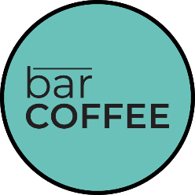

Volleyball Retail Menu

Assorted Baked Goods
$4.00 - $6.00
Assorted Grab n’ Go Items
$6.00 - $12.00

Cheese Pizza Slice
$8.50 OR $14.00 Combo
(Pop & Chips)

Pepperoni Pizza Slice
$9.00 OR $14.00 Combo
(Pop & Chips)

Hot Dog
$9.00 OR $14.00 Combo
(Pop & Chips)

Turkey Wrap
-Havarti, Lettuce, Tomato, Sun Dried Tomato Aioli-
$12.00

Falafel & Halloumi Sundried Tom. Wrap
-Hummus, House Giardiniera, Tzatziki, Greens-
$12.00

Chicken Caesar Salad
-Romaine, Croutons, Crumbled Bacon, Parm Shards-
$15.00

Niagara Powerbowl
-Wild Rice, Ancient Grains, Black Bean Pico, Spiced Chickpeas, Pickled Onion-
$12.00

Lemon Garlic Chicken Powerbowl
-Wild Rice, Ancient Grains, Black Bean Pico, Spiced Chickpeas, Pickled Onion-
$15.00

Garlicy Grilled Cheese Panino
-Cheddar, Provolone, Sourdough-
$13.00

Hamburger or Cheeseburger
$11.00 OR $16.00 Combo
(With Fries & Pop)

Fries
-Double Fried-
$10.00
Poutine
-Vegetarian Gravy, Ontario Cheese Curds-
$15.00

