College Bound Student Athletes (CBSA)
PRESENTS
DEVELOPMENTAL SUNDAY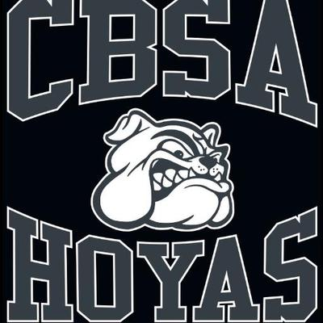

LOCATION: Frederick High School
650 Carroll Parkway
Frederick, Maryland
DATES: Every Sunday January 20-March 10
AGE GROUP-3rd-6th Grade -Boys and Girls
TIME: 4pm-6pm
Basketball Drills For Skill Development
Core, Speed, and Agility Training

CONTACT INFORMATION
Anthony Bowie- (240) 626-1622 or wfcoach@msn.com
Jon Carrington- (717)-414-8207 or joncbsa@yahoo.com

