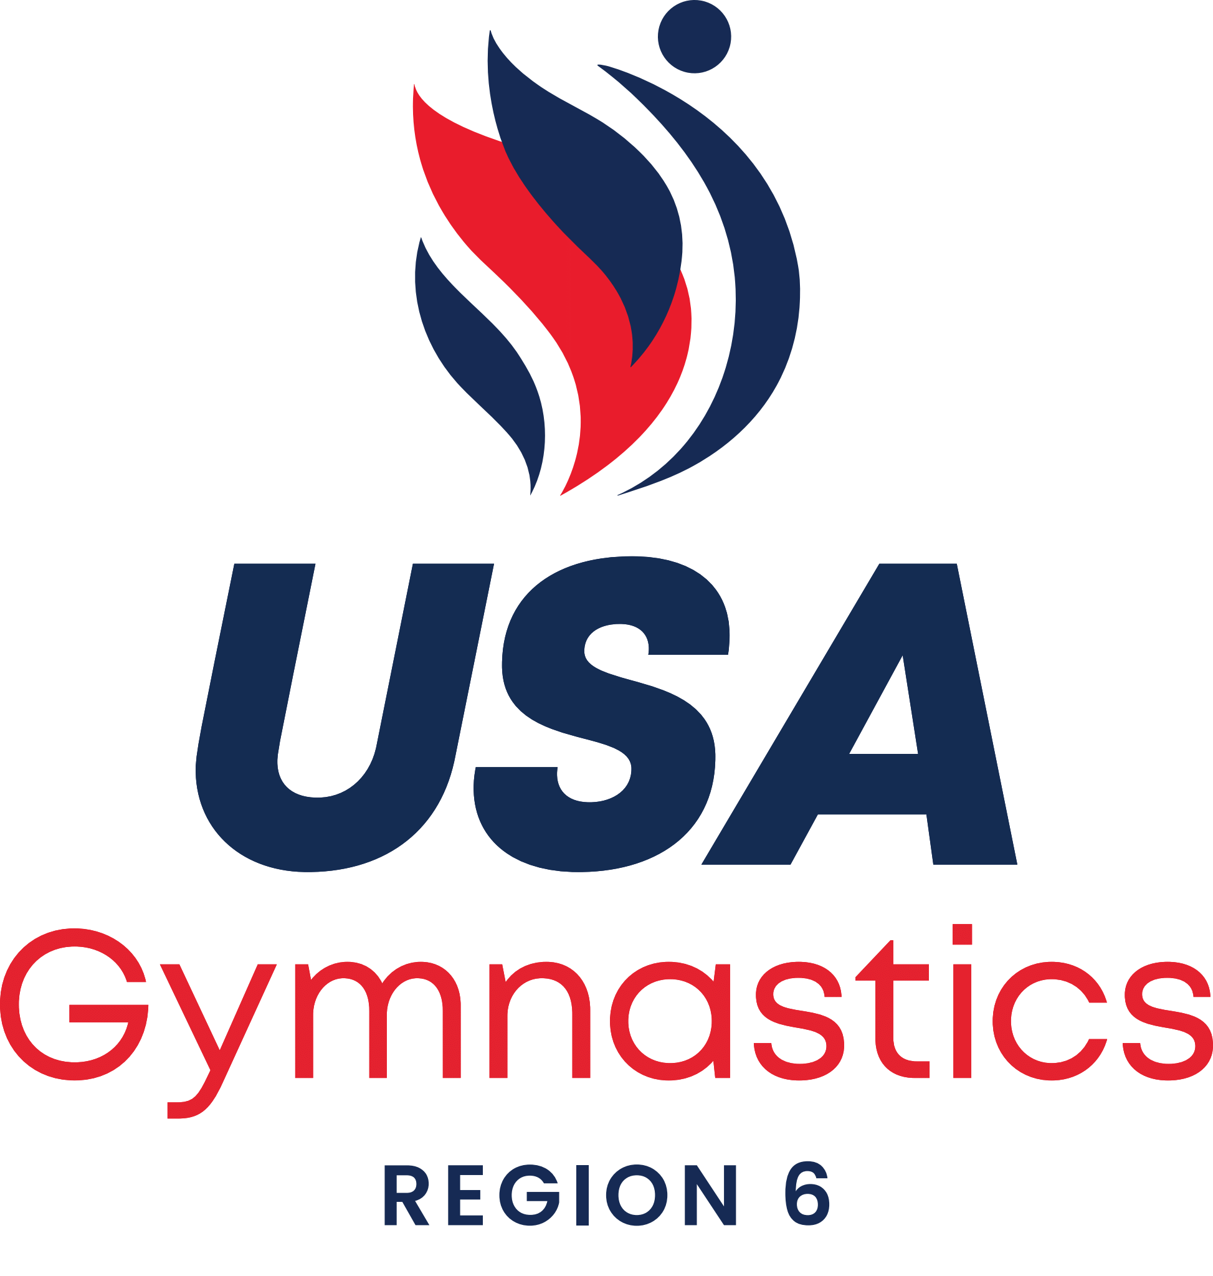

NEW 2023

IES Petitions will be allowed at the
Level 10 Regional Championships.

The following must be received by the RTCC [Pat Panichas] no later than 3 days after your State's Level 10 State Championships.

- Petition Form - completely filled out with COMPLETE INFORMATION https://usagym.org/PDFs/Forms/Women/injury2021.pdf

- Photocopy of TWO pre-state; current sanctioned competition at the level the athlete is petitioning - with a MINIMUM score of 9.30

- A written request from the coach stating the reason for the petition [reasons are illness; injury or personal tragedy]

A Licensed Medical Professional's written verification of the illness or injury and DATE of RELEASE to return to gymnastics activity. The release date must be AFTER the State Championships and prior to the Regional Championships.

In order to meet the deadline: Attach / Scan all the required paperwork listed above and submit it electronically to:
Pat Panichas
panichas@aol.com
(203) 215-8420

If you do not have the Licensed Medical Professional's note, please send all other materials by the deadline and the note ASAP

