WNS BANNER HANGING INSTRUCTIONS (Varsity and JV)

ARRIVAL TIME: 20 minutes early if there is a JV game preceding the Varsity game. 35 minutes early if it is a Varsity only game night.
BANNERS LOCATION: Banners are stored in the WNS “cage” which is the first enclosed storage area in the locker tunnel, located just past and to the left of the vending machines.

- Hang “Storm Hockey” Banner. It is recommended that you find and hang this banner before doing any other activity. This is so you are sure it is completed before coaches/players get to the bench.
- Find Banner in cage and grab two “S” hooks.
- Grab the hook hanging tool, which is a 2’ stick that extends to 4’ and has a fixed S-hook on the end. You will use this to hang the banner.
- Go to home bench and hang banner on the glass behind the bench at the blue line. See photo below.
- Return hook hanging tool to cage and proceed with next step.
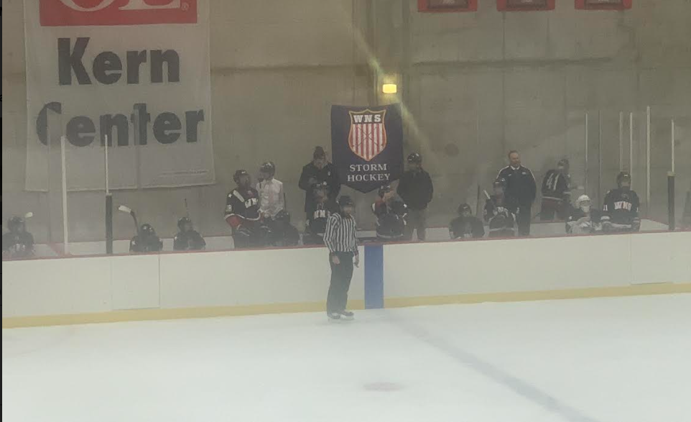
1
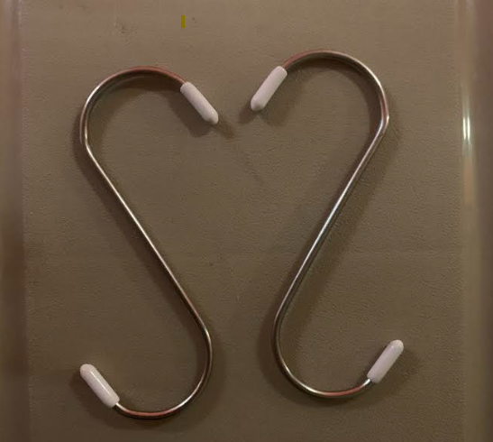
S Hook
- Hang Senior Player banners. You will find the 14 senior banners in the cage.
- Find the black velcro straps in or near the “WNS game day” bin; two straps per banner
- Hang banners on the South (Home team) end of rink. See photo below.
- Hang smaller “Storm Hockey” banner
- You can either hang this banner next to the senior banners as shown in the photo or alternatively, you can hang it in the Northeast corner (above the Zamboni garage).
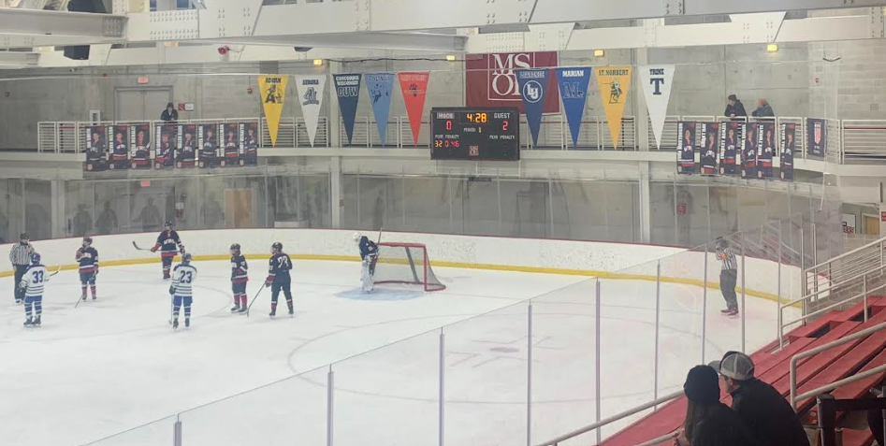
3
2
2

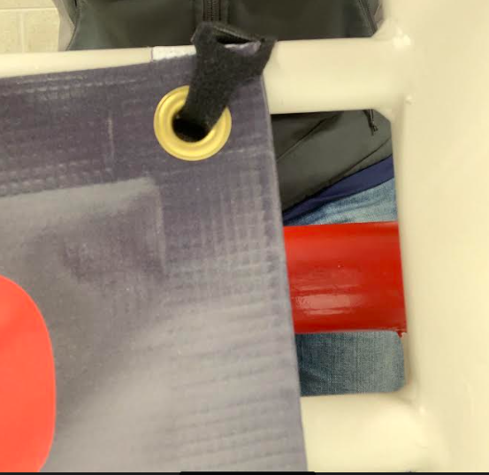
Velcro Strap

