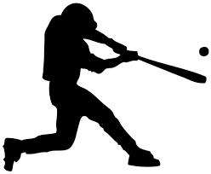
GET READY, GET SET, SWING!

Hitting mechanics that help you produce your “A” swing consistently

GET READY

GAS & BRAKE Mentality with your front foot
- Let your front foot assist in getting back
- Feel your move (Pelvic / Down angle pinch)
- Knee to knee
- Don’t get over your back knee

Issues during your get ready phase…..

- No movement at all
- Going linear before getting back

Drills that help hitters complete this move with explanation

- Back Foot Box Drill
- Furniture Slider “Get Back” Drill
GET SET

FRONT FOOT & FRONT SHOULDER need to match keeping you connected during your linear move
- 50 / 50 Balanced position
- Equal flex in knees
- Stay away from sitting on your backside

Issues during your linear phase…..

- Hitters getting stuck in 60 / 40 position
- Rubber band movement of getting back and striding at the same time.

Drills that help hitters complete this move with explanation

- “Walk Through” Tee & Front-Toss
- Momentum Tee & Front-Toss
- Cross Behind / Stride

SWING

FRONT & BACK SIDE CONNECTION allows you to pull to plane and whip the bat through the zone with body support

- Front side “L” / Power “L”
- Proper rotation in your back foot (No Pushing)
- Body position of back & behind the ball

Issues during the rotation phase that hitters face….

- Leaking
- Spinning
- Casting
- Barrel drop
- Break in connection

Drills that help hitters complete this move with explanation

- PVC Pipe Body Rotation
- Lift the Back Heel
- Pull to plane

