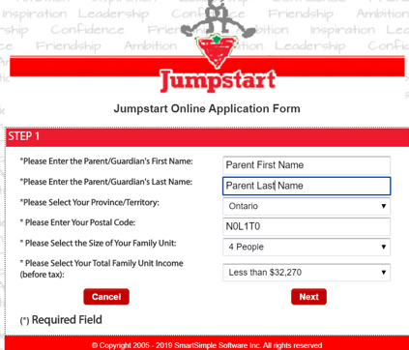
Step 1:
Enter in your personal information with number of people and choose from the list for income.
Click Next

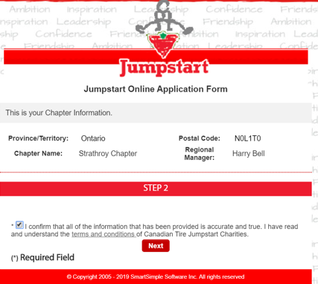
Step 2:
Read the disclosure and Check the Box
Click Next

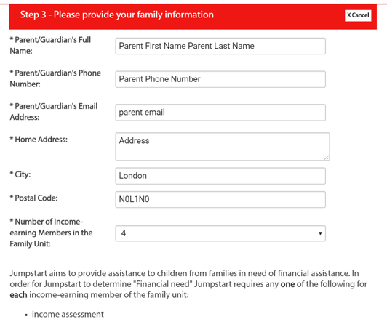
Step 3:
Enter in your information and click Save
Click the upload button and choose the file with your information.
Then click save again.
Click Next

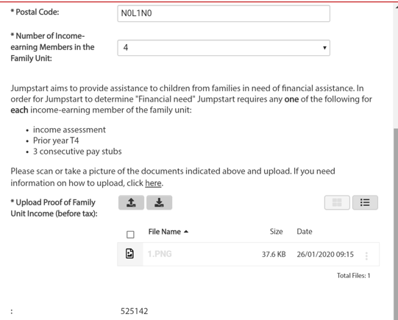

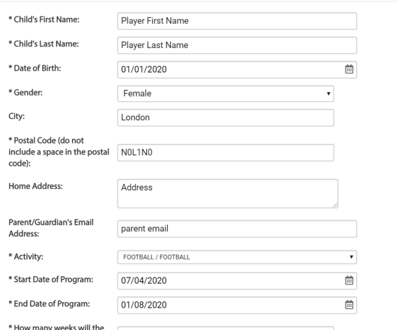
Step 4:
Enter your player information, including date of Birth and Gender, address of player (only change if there is a different address, and email.
Activity: Football
Start Date: April 1, 2023
End Date: August 7, 2023
How many weeks: choose more than 12 weeks
Days per week: choose 3
Total Registration:
$810 ( $150 for tryouts +$660 Season fee)for Atom and Peewee
$975 ($150 for tryouts +825 Season fee) for Bantam, JV and Varsity
Number of hours: 3 hours
Organization: London Junior Mustangs
Key Contact: Jennifer Selby
Email: Registrar@londonjuniormustangs.com
Phone: 226-790-6513
Mailing Address: PO Box 35009
London, Ontario N5W 5Z6
Facility Address: Western Stadium
100 Philip Aziz
London, Ontario N6A5P9
Click Save

.
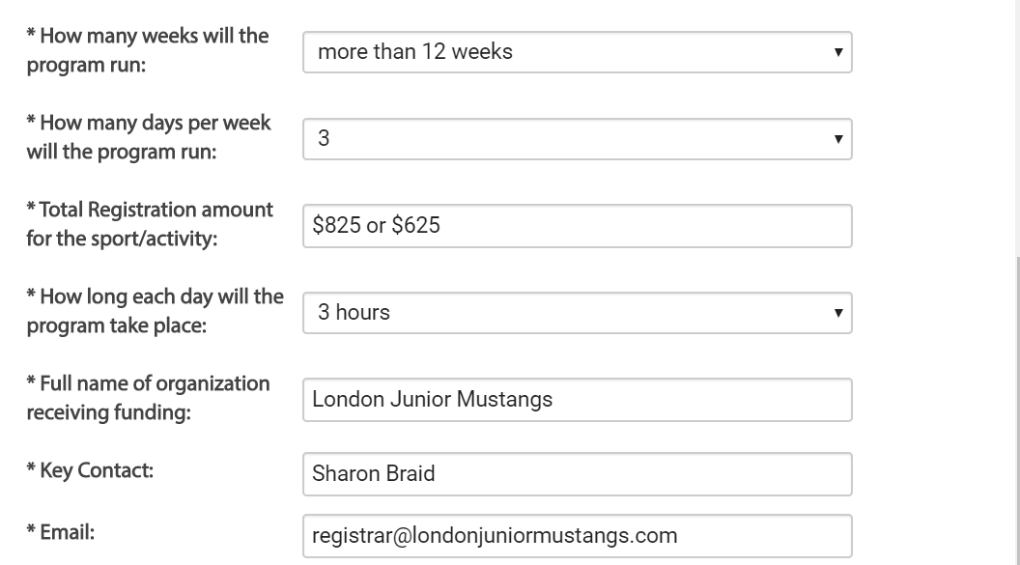
226-790-6513
Jennifer Selby

$810 or $975
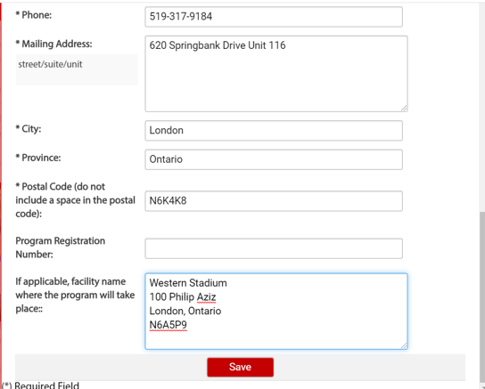
N5W 5Z6
PO Box 35009

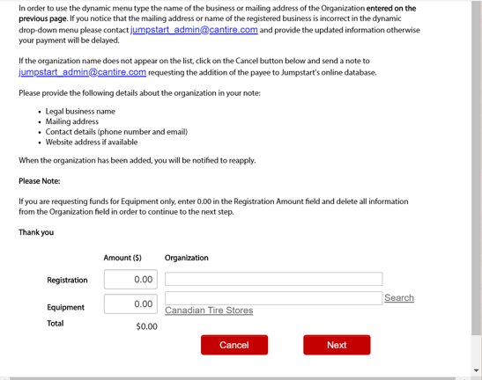
Step 5:
Registration: $300 is maximum
Organization: Choose London Junior Mustangs from the dropdown.
Click Next
London Junior Mustangs
$300.00

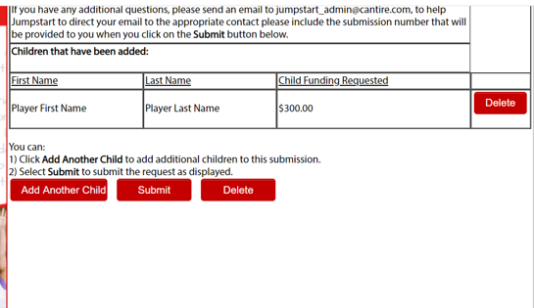
Step 6:
This should be the final screen before you submit, you can add multiple children for the same or different sports.
Click Submit: There will be an application number. Please save this number and email to registrar@londonjuniormustangs.com

