Player Assessments
U9 – U11
- Technical ball control (Measured score): Includes dribbling, ball control & creativity

Toe Taps:
    - Number of touches in 30 seconds times (2)
Foundations
    - Number of touches in 30 seconds times (2)
Figure 8
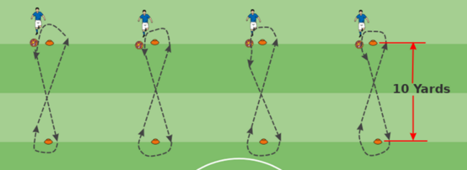
    - Assess ball control, turns, change of direction, use of both feet inside and out for 30 seconds.

- Technical other (1 – 5)
Change of direction
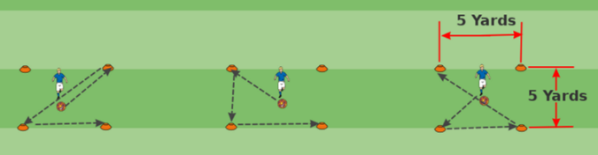
    - Create a box with cones approximately 10 yards apart. Encourage the player to dribble using both feet towards a cone, change direction & repeat for 30 seconds. Look at creativity with moves and acceleration after turn or move.
Creativity
    - Player demonstrates the ability to problem solve and make quick, successful decisions on the field.
Ball control
    - How well the player is able to control the ball, use both feet, inside and outside for 30 seconds.
Passing
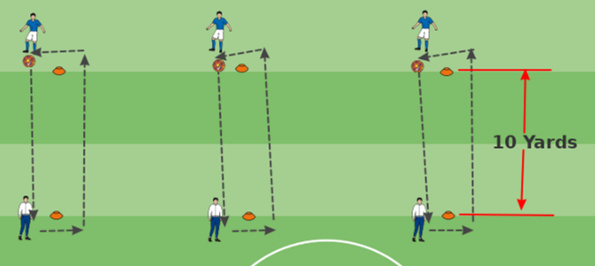
    - Directional passing with evaluator. Is the player able to use both feet, hit the intended target, and use proper pace on the ball for long and short passes.

One touch
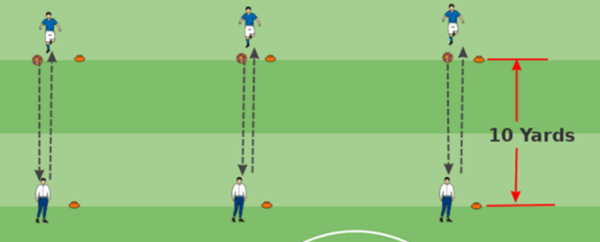
    - Is the player able to pass accurately with one and two touches back to the intended target using both feet?

- Small sided play
1v1 offense
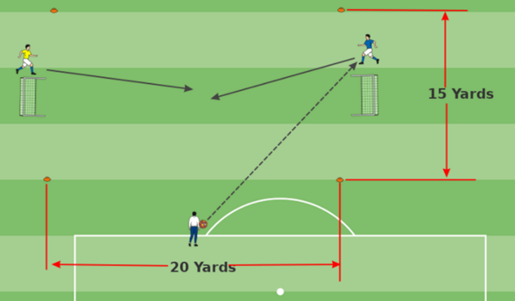
    - Players demonstrates the ability to control the ball, make moves, move forward past the defender using both feet and uses inside and outside of both feet.
1v1 defense
    - Player shows the ability to confront the offensive player, stop forward momentum and gain control of the ball.
- Open play
Positioning
    - From the four pillars of soccer - includes the strategic aspects of play including spacing, vision, and anticipation. Player understands his position and territory. Being able to read the game and help others when necessary.
Off the ball movement
    - Player creates space and support for other players when not in possession of the ball. Creates passing lanes and opportunities to advance.
Movement with the ball
    - Includes dribbling, foot skills, and shooting. Player shows vision, knowledge of the field, and pace of play. Player recognizes change of direction and change of play.
Offensive minded
    - Player looks for and creates opportunities to move the ball into the offensive third.
Defensive minded
    - Player recognizes when to hold and find players to defend. Player looks to prevent the opposing team and player from advancing and does so while maintaining position and communicating.
WOW factor
    - Player’s knowledge and passion for the game is evident in their skills, coachability, and willingness to learn. Player’s skill makes them standout from their teammates.

- Fitness
Obstacle course with ball
    - Using cones and poles to create an obstacle course that highlights the player’s ability to dribble, turn, and create moves. Add additional poles for a weaves section to the course.
Obstacle course without ball
    - Using cones and poles to create an obstacle course that highlights the player’s ability to dribble, turn, and create moves.
40-yard dash
    - Timed 40-yard dash without a ball.

Player Assessments
U12 – U18

- Technical
Circle drill
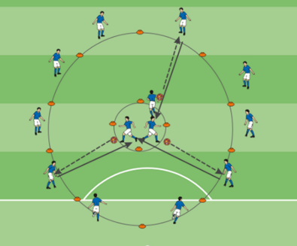
    - Create two circles. One large and one smaller within the larger circle. Each player on the inner circle has a ball and passes to a player on the outside and follow their pass. Once received, the player on the outside dribbles towards the inner circle using both feet, inside and outside while avoiding the other players. Repeat.
Passing
    - Using the same two circles players will showcase their ability to pass the ball with appropriate pace and direction.
Change of direction
    - Players will showcase their ability to change directions while maintaining control of the ball.
Ball mastery
    - Player will showcase their ability to control the ball with both feet using the inside and outside of their feet.
Field awareness
    - Player is able to sense what is going on all over the field and views the next move before it happens.

- Technical other
First touch instep pass and volley
    - Players will showcase their ability to volley pass the ball using both feet and instep.
First touch laces pass and volley
    - Players will showcase their ability to volley pass the ball using both feet & laces.
Chest to pass and volley
    - Players will showcase their ability to trap the ball with their chest and volley/pass it to their partner.
First touch thigh pass and volley
    - Players will showcase their ability to trap the ball with their thigh & volley pass it to their partner.
Heading
    - Players will demonstrate the ability to control, redirect and finish using their head in the appropriate recommended and safe way.
Short/Short/Long
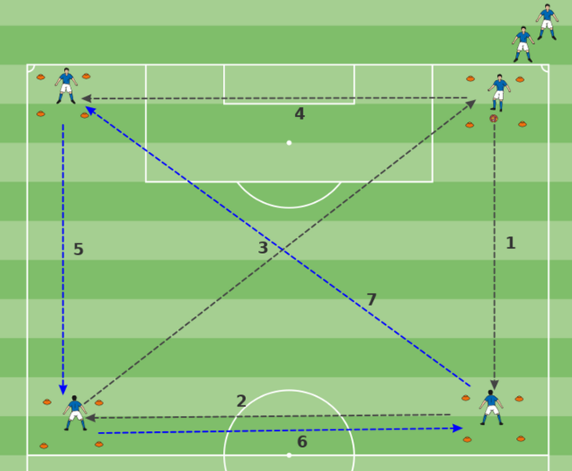
    - Players will demonstrate their ability to make effective short & long passes using their instep, laces and outside of both feet. Drill consists of four boxes approximately 25 yards apart. Using one ball, player (1) will use a long pass to move the ball to box #2 and follow their ball. Player (2) will receive the ball, use a short pass and send it back to player (1) who then plays the ball into space between boxes #2-#3 using a short pass. Player (2) receives and short passes the ball to player (3). Repeat around the playing area. Player (4), after receiving and passing the ball goes to the end of the line formed at box (1).

- Tactical
3 or 4 line drill
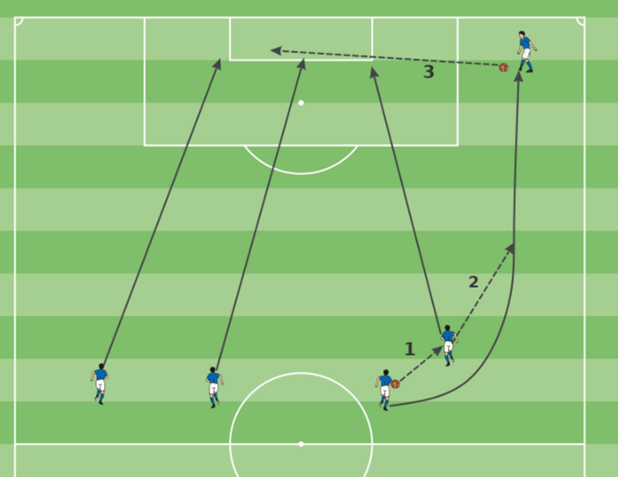
    - Players will demonstrate their ability to make short passes, overlap and cross the ball from the end line in order to create opportunities to score. Players without the ball will time their runs and showcase their finishing skills within the goal area using proper technique. Players will communicate who and where they will make their runs. (near post, far post, and middle). Coaches will also cross balls in giving players the ability to display their finishing skills. If a cross does not make its destination, players should run to the 18 yard box, reset, and communicate where their runs will be.
Off ball movement
    - Players showcase their ability move off the ball and create gaps, openings, disrupt the defensive player and create passing lanes and scoring options.
Timing of runs
    - Player showcases their ability to time their runs and split the defense in order to create scoring opportunities and passing lanes.
Ball placement
    - Players will showcase their ability to pass the ball into space and to the desired location. E.g., crosses should be away from the defenders and goalkeeper.
Finishing
    - Players will demonstrate their ability to shoot with precision, accuracy, and power while keeping the ball away from the goalkeeper using both feet inside and out.

- Open Play

- Fitness
Pro agility 5-10-5
    - Shuttle Run
40-yard dash

