WAUKESHA WEST
WOLVERINES

BOYS SOCCER PROGRAM




2021


PLAYER GUIDELINES HANDBOOK



Waukesha West Boys’ Soccer
Wolverines 2021 Season

Varsity Captains:
Oliver Kraklow Ph: 262-290-8511 Email: oliverjk04@gmail.com
Michael Poquette Ph: 262-720-2705 Email: mpoquete000@stu.waukesha.k12.wi.us

Picture Day: August 30, 2021 @ 2:30 p.m. on Stadium Field
Varsity and JV teams

Fall Practices: VARSITY: 3:15 – 5:15 pm
JV/JV2: 3:15 -5:00 pm

Eligibility Card:
All sport participants must have a WIAA physical card or alternate year card on file in the
athletic office before they can participate in practice or tryouts. Registration and payment
can be done online at https://www.westwolverines.com/reg. If you do not have computer
access, the forms are available at WEST during regular school hours.

Contact Numbers:
Waukesha West High School 262-970-3900
Mr. Kyle LeMieux – Assistant Principal/Athletic Director 262-970-3911 klemieux@waukesha.k12.wi.us
Mrs. Kim Dutelle - Athletic/Activities Secretary 262-970-3919 kadutelle@waukesha.k12.wi.us

COACHING STAFF:
Varsity Coach……Bryce Warner 224-436-9317 bwarner@waukesha.k12.wi.us
Asst Coach………..Matt Vraney 414-229-8575 matt.vraney33@gmail.com
JV Coach……….…..Matt Vraney 414-229-8575 matt.vraney33@gmail.com

West Trainer……Missy Hansen, MS 262-498-6197 mhansen2@chw.org
Children’s Wisconsin
School hours: M-F 2:30 - 5:30pm

End of Season Banquet Date: November 11th - 6:30 p.m. – Tuscan Hall
W A U K E S H A W E S T W O L V E R I N E S
2 0 2 1 V A R S I T Y S O C C E R S C H E D U L E

DATE: OPPONENTS: TIMES: Game / Bus departs
________________________________________________________________________________________________________

Tues Aug 24 St. Thomas More HS (Camper Night) 6:30 p.m.

Sat Aug 28 Whitnall HS 1:00 p.m.

Tues Aug 31 Away @ Kettle Moraine HS* 6:30 p.m. TBD

Tues Sept 7 Arrowhead HS* (Cancer Awareness Night) 6:30 p.m.

Thur Sept 9 South HS* (Parents Night) 6:30 p.m.

Sat Sept 11 Away @ Badger HS 1:00 p.m. TBD

Tues Sept 14 Away @ North HS* 6:30 p.m. TBD

Tues Sept 21 Away @ Mukwonago HS* 6:30 p.m. TBD

Fri Sept 24 New Berlin Eisenhower HS 6:30 p.m.

Tues Sept 28 Oconomowoc HS* (Senior Night) 6:30 p.m.

Sat Oct 2 Away @ Homestead HS 1:00 p.m. TBD

Tues Oct 5 Away @ Muskego HS* 6:30 p.m. TBD

Tues Oct 12 Catholic Memorial HS* 6:30 p.m.

Tues Oct 19 WIAA Regionals

Sat Oct 23 WIAA Regionals

Thur Oct 28 WIAA Sectionals

Sat Oct 30 WIAA Sectionals

Fri Nov 5 WIAA Division 2 Semi-Finals @ Uihlein Soccer Park 4:30 p.m./7:00 p.m. TBD

Sat Nov 6 WIAA State Championship @ Uihlein Soccer Park 7:00 p.m. TBD

NOTE: Bus & tournament times are subject to change, players should always confirm with their coach!

Bold = home games

* = Classic 8 conference Games

W A U K E S H A W E S T W O L V E R I N E S
2 0 2 1 J V S O C C E R S C H E D U L E

DATE: OPPONENTS: TIMES: Game / Bus departs
________________________________________________________________________________________________________

Tues Aug 24 St. Thomas More HS 4:30 p.m.

Sat Aug 28 Whitnall HS 11:00 p.m.

Tues Aug 31 Away @ Kettle Moraine HS* 4:30 p.m. TBD

Tues Sept 7 Arrowhead HS* 4:30 p.m.

Thur Sept 9 South HS* 4:30 p.m.

Sat Sept 11 Away @ Badger HS 11:00 p.m. TBD

Tues Sept 14 Away @ North HS* 4:30 p.m. TBD

Fri Sept 17 Quad @ Arrowhead (Arrowhead, Appleton North) 4:30 p.m. TBD

Sat Sept 18 Quad @ Arrowhead (Arrowhead, Appleton North) ? TBD

Tues Sept 21 Away @ Mukwonago HS* 4:30 p.m. TBD

Fri Sept 24 New Berlin Eisenhower HS 4:30 p.m.

Tues Sept 28 Oconomowoc HS* 4:30 p.m.

Sat Oct 2 Away @ Homestead HS 11:00 p.m. TBD

Tues Oct 5 Away @ Muskego HS* 4:30 p.m. TBD

Tues Oct 12 Catholic Memorial HS* 4:30 p.m.

NOTE: Bus & tournament times are subject to change, players should always confirm with their coach!

Bold = home games

* = Classic 8 Conference Games

HIGH SCHOOL ADDRESSES: (Only schools that are away this year)

Arrowhead High School
700 North Ave., Hartland, WI 53029

Badger High School (Lake Geneva)
220 E. South Street, Lake Geneva, WI 53147

Homestead High School
500 West Mequon Road, Mequon, WI 53092

Kettle Moraine High School
349 N Oak Crest Drive, Wales, WI 53183

Mukwonago High School
605 W School Road, Mukwonago, WI 53149

Muskego High School
W183 S8750 Racine Avenue, Muskego, WI 53150

Waukesha North High School
222 Michigan Ave., Waukesha, WI 53188

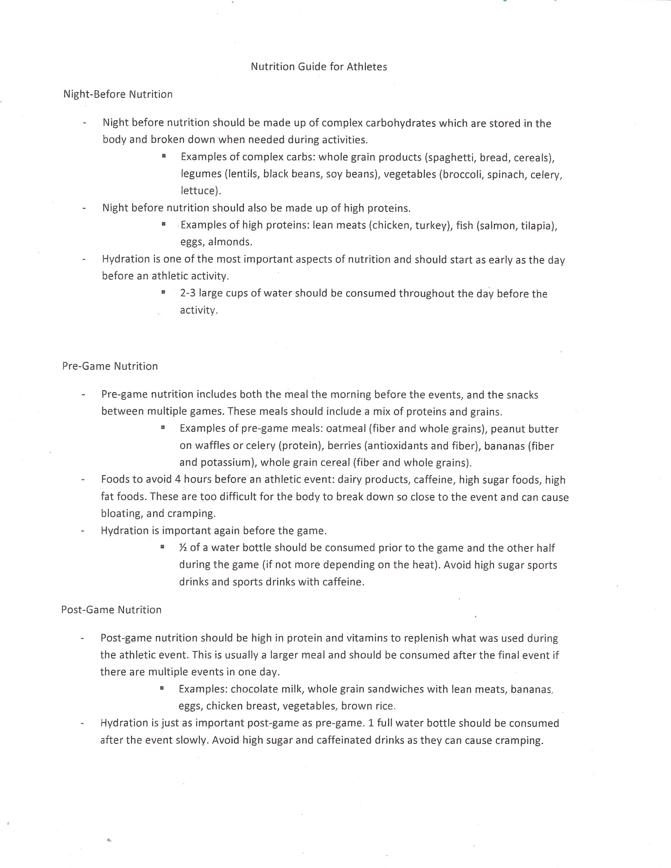

WAUKESHA WEST PLAYER GUIDELINES

This booklet of Soccer Guidelines is a series of rules and regulations plus information governing such matters as team play, personal conduct, practice times, attitudes, and team schedules. It can answer a lot of questions for you. READ AND USE IT!

SOCCER PROGRAM

The program at Waukesha West High School is comprised of a 3-team system:
1. Varsity
2. Junior Varsity
3. Junior Varsity 2 (if there are enough players)

1. Varsity: Any player (Freshman, Sophomore, Junior and Senior) who has shown they have the talent to compete at that level. The best play here. Max 22 regular game schedule and post season.

2. Junior Varsity (JV): Juniors who are Varsity reserves and all sophomores not brought up to the Varsity or any talented freshmen in the particular year. Max 22 game schedule.

3. Junior Varsity 2 (JV2): All Freshmen except those talented enough to play with the JV or Varsity Squads. Some sophomores who are still developing can get playing time on JV2. Max 17 game schedule.

BEING A TEAM PLAYER

In recent years, an anti-conformity movement has spread into high school athletics at a rapid pace. Everyone wants to “be his own man” so to speak. However, any GOOD TEAM needs a great deal of conformity and “working together” from its players. Our people are, have been, and always will be a team! We don’t want nor will we tolerate those “individuals” who place their own glory above that of the team. Together we WIN and divided we LOSE.

A. PRACTICES

1. You will be supplied with a schedule of all practice times for the year. Many of our practices will begin immediately after school. You will have 15 minutes to dress and be on the field. Unexcused latecomer may be penalized in some way, which could include a disciplinary action (such as running) at the coaching staff’s discretion. If you must be taped or wrapped, you must hustle even more to get on the field early and communicate with the coaching staff.

2. Practices begin and end according to the posted schedule. Get dressed quickly and without horsing around, if we get started on time – we get done on time (or earlier). You may be asked to stay later to work on individual skills.

3. A certain amount of interchange with coaches on the field is allowed if it is of a positive nature. Iron out any personal disagreements with a particular coach in a private meeting. Don’t do it on the field.

4. PROFANITY at practice WILL NOT be tolerated. FIGHTING with another team member in practice should be avoided. If it happens, these disagreements should always be left on the practice fields at the end of the day. Coaches always reserve the right to dismiss players from practice.

5. ALL UNDRESSING OF UNDERGARMENTS should be done in a bathroom or locker room. Going to the bathroom should be done in the bathroom, not on the field or any public area. There is no tolerance for not utilizing the bathrooms.

6. After practice, pick up your equipment! DO NOT leave garbage on the fields—this could result in the team running at the coaching staff’s discretion.

7. Times for practice on non-school days means on the field at that time – BE EARLY! Remember, on time is late… 15 minutes early is always a good rule of thumb.

8. Each player has to bring his OWN SOCCER BALL AND SHINGUARDS TO PRACTICE.

9. SCHEDULED UNDERCLASSMEN PLAYERS HAVE TO GET THE WATER BEFORE PRACTICE. If they have a game, then the JV players are responsible for the water! Communication between all players is encouraged.

***A violation of any of the above can result in a reduction of playing time.

B. ATTENDANCE AT PRACTICES AND GAMES

1. Attendance of all players at all practices is required. The coaching staff will not tolerate skipped practices. If you cannot attend a practice, notify the coach in person in advance. DO NOT “send word with another team member!” The only EXCUSE for missing a practice unless notified in advance is that you are receiving special help academically. Missed practices will result in a reduction of playing time.

2. If you are ill during the week (especially a sore throat) get to a doctor right away, don’t let it develop into something more serious. If you are ill the day of … or the day before a game- call or text your Coach. Stay home for a few extra bed hours. Come to school later if able, within WIAA guidelines.

3. You should be in school half of the day to play a game that night – School trips are exceptions.

4. Never miss school or practice unless absolutely necessary. You miss things that are done and said by coaches and other players that can never be made up. If nothing else, just sit, watch practice, and support teammates.

C. GENERAL TRAINING RULES, ETC.

1. SMOKING/VAPING - Absolutely prohibited during the entire year by our Athletic Code.

2. DRINKING - Alcoholic beverages also prohibited – same procedures as for smoking.

3. DRUGS – Also prohibited – Athletic Code decides penalty (and local authorities)

(CHECK YOUR ATHLETIC CODE OF CONDUCT FOR FURTHER INFO)

The above 3 are the most damaging things you can do to your physical condition. You are not an athlete for just a few months. Violators meet with Athletic Director and punishment is enforced according to code rules.

Coaching staff reserves the right to reduce playing time beyond the athletic code punishments.

4. GUILT BY ASSOCIATION: As an athlete you have a responsibility to yourself, your team, your school, and your community to represent them in the best way possible. Attending “get–togethers” or parties where alcoholic beverages and/or drugs are being consumed is not the proper way to meet this responsibility. In order to avoid the problems and rumors involved in the “I was there, but I didn’t drink” situation, it shall be considered a VIOLATION OF THE TEAM RULES FOR A TEAM MEMBER TO EVEN ATTEND A PARTY WHERE ANY OF THE BEFORE-MENTIONED ACTIVITES ARE TAKING PLACE. As an athlete you do not belong in these situations. (The Coaching Staff will handle the solution as they see fit.)

5. COACHES LATITUDE IN HANDLING TEAM PROBLEMS: All the training rules in the world won’t cover all situations. Also some situations merit different consideration than others. THEREFORE IF YOU DO ANYTHING THAT THE COACH FEELS IS DETRIMENTAL TO THE WELFARE OF THE TEAM, HE WILL HANDLE IT AS HE SEES FIT. This means that the team penalty might be even more severe that the Athletic Department policies.

6. SUSPENSIONS: Suspensions may be handed out as the coach sees fit for definite or indefinite periods of time for an activity considered to be detrimental to the team or any breaking of team rules, including unnecessary yellow/red cards at discretion of Coaching Staff. During the time of suspension the players must still practice with the team but will not suit up for games.

7. ELIGIBILITY: In order to play you must be scholastically eligible and to reach this status you must be doing your classwork. TEACHERS DETERMINE ELIGIBILITY, COACHES DO NOT!

If you think you might be in danger of failing a class, LET COACH KNOW and they will talk to that teacher and see what the problem is. Perhaps the Coach can communicate better that you can. However, our system demands intelligent players – you don’t have to be getting all A’s, but at least get the grades you are capable of getting. A CHAMPION ON THE FIELD IS USUALLY A CHAMPION IN THE CLASSROOM.

8. DIET:
a. Try to eat balanced meals at home –good breakfasts especially – and supplement your diet with vitamins if possible, or other sources (fruits, juices, etc.) This is very important in avoiding sickness.
b. Some players like to bring a sandwich or some other food to eat shortly before practice. Some days it has been a long time since you ate lunch.
c. Day of Games: Use common sense in what you eat at all times – be most particular on game days. If you must eat an evening meal before you play, EAT EARLY – as soon as you get home from school and then don’t eat again until after the game. IT TAKES ABOUT 4 HOURS TO COMPLETELY DIGEST MEALS, so eat early. IDEALLY – the last meal should be at noon or earlier and should contain a heavy concentration of CARBOHYDRATES (STARCHES), IF YOU HAVE QUESTIONS, SEE THE COACH.

D. PLAYER CONDUCT:

1. Conduct in the hall, classes and at school events should always be a step above the ordinary. Misconduct by team members tends to severely hurt team moral. COACHES DO NOT want to hear about conduct problems in class involving players from any teachers. WE HAVE NO TIME FOR THAT. If you want to be a problem in class, you don’t belong on the team. If we hear about it, disciplinary action will be taken, which could include reduction in playing time or suspension from team.

2. OUT OF SCHOOL your actions determine to a great extent what people think of our team and the overall athletic program – we need strong and positive community support.
a. Pick your company and social areas wisely – avoid the “bad crowd” and the “bad hang–out”. Stories get started by jealous people and are nearly impossible to disprove, if you were with violators or at a party. Just stay out of these situations.
b. NEVER talk with writers or any other media unless it is cleared first.

E. TEAM SPIRIT AND MORALE:

1. WINNING AND LOSING: Winning is the name of the game in Varsity athletics; it is what you must be striving for each time you take the field. SIMPLY DO NOT ACCEPT LOSING SINCE THERE IS A MUCH BETTER WAY. Unless you devote yourself to it, you are cheating yourself and your teammates who do. Learning to accept losing is a dangerous trait, not only here but in other walks of life as well. Winning must be within the guidelines of sportsmanship and intense competition and the desire must be there. Winning is also more than just saying you want to win. It takes a GENUINE POSITIVE ATTITUDE to consistently be a winner along with the following:
1. Be in CONDITION to play (mentally and physically)
2. Execute FUNDAMENTALS well and quickly
3. Play as a UNIT
4. Learn from mistakes

There may be times no matter what you do, that winning may not be possible in some cases. DON’T BE A GOOD LOSER – BUT A GRACIOUS ONE. Don’t let extreme emotions show what you might be feeling inside.
1. Give the other team credit.
2. In order to keep team spirit and morale high, we regard the team as a “unit”
pulling together for one common goal. It’s “WE” vs. “THEM” – NOT “ME” vs. “YOU”.
3. Open jealousy and rivalry between team members does nothing but injure our chances for a successful season. We need players who want to play and who are competitive in trying to win positions, but once the course of the team is set, you must accept your role. Competition for positions is an excellent characteristic of good teams, but let that competition end on the field at practice.

2. PLAYER DIGNITY: A player’s dignity is a very important personal possession. You cannot play well without it. Be sure you don’t destroy your own by foolish actions on and off the field. Be sure that you allow your coaches their dignity too.

3. PRAISE AND CRITICISM: When you have done something wrong – expect to be told about it but never take it personally. When you do something outstanding on the field, you should also be complimented – this is our philosophy. If you earn and deserve compliments, you will get them; if you do not, you will receive your according constructive criticism. Never worry about personal criticism, since then you know you are at least being noticed by the coach and he is concerned about what you are doing.

4. REMEMBER THAT WHEN ANY COACH ON THE STAFF TELLS YOU TO DO SOMETHING, IT IS JUST AS IF THE COACH OF YOUR PARTICULAR TEAM HAD SPOKEN THOSE WORDS.

5. STRONG SUPPORT from players on the bench helps greatly during games. Everyone, no matter in the game or not, has a part in the team’s success.

6. NEVER, NEVER, NEVER CRITICIZE another player’s individual performance, or the coaching staff, in public, in school, or at home, since this type of thing most surely will breed discontent and unsure feelings among the rest of the team.

7. CAPTAINS – Being a Captain is a privilege. Captains do a lot within the program to help lead the team in a positive direction. Captains must lead by example and vocally. If you are selected as a captain, you represent the program on a higher level. There is a “3-strike” policy to being a captain. Coaching Staff reserves the right to withhold captaincy at any time depending on the severity of a situation.

BE HUMBLE but BE CONFIDENT

------------------------------------------------------------------------------------------------------------------------

By signing this page, you affirm that you have thoroughly read the Player Guidelines and have a clear understanding of the rules and expectations, and the potential consequences for violations of the expectations.

___________________________ ______________

Player Signature Date

___________________________ ______________

Parent Signature Date

