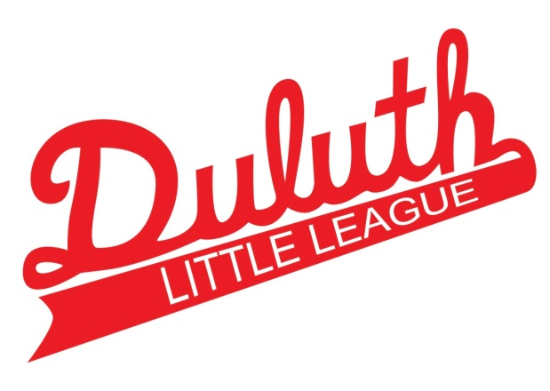
Coaches Checklist

1. Register via SportsEngine on our website at littleleagueduluth.org
Please be sure in account settings under “communication preferences” that notifications are enabled for email & text.

2. Complete background check (will be sent to the email address you entered at registration) and will be sent from JDP (the company that Little League International uses). Please complete this ASAP as no contact with players will be allowed until these are returned. Once completed, we typically get results quickly.

3. If you have current CPR/first aid certification, please submit a copy to duluthlittleleagueboard@gmail.com

4. First aid training can be found at https://www.littleleague.org/university

5. Online course training provided by the CDC website and specifically located at https://www.cdc.gov/headsup/youthsports/coach.html. Once completed, a certificate will be generated with the coach’s name and this will be emailed to the Safety Officer for recording and verification purposes.

