Hussey Seat Quote
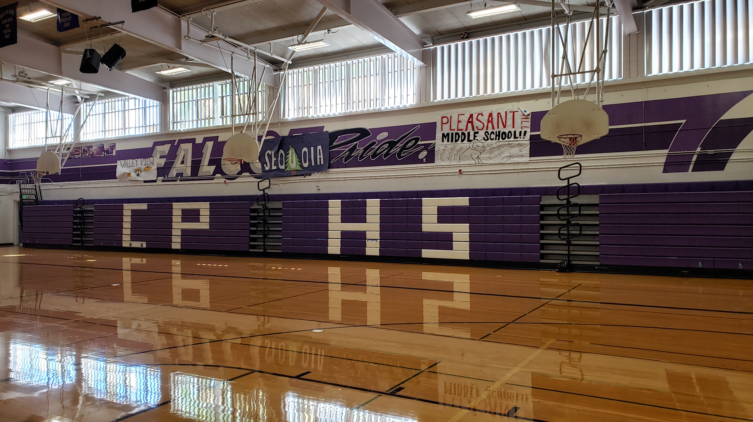 | No. California Hussey Seating Rep. | Date 1/19/21  Quote # 21019  Quote expires in 60 days

  1225 Cayetano Dr.  Napa Ca 94559  Phone 916-434-6561  Fax 916-434-6562  Jerrykincanon@gmail.com | TO | College Park High  To finish Bank B  East side of the gym  Hussey seat replacement

Qty | Description | Unit Price | Line Total
231 | New Hussey Courtside seats | 26.00 | 6006.00
 | Sales tax 8.75% |  | 525.33
 | Freight |  | 900.00
 | Labor to replace old MVP Seats with new Courtside seats on East side of the gym only. |  | 2,950.00
 | Take good old seats and replace broken seats thru out gym
 | Disposal of old seats |  | 600.00
 | Convert from MVP to Courtside Seating
Seat price |  |  | $10,981.33

:

