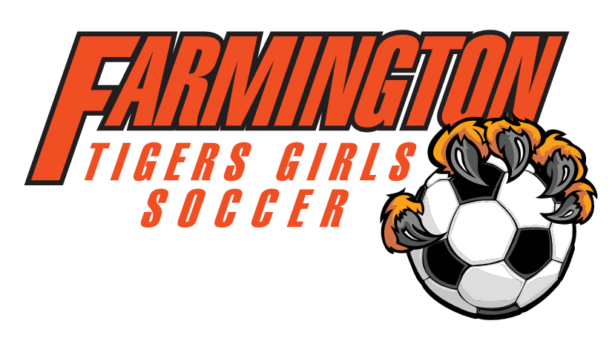
August 7th, 2017
6:30– Celts

- Call to Order
- Approve June minutes
- Fundraisers
  - Cub
  - Bingo
  - Mattress Fundraiser
  - Golf Tournament
- August 19th concessions discussion
- Updates on Warm-ups and getting them to Dakota Logo
  - Some stuff has arrive at Dakota Logo
  - Fan Shirts
- Team Bonding plans- August 30th
  - Pictures
  - Potluck
  - Sign-up Genius for food
- Busses for Owatonna and Rochester
- Meal plans for away games- need people in charge and plan
- Who can organize team reps?
- Treasury Report
- Any new Business
- Set September meeting and adjourn

