Lake Zurich Flames Cheerleading Code of Conduct
The Lake Zurich Flames Cheerleading program has continually advanced year-over-year. We are all very proud of the program and the cheerleaders and families who put their heart and soul into it. To continually advance the program, and provide our cheerleaders with an opportunity to perform at their highest levels, we ask that all participants and their parents follow our core expectations.
Behavior
• I will set a positive example whether in or out of my uniform. That includes the way I speak; absolutely no profanity, act; respectful to all those around me and handle myself in difficult situations.
• I realize that all of my coach’s decisions on uniforms and schedules are final and not up for discussion.
• Unsportsmanlike behavior, bullying, unkindness, sassiness and “attitude” or disrespect to my teammates or coach is inappropriate and will not be tolerated.
• I understand that it is the TEAM as a whole that succeeds or fails together. It is never a single person’s fault or credit and therefore I will not place blame on others or take credit for just myself.
Attendance
• I understand the time commitment necessary to be part of LZ Flames Cheerleading and agree to attend and be on time (meaning fully prepared to participate at the start time) to all practices, games, competitions and other functions.
• I will have my parents notify the coaches of all expected absences at least 1 day prior to my absence or sooner if I am aware.
• If I am sick and cannot make practice, I will have my parents notify coaches by 3:00pm that day.
• I will always attend regular and extra practices because I understand my team depends on me and cannot fully practice without the full team.
• I will keep my coach informed of any injuries I have that could prevent me from participating in a practice or event.
• I know an injury that prevents me from practicing does not excuse me from attending practice. I can still learn from being there.
• I know missing practices the week before a competition means that I may not be able to participate in the competition or may have my position changed.
• I know LZ Flames Cheerleading is a serious commitment. I will participate fully and put in 100% of my effort and attention.
Appearance
• I will not wear any jewelry to practices, performances or events as it is both a safety hazard.
• I will keep my uniform, spirit wear, practice wear, shoes and bows clean for all events.
• I realize that I must dress in the assigned attire for all practices, competitions, games and team functions.
Practice
• I will not participate in unnecessary conversation or goof off during practice.
• I will not use my cell phone during practice.
• I will not bring food, gum or drinks (except water) to practice.
• I will not allow anyone (friends and family included) to distract me during practice, and in return I will not distract anyone else.
Competitions/Games
• I realize I must be courteous to all officials, coaches, hosts, competitors and fans at all functions. I will accept my team placement/scoring with no criticism or comments.
• I realize I must be prompt to competitions/games and show up when indicated.
• I will be competition/game ready at the time indicated—meaning I will be in full uniform with hair done.
• I will wear my hair and makeup in accordance with team standards.
• I understand nail polish and jewelry are not allowed at competitions. I understand my coaches will remove it if I have it on.
• I will give my belongings to someone who is not on the team to hold until the competition is over.

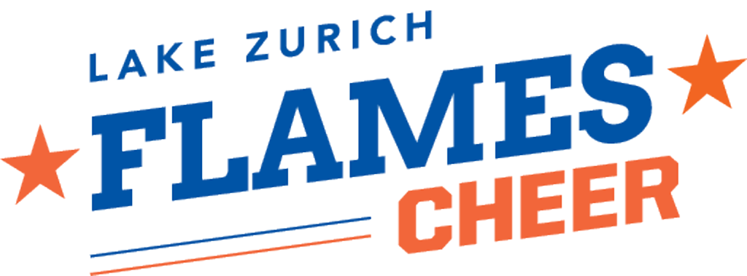

Cheerleader Commitment

I have read and agree to all of the points listed in the Lake Zurich Flames Code of Conduct. I understand that if I break any of these codes I could lose my right to participate on LZ Flames Cheerleading and will not be entitled to any refunds.

Cheerleader Signature____________________________________________
Print Name ______________________________________________
Team ______________________________
Date __________________

Parent Commitment

I have been given and reviewed the Lake Zurich Flames Cheer Handbook
I have read and agree to all of the points listed in the Lake Zurich Flames Code of Conduct. I understand that if I break any of these my child could lose my right to participate on LZ Flames Cheerleading and will not be entitled to any refunds.

Parent Signature_________________________________________________
Print Name _______________________________________________
Team ________________________________
Date __________________
