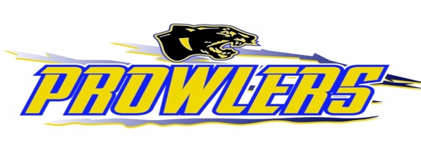

Thief River Falls Amateur Hockey Association
Board Meeting Agenda
The American Legion
Monday August 25th, 2025
Finance Meeting 5:30 PM
Board Meeting 6:00 PM

- Call Meeting to Order:
- Review and Approve Agenda:
- Request to Appear:
- Approve Minutes From: 7-28-2025
- Treasurer's Report/Finance Committee
  - Finance Committee Report
  - Approve Checks
- Gaming Report:
  - Finance Committee Report
- Administration:
  - Committee Reports and Assignments
    - Master Schedule
    - Safe Sport Committee Report
    - Tournament Committee
    - Gaming Committee Report
    - HOC Committee Report
    - Old Arena Report / Compressors Update
    - Weightroom Committee
    - Game Sheets Committee
    - Fundraising Committee
Other Committee and Committee Assignment
- Old Business:
  - Fundraising ideas throughout the season

- New Business:
  - Equipment hand out date
  - Equipment return? Start now or next year
  - Equipment deposit / Summer hockey equipment rental
  - One year hold on DIBS fee reimbursement
  - Ref scheduler starting pay per game
  - Material for mini nets
  - Try Hockey For Free director
  - 25/26 Teams
  - New checking acct: OA Concessions

- Adjournment:

Assignments
Note the President is a de facto member of all committees whether listed or not.

Board Members
President - Leif Spears
Vice President - Elizabeth Jahn
Treasurer - Kate Anderson
Secretary - Kevin Walseth
Members at Large - Davina Brown, Matt Olson, Mark Esala, Aron Muetzel, Derek Neisen, Dylan Barry
Assignments (Current Members)
Gaming Manager (Kelsie Dicken, Alicia Schneider)
HOC (Kyle Anderson, Brett Johnson, Mike Roff, Travis Collins, Mike Eickman, Mike Dowers, Cody Bottem)
HOC Board Liaison (Mark Esala)
GameScheduler (Josh Knott)
Equipment (Davina and Nathan Pray)
Referee Scheduling (Taya Mossestad)
Website (Kevin Walseth)
Social Media (Danielle Carlson)
Tournament (Team GM/Davina)
Old Arena (JR Novak)
Budget/Finance (Elizabeth Jahn, Leif Spears, Kate Anderson)
Practice Scheduler ( Aron Muetzel )
Registrar (Kacie Arlt)
Fundraising Scheduling (Elizabeth Bottem)
Accountant (Esther Gallagher)
MegaRaffle (Danielle Carlson)
Hockey Camps ( )
Safe Sport (Leif Spears)
Handbook/Bylaws (Elizabeth Jahn, Davina Brown, Kate Anderson)
Marketing/Sponsorship (Mike Dowers)
GMCoordinator (Davina Brown)
Coupon Books (Kate Anderson)
Fundraising Committee Members (Leif Spears, Danielle Carlson, Davina Brown, Erica Srnsky)

