BACH SOCCER SHIRT ORDER FORM 2023 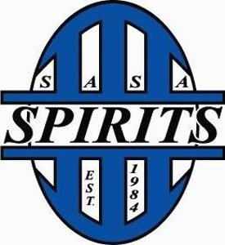

Team name: Division: .

Captain: Preferred Color: .

Please list below the quantities of each size you need. If players require a shirt size.This form has to be completed and returned by May 19th or you will get general random sizes.

Please note we will order a couple extra shirts in general sizes once shirts are handed out we will not reorder shirts. In the event you would like to order more you may reach out to Primo directly. If you need a size that is not listed below, please list an additional size in the box below.

We will not be ordering goalkeeper specific jerseys. Players will need to bring them on their own.

Team colors are not guaranteed. We will go with returning teams, then first sign up before we order. In the event you do not get the color you listed we will pick a color for you.

AS .

AM .

AL .

AXL .

A2XL .

A3XL .

Additional sizes: .

Logo sponsorship: .
(You will need to provide us with a PDF or vector file).

