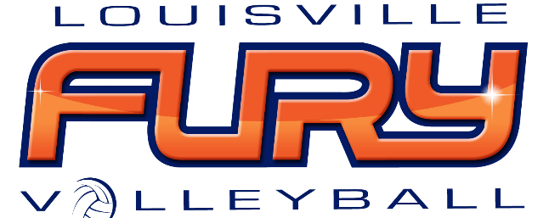

Player & Parent/Legal Guardian Handbook Acknowledgement

We have read the 2021-2022 Louisville Fury Player & Parent/Legal Guardian Handbook and agree to the terms and conditions listed within. Please sign below.

Player:__________________________________________________Date__________________

Parent:_________________________________________________Date:___________________

Parent:_________________________________________________Date:__________________

