SAC - MT
Meeting Minutes
11.20.2024

Call to Order: Josh Burnham (SACC) called to order the regular meeting of the SAC-MT at 10:05 a.m. via Google Meeting. Present members: Josh Burnham, Denis Berry, Crystal Lawrence, and Sharon Mozer.

Announcements:
- Financials - $50,650.60

Old Business:
1. State Cup - Meet host LMG January 10-12, 2025
- 1-set of equipment
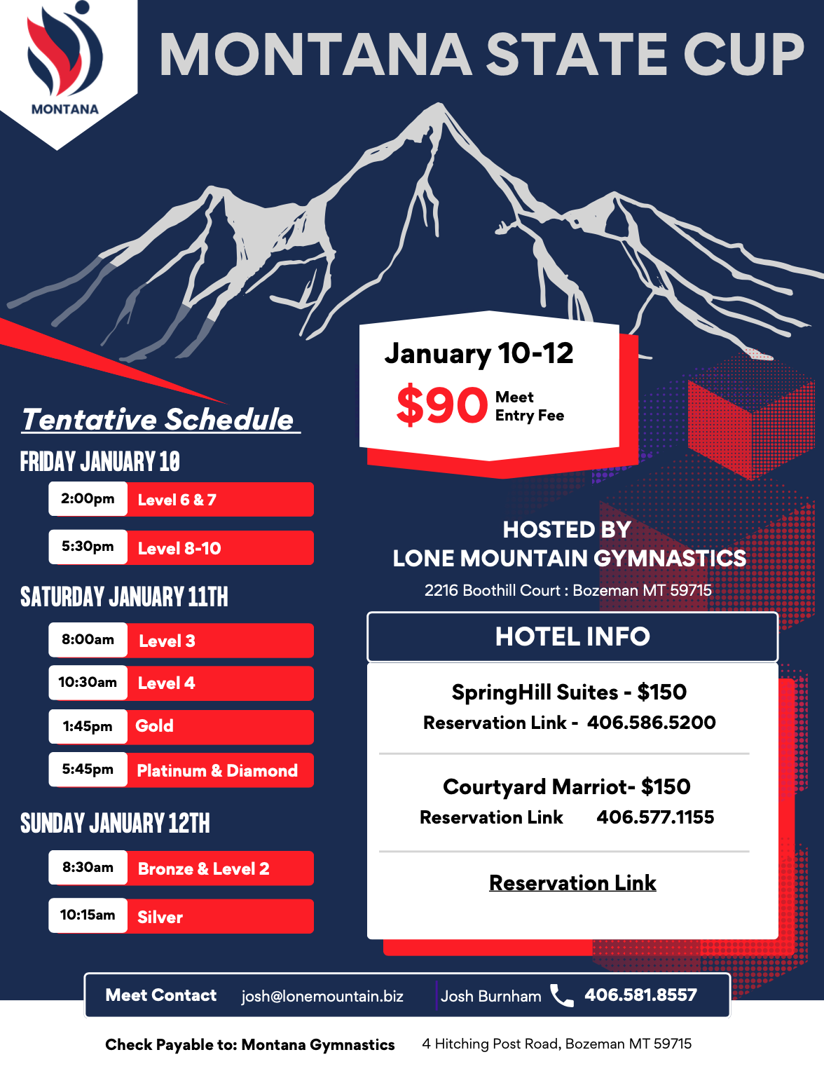
Host | State | Split
$5,000 | Entry Fees | Gate Fees
Concessions | Pay Medical
 | Pay Sanction Fee
 | Pay Awards
 | Pay Officials, Meals, Lodging, Mileage and Per Diem

2. State Leotard Fundraiser
- Ready to roll at the first of the year 2025
- Start a google spreadsheet for tracking
- Order form will have a QR Code
- $55.00 per leotard
- Post to social media once it’s up and running

3. Montana Summer Camp 2025 (June, July, August)
- Proposing to have three camps with separate dates
- Camp #1 (June 21st-22nd or 28th-29th)- Levels 8-10. Will bring in two high level clinicians. Possible locations are Helena and Missoula
- Camp #2 (July) - Levels 6-7 and XP/D. Possible locations are Helena and Bozeman
- Camp #3 (August)- Levels 2-4 and XB/S/G. Possible location is Great Falls. Will have in-state coaches work the camp along with Dianne Palmer of WA. Would like to include a 2-hour coaches clinic with Dianne Palmer as well.

New Business:
1. Regionals 2025
- Judging rotation is not guaranteed
- 2-judge panel for L6/7/8
- Tentative schedule below:

Thursday | Friday | Saturday | Sunday
8 | 8 or Training Day | 9 | 7
8 | 10 | 9 | 7
8 | 10 | 9 | 7
8 | All Star | 7 | 7 or 6 Invite

Other:
1. Declaration date 2025 remains the same - 2nd Monday of February each year for WDP/IES/XCEL

2. Bids will open for the State Championships 2026 will begin December 1, 2024

Adjournment: Motion to adjourn at 11:03 p.m.
Motion: Crystal Lawrence
Second: Sharon Mozer
PASSED
Next Meeting: TBD
Minutes submitted by Sharon Mozer

