- You will need “admin” access to edit the website. Current board members can give this access.

- Go to the SSRLAX website: https://www.sartellsaukrapidslax.com/home

- Sign in to SportsEngine

- Turn on “Edit Mode” (left side of screen)

- Click on Teams tab

- Select the Season (Spring or Summer) *Season must be activated before teams*

- Click the Admin tab

- Change to Public Access
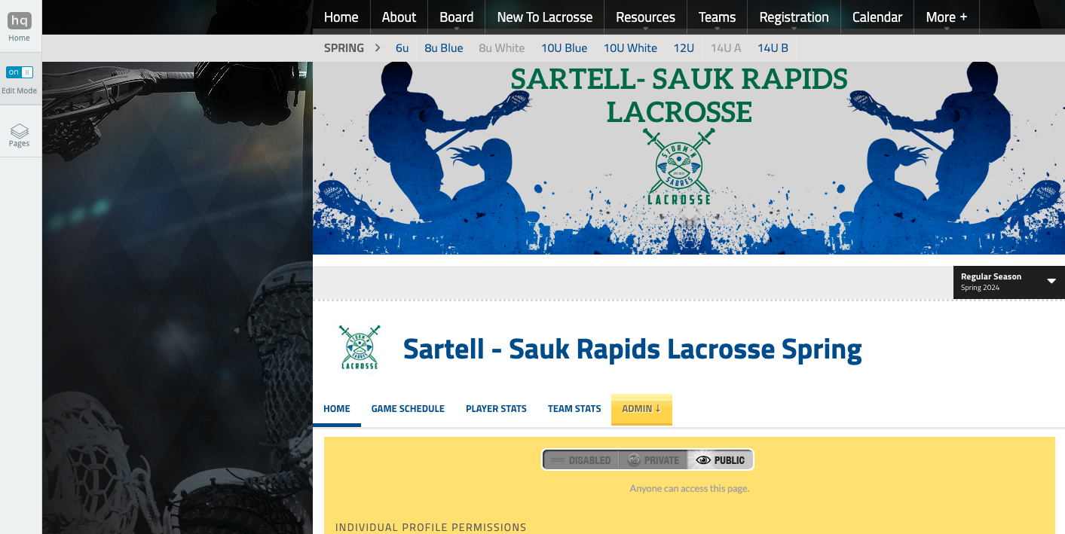
8
7
5
4

- All teams should appear under the Teams tab and season selected. Inactive teams will be light grey, active teams will be in blue.

- To activate the teams, click on the team you want to activate

- Click the Admin tab

- Click the Permissions tab

- Change to Public Access

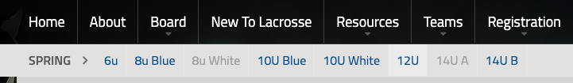
- Do this for all of the teams you would like to activate. Once active, you should be able to click on the team and be directed to that specific team page when you are not in edit mode. In edit mode you will still see any disabled teams for the season.
9 & 10
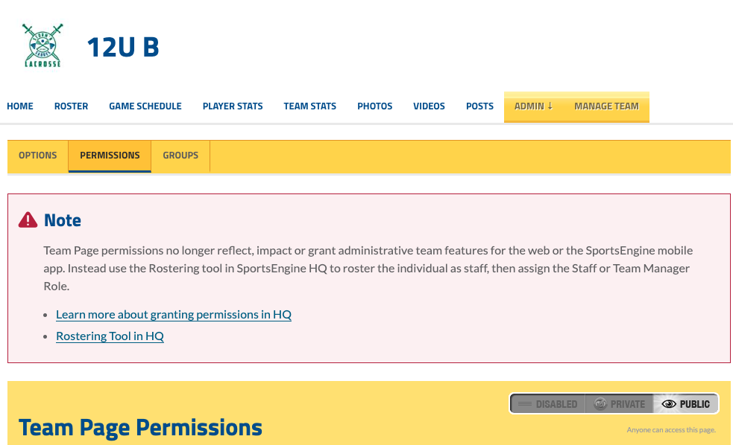
12
11
8
13

