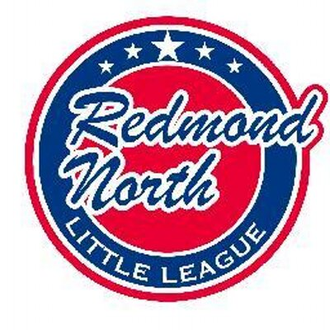

November 19th 2019 Meeting Minutes

In attendance:

Alec Weintraub
Sean Kronkite
Kathy Duncan
Jeff Cobb
Stacey Hanson
Mike Sessions
Tiffany Gore
Matt Winkler
Jessica Martin

Registration

Alec showed the new flyers and business cards. Banners and yard signs are ready to be displayed. Comments on flyers welcome. All board members are encouraged to print out and distribute flyers. Registration is ready to go – just needs to be linked to the website.

It was discovered that the old website is still up and running and can come up when Redmond North Little League is searched instead of www.rnll.org This needs to be closed asap. Matt to look into with Jorge? Libby Winkler has offered to run the facebook page.

It was decided to have a $25 fee for T-ball. Emails to be sent to members – registration open. T-ball will be jamboree style on Saturday mornings or Sunday evenings, depending on field availability.

Managers

We are trying to nail down managers for each division. Also, looking for an IB coordinator – any ideas welcome !

Local Rules

The local rules have been drafted. The main changes are to AAA and have been ran past last years AAA managers. Rules were positively received. Main changes include changing “No new Pitch” to “ No new AT Bat” for the time limit. Also the no free pass has been changed to a walk limit. A pitcher cannot walk 4 players in one inning. Any player Hit by Pitch will be awarded first base (except when hit by the coach pitcher). Removable fences MUST be installed and the home team is responsible for fences. It is noted that Redmond North is not always the home team at Redmond Ridge fields.

It was suggested that a laminated 1 page cheat sheet of the rules be placed in each dugout.

UNW – Alec to provide details of previous contracts and contacts to Jeff .

The motion to approve the drafted local rules was approved unanimously and they will now be sent to D9 for approval.

Constitution

The drafted copy of the constitution which was emailed to the board last week had some inconsistencies with ages throughout the document. Alec to review.

Jeff Cobb will update the Redmond North Little League Mission Statement.

Schedule

Proposed dates:
The Jackson Roos Tournament will be held the first weekend in June (6th & 7th).
The Pre-Season games are estimated for end of march.
AAA scrimmages will likely be on 14th March. This will include umpire and scorekeeper training.

Safety Plan

The safety plan is pretty much done. We just need an estimate of numbers of players. Email to be sent out to board members re background checks.

UIC

Jeff has done a review of gear. We are ok for hats and shirts but we are in need of chest protectors. Jeff to source, likely through Dicks Sporting Goods.

OTHER

Jamey McMahan is the evaluation day coordinator.
Financial - The board is to be provided with an end of season financial statement. Jessica to coordinate with Kristal to complete transfer of role.
Mariners Day – Alicia Burt and Sheryl Snow have agreed to take the lead on Mariners Day. The board decided on Sunday May 3rd vs the Astros. Bleacher seats were decided upon.
Website – Matt has been cleaning up the website, removing stale content and old links. Looking into changing over to Blue Sombrero but it is not an easy change so looking at June.

TRAINING
Free Mariners clinics are being held on December 15th or January 25th. January 25th was decided upon. SBA training and baseball positive bootcamps are to be rebooked. Keeping catchers clinic at SBA and Baseball positive pitching clinics.
To look into Big Al’s online clinics.

BATTING FACILITY
Contract has been signed. We are awaiting the contract back from King County. Alec is finalizing numbers with the contractors. Local Rules are to be added to include the batting cage times.

Next Meeting

Next meeting will be Tuesday 17th December 2019, at Ixtapa Redmond Ridge.

