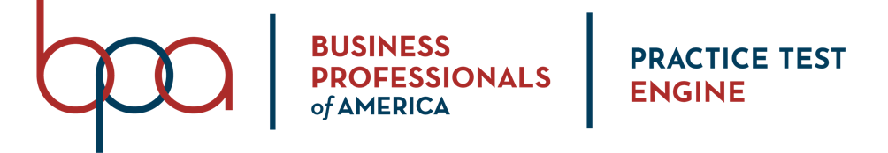
STUDENT MEMBER GUIDE

BPA Practice Test Engine Login Instructions
Method #1:
- Navigate and log into the Registration System Student Member Portal: https://register.bpa.org/members
  - Username: BPA Member ID (8-digits)
  - Password: Default Student Password from your local chapter

- Click on the BPA Practice Test Engine tab in the menu.
  - If access to the BPA Practice Test Engine has been purchased for the member, they will see the Go To AnswerWrite button.
  - If access has not been purchased for the member, they will receive a notification that they need to contact their local chapter advisor to obtain access to the BPA Practice Test Engine.

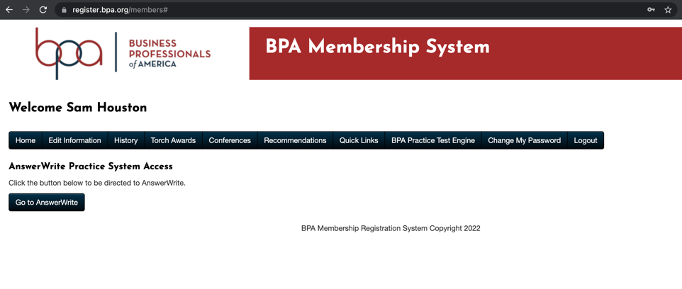
- After clicking on the Go To AnswerWrite button, BPA student members will be presented with a login form (see below).
  - Username: BPA Member ID (8-digits)
  - Password: Default Student Password from your local chapter
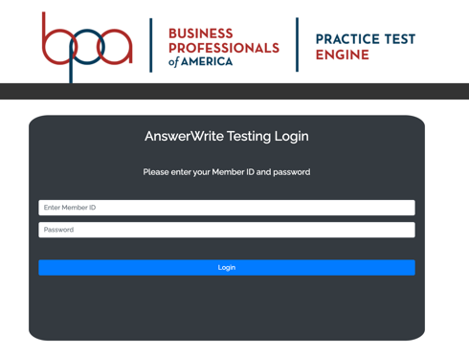
- Once logged in, student members will be presented with a list of objective question practice tests that can from previous membership years. Members will only be shown tests that are available to their membership division.

- A few notes about the practice tests:
  - All tests are timed to mimic the actual competition environment.
  - All tests are set to unlimited attempts and can be repeated at any time of the day or week.
  - All tests will provide immediate feedback to the member when they finish a test.

- Members will be presented with a prompt to accept before testing. 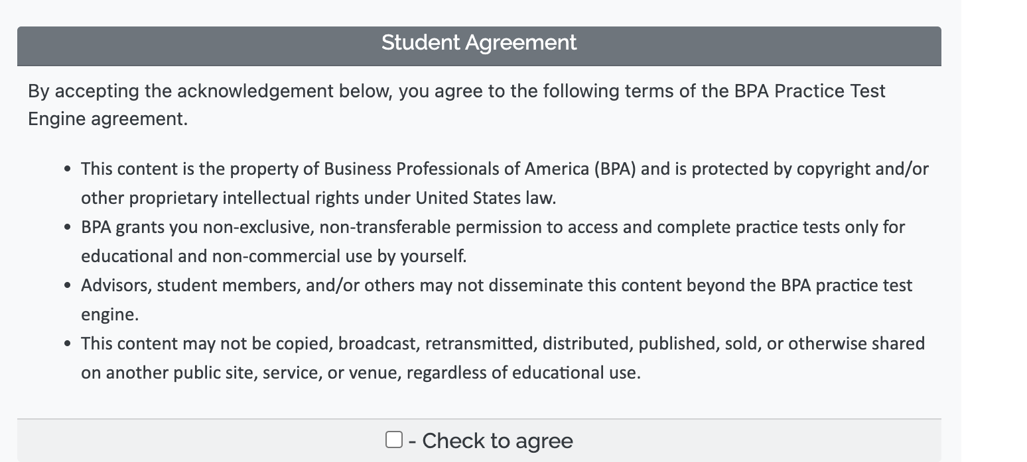
- After accepting the student agreement, a list of the available tests will be presented to the member. Use the Select button next to a test to being the test attempt.
