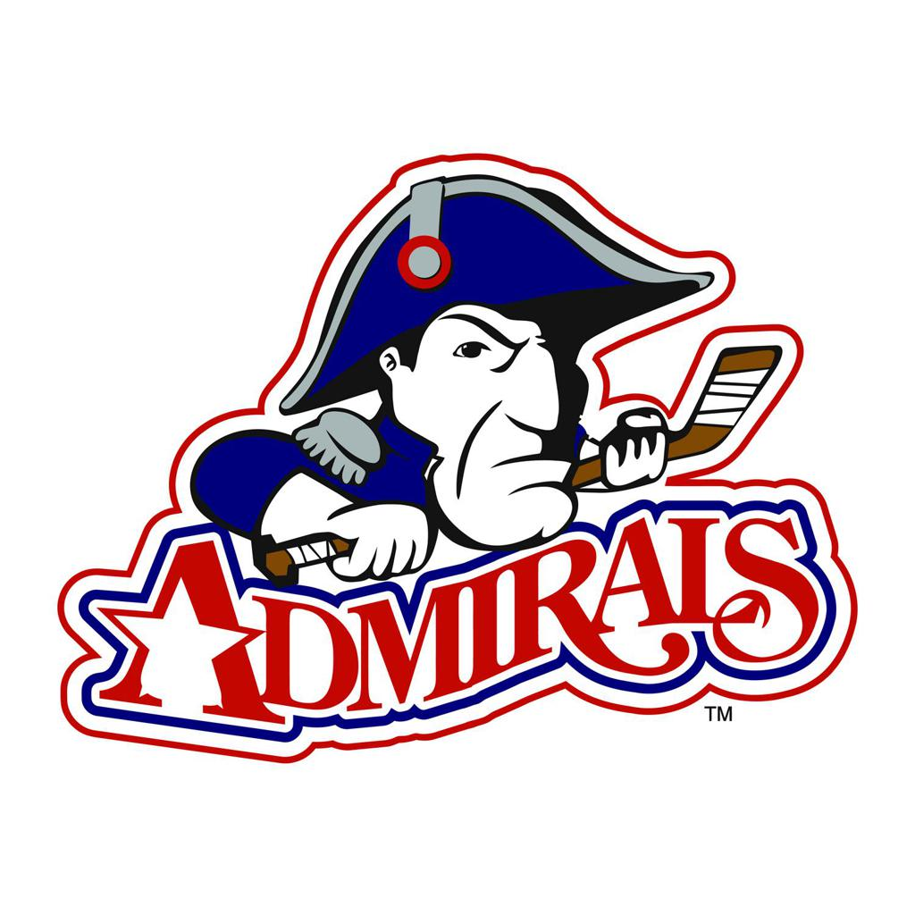  Admirals Hockey Club  2021-2022 Hockey season  Registration for the 2021-2022 Fall season is now open. This packet will provide you all the information you will need to register.  2021--2022 Fall Levels by birth year  Future Admirals In-House 8 & Under 2013 & younger  Future Admirals In-House 9 & Older 2012 & older  8U Junior Admirals 2013 - 2016  10U Squirts 2012 - 2011  12U PeeWee 2010 - 2009  14U Bantam 2008 - 2007  16U/18U Midget 2003 - 2006  Girls 1oU-16U 2005 - 2012  Key Dates  Hockeypalooza August 4, 2021 @ Center Ice 5:30 pm  3S preseason camp starts August 3, 2021 Check age level ice schedule  Uniform fitting #1 TBD @ Center Ice  Uniform fitting #2 TBD @ Center Ice  Home Rinks  Center Ice of DuPage 1N450 Highland Ave / Glen Ellyn, IL Carol Stream Ice Rink 450 Gundersen Dr / Carol Stream, IL | admirals hockey club  Center Ice of DuPage  1N450 Highland Ave  Glen Ellyn, IL  Admiralshockeyclub.com

Registration Information & Details

- Review this packet for details regarding the pre-season camp options, program details, fees, NIHL & CUHL tryouts and Girls tryouts, and other information. All registrations must be completed online prior to tryouts or evaluations.

- NIHL and Future Admirals players must have a valid 2021-22 USAH number. Go to www.usahockeyregistration.com to find (or register) your USAH number. You must provide your confirmation number during the online registration process. Registration with USA Hockey is required for all hockey players 10U and older in the United States. If you registered with USA Hockey on or after April 1, 2021, your registration is still valid for this fall’s season.

- CUHL players must have a valid 2021-22 AAU member number. If you did not purchase a multi-year membership in 2022, you will need to register for a new number. New membership registration for 2021 will not open until 8/15/2021. Go to https://play.aausports.org/joinaau/membershipapplication.aspx to register (or lookup multi-year membership number).

- Go to www.admiralshockeyclub.com and register your player for the program of your choice using the appropriate registration link.
  - For NIHL & all Girls teams
    - Players at the youth 10U through 18U level and girls 10U through 16U should register for 3S pre-season camps and tryouts/evaluations or camps with the 2021-22 Step 1 Registration for Camps and Tryouts.

- Step 2 must also be completed by September 15, 2021. Complete 2021-22 Step 2 Team Fee Payment Options to make team fee payments in full or establish your payment plan for this season’s team fees. Do not complete Step 2 until you have registered for camps and tryouts/evaluations and camps using the Step 1 registration link.
  - For CUHL (8U Junior Admirals)
    - All players should register with the 2021-2022 Step 1 Registration for 8U Mites CUHL Tryouts & camps registration.

    - Step 2 must also be completed by September 15, 2021. Complete 2021-22 Step 2 Team Fee Payment Options to make team fee payments in full or establish your payment plan for this season’s team fees. Do not complete Step 2 until you have registered for camps and tryouts/evaluations and camps using the Step 1 registration.

  - For Future Admirals
    - Players should register with the 2021 Fall Future Admirals In-House League registration.

If you have any questions about programs options, please contact:
Program | Contact | Email
Hockey Director | Nick Fina | ncfina@gmail.com
Future Admirals (all) | Abbie McDonald | Abbie.mcdonald24@gmail.com
8U Junior Admirals | Chris Bolognino | cbolo23@aol.com
10U | Ryan Martaugh | ryanjmurtaugh.85@gmail.com
12U | Jay DeMaria | jason.demaria@gmail.com
14U | Matt Benton | mbenton@puckstarhockey.com
16U-18U | Matt Benton | mbenton@puckstarhockey.com
GIRLS director | Sydney Cihak | smcihak59@gmail.com
General Registration Questions | Cyndi Kochowicz | Registrar@admiralshockeyclub.com
Fee or Payment Questions | Kirsten Torling | Treasurer@admiralshockeyclub.com
Uniform Questions | Lori Notta | uniforms@admiralshockeyclub.com
he Admirals Hockey Club prides itself on the development of our players. We focus on the development of players at all skill levels and ages, utilizing the principles of USA Hockey's ADM (American Development Model) and LTAD (Long Term The Admirals Hockey Club prides itself on the development of our players. We focus on the development of players at all skill levels and ages, utilizing the principles of USA Hockey's ADM (American Development Model) and LTAD (Long Term Athlete Development). These principles serve as the foundation to help each player realize their maximum potential in the game of hockey. This approach requires a commitment to not just the training of our players, but to our coaches as well. Our Hockey Directors, Nick Fina (Youth) and Sydney Cihak (Girls), along with our Head Coaches bring a high level of skill, passion, commitment and experience to their roles and have dedicated themselves to the development of excellence in both our players and our coaches. At the Admirals Hockey Club, your children will receive the highest caliber training, correct practice to game ratios, and age-appropriate practice concepts and skills. They will develop, compete and have fun playing the greatest game in the world.
This fall season the Admirals will field competitive teams in the Chicago United Hockey League (CUHL) at the Mite level, Northern Illinois Hockey League (NIHL) and NIHL Premier Selects. We offer NIHL teams at 10U, 12U, 14U, 16U/18U and Girls. We also offer our Future Admirals programming for those beginner skaters. NIHL teams will be selected on a try-out basis. All players who try out will be placed on a team that best suits their development.
Which program is right for my player?
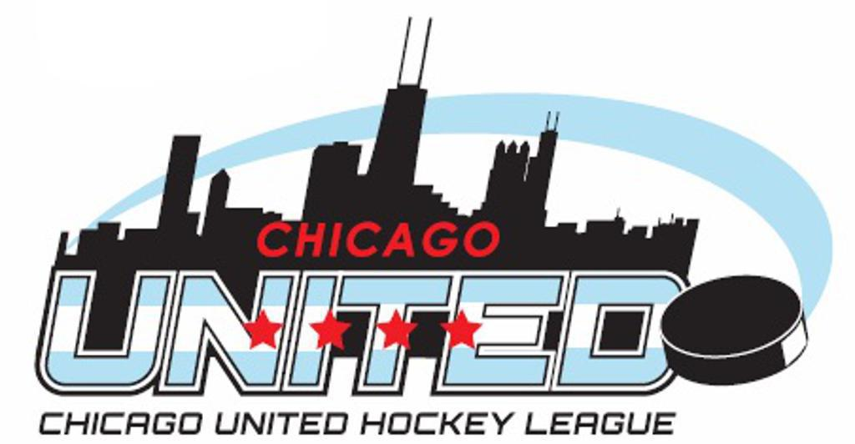
8U Mite (CUHL Junior Admirals)
Players will participate in an evaluation during which the head coaches will evaluate players based on the following criteria: skating, puck control, physical ability, shot strength, play making ability, work ethic and coach-ability. Each coach may weigh these differently based on coaching philosophy and/or team needs. Players are given a ranking by all evaluators. The highest rated players are selected for the first team, then the second, etc.
CUHL is a mite only league governed by the AAU (Amateur Athletic Union) and is not affiliated with USA hockey. CUHL typically has 90+ teams in four divisions, each with several tiers, ensuring parity and appropriate competition. Depending on team placement, the season can have up to 24 games plus playoffs, and may require out of state travel. The CUHL season runs September – March.

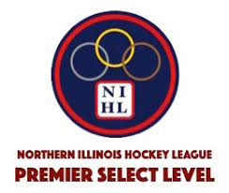
AA Elite level travel (Squirt-Midget)
The Premier Select Level will have a maximum of 12 teams per age classification. Each age level will have a Minor & Major team based on birth year. All players will participate in a tryout process. Our Hockey director and head coaches evaluate players based on the following criteria: skating, puck control, physical ability, shot strength, play making ability, sense of the game, work ethic and coach-ability. Each coach may weigh these differently based on coaching philosophy and/or team needs. Players are given a rating by all evaluators. The highest rated players are selected for the Premier Select Level.
AA-A level travel (Squirt-Midget & Girls)
Players will participate in a tryout process. Player selection will occur at this time. Our Hockey director and head coaches evaluate players based on the following criteria: skating, puck control, physical ability, shot strength, play making ability, sense of the game, work ethic and coach-ability. Each coach may weigh these differently based on coaching philosophy and/or team needs. Players are given a rating by all evaluators. The highest rated players are selected for the first team, then the second team, etc. In the NIHL league, player positions and ice times will vary and are at the discretion of the coaching staff. NIHL is a competitive travel league. The season can have up to 40 games, tournaments and might require out of state travel.

Learn to Play Hockey – (all ages)
Center Ice’s Learn To Play Hockey programs are designed around the guidelines of the USA Hockey’s ADM model. The Skating Academy coach staff is partnered with Admiral coaches to create a fun, relaxed learning environment for participants to learn the fundamental skills of ice hockey. This non-competitive and positive atmosphere not only makes a child’s first experience with hockey positive, but also creates an environment in which they can excel.
Participants will not only learn to skate, the skills and game of ice hockey; they will also develop self-esteem and self-confidence. The program operates under the premise that if a player's introduction to the sport is positive, they will develop a lifetime love of the game.
http://www.centericeofdupage.com/learnhockey.html
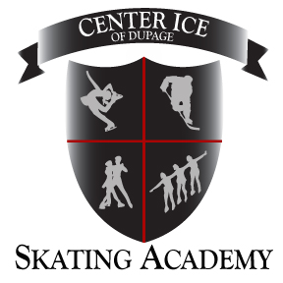

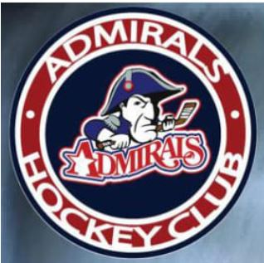
Future Admirals In House 8 & Under – Level 2 (2013 & younger)
Players born from 1/1/2013 & younger are invited to join the best developmental hockey league in the state. We following the USA Hockey Athletic Development Model (ADM) to provide the best possible experience for your up and coming hockey player. At ages 5-8 years old, our objective for physical development is to refine fundamental movement skills and begin to acquire basic sports skills. This is the time when the foundation is laid for future acquisition of more advanced skills. As far as psychological development goes, we will be focusing on providing FUN, motivating practices and games, developing reasoning skills through unstructured competition, building confidence by creating competitive groups, which will allow for a high rate of success and promoting individual and group participation as well as introducing the participants to simple rules and sports ethics (fair play). The In-House program will meet for skills, practices, and half-ice games. We will attempt to team up with other local organizations for Jamborees and practice games. All players who register will be placed on a team – there are no cuts.

Future Admirals In House 9 & Older – Level 2 (2012 & older)
The Future Admirals In-House League is a developmental league for players birth years 2012 & older. We will have weekly skills, practices, and half-ice games. The focus will be on providing FUN, motivating practices and games, developing reasoning skills through unstructured competition and building confidence by creating competitive groups. This program assists our beginning hockey players to develop their skills with players who are of similar age, size, and ability. All players who register will participate in a session evaluation and be placed on a team – there are no cuts.

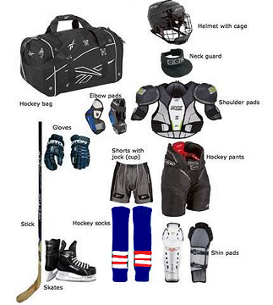

Required equipment for all Future Admiral programs.

Future Admirals
IN-HOUSE
In House  (2013 & younger) | 3 days / week  Tuesday 5:00-6:00 pm  Thursday 5:20-6:20 pm  Saturday 9:30-10:40 am | $975 | Fall Session | Sept 7 – Dec 18
In House  (2012 & older) | 3 days / week  Tuesday 5:00-6:00 pm  Thursday 5:20-6:20 pm  Saturday 9:30-10:40 am | $975 | Fall Session | Sept 7 – Dec 18
*dates & times are subject to change

Evaluations for In-house will be Tuesday 8/31 at 5:20 pm @ Center Ice (A)

Fees Include:
- One pair of hockey socks | - Station-based practices
- Half-ice games

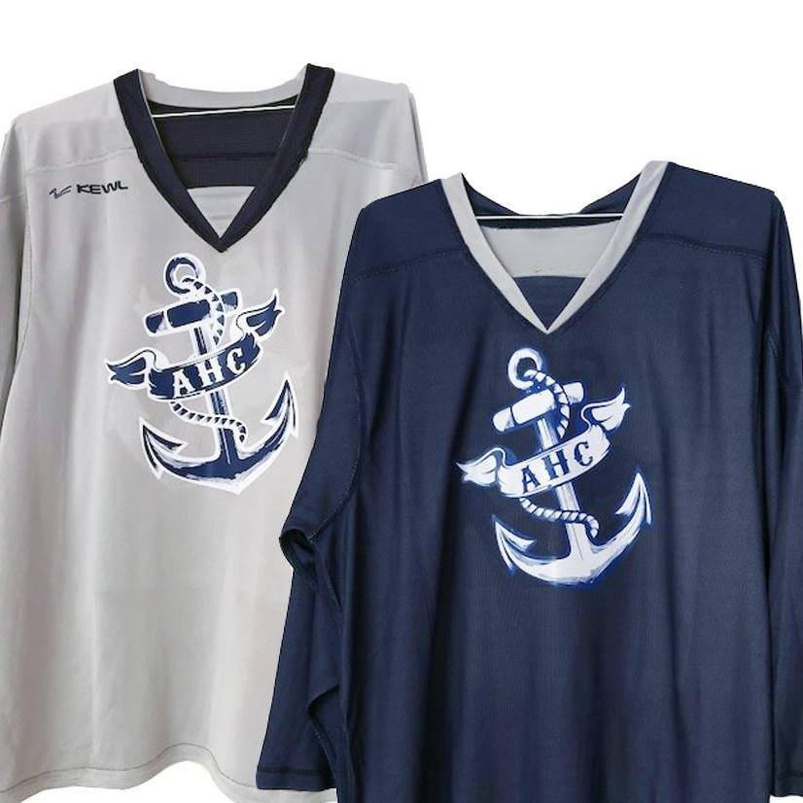

Reversible jersey for Future
Admirals In-House program.
If you already have one, you’re set.
If you need to order one, they are $36 (plus tax).

Uniform Standards & Ordering Information

Club uniform is mandatory for all players in CUHL, NIHL & Girls teams.

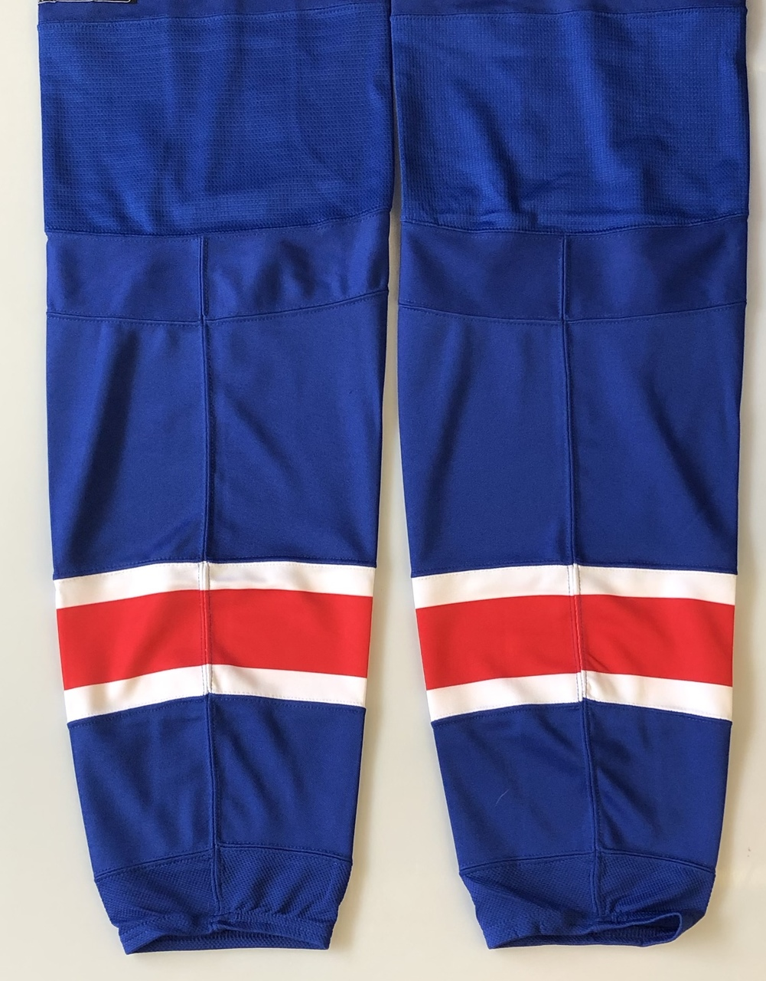
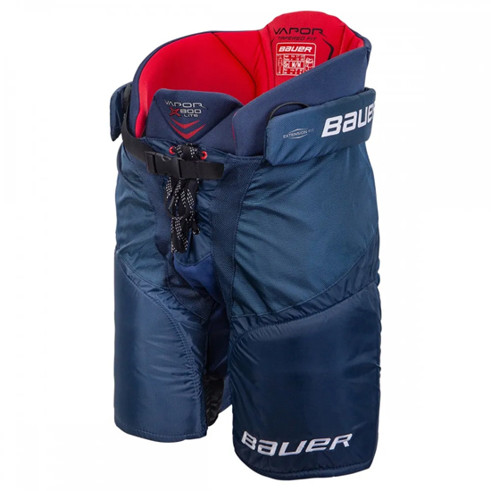
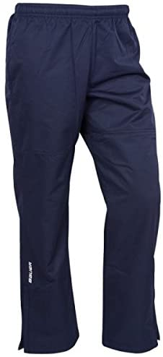
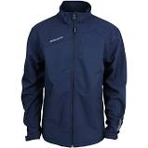
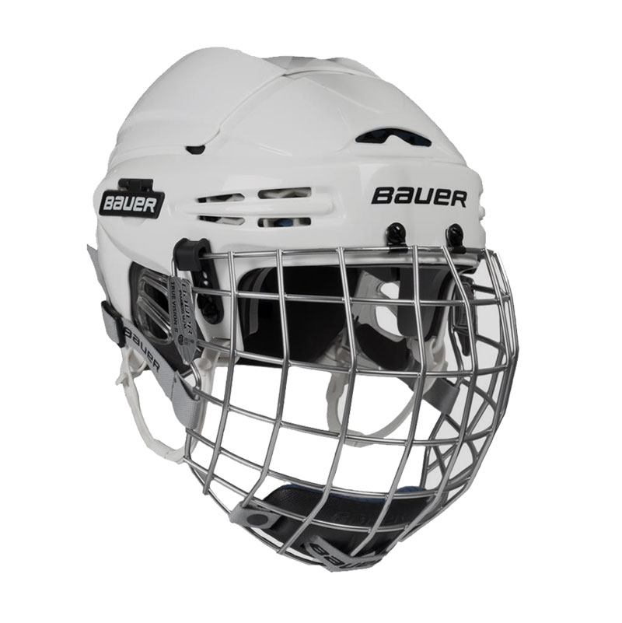
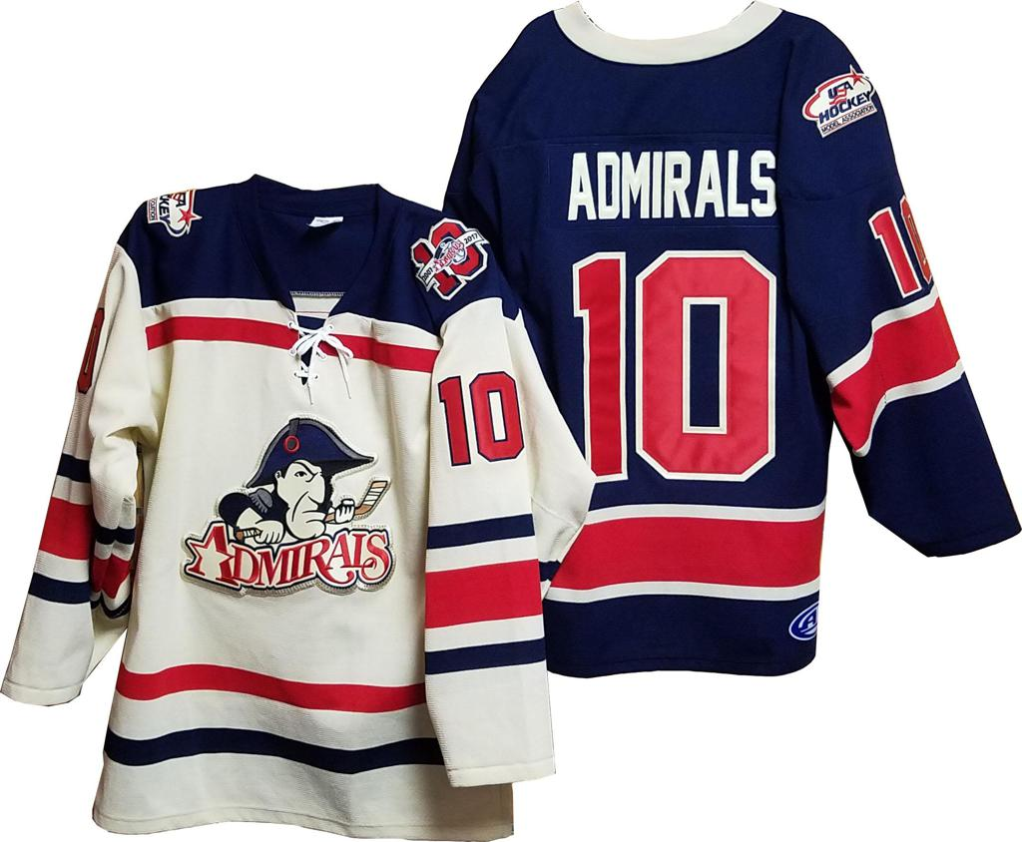

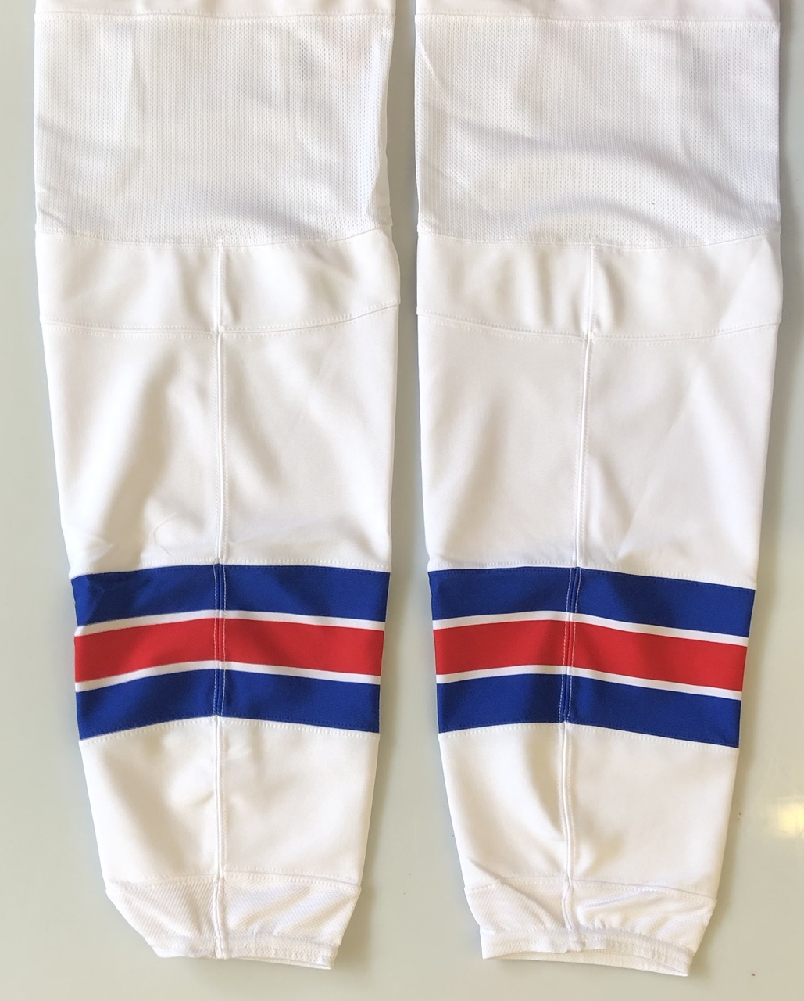

*Practice Jersey

JERSEY:
- Jerseys for all 8U through 14U and Girls are $200 + tax for a set of home and away jerseys. Players who do not own a set of jerseys will be required to purchase a set. It is highly recommended that players in need of new or replacement jerseys attend a sizing session, with shoulder pads, so that the correct size jersey can be determined. All jerseys come with the name and a number. There will be no refunds on these personalized jerseys. All payments must be made at the time of ordering.
- Jerseys for 16U-18U Midgets are the Admirals practice jersey. They are $36 + tax and are reversible.
- Future Admirals players will be provided 1 pair of socks. If you are new to In-house or returning but need a new jersey, they are $36 + tax.
- Current Admirals players whose birth year is 2014 and older will be able to retain their current jersey number if possible. For those players birth year 2015 and younger and/or are new to the Admirals Hockey Club will be assigned a number based on their birth year. Odd birth years will be given an odd number and even birth years an even number. Number requests within this birth year policy will be taken into consideration; however, Admirals reserve the right to assign available numbers.

PANTS/SHELLS:
- Navy blue pants or navy blue shells are required for all CUHL, NIHL and Girl players. Future Admirals In-House players are not required to have navy blue. Shells are available for purchase at any hockey store such as Jerry’s or Pure Hockey. Should your child need new hockey pants we would recommend purchasing a navy blue pair.

HELMETS:
- White helmets are encouraged, but not required. Should your child need a new helmet, we suggest purchasing a white one.

WARM UP:
- Warm ups are required for all CUHL, NIHL and Girls players. They are optional for Future Admiral & Midget players. For new players or those in need of replacement warm ups they can be ordered during the established sizing/ordering dates. As with the jerseys, sample warm-ups will be available for sizing purposes only and it is highly recommended that you attend a sizing session, so you may order your correct size warm-up jacket or pants. All jackets come with the player’s name. There will be no refunds on these personalized warm-ups. All payments must be made at the time of ordering.
- Warm up prices are as follows:
  - Lightweight jacket - $70 plus tax
  - Pants - $42 plus tax

Uniform Standards & Ordering Information Cont’d

PRACTICE JERSEY:
- Practice jerseys for all 8U through 18U players are $36 (plus tax). Players who already have a current practice jersey that still fits are not required to purchase a new practice jersey. Players who are new to the club or do not own a practice jersey are required to purchase one. Random numbers will be assigned. Practice jerseys can be ordered during the established sizing/ordering dates. All payments must be made at the time of ordering.

SOCKS:
- Two pairs of game socks are included in the team fees for all 8U through 14U players. Midgets will receive 1 pair of away (navy) game socks.
- One pair of game socks is included in the team fee for Future Admirals In House players. Players do not need to be sized or place an order for their socks.

CUHL / NIHL / Girls league players
Uniform Fees List
Game Jerseys | 1 home / 1 away | $200 (+tax) for the set | Required for 8U-14U
Practice Jerseys | Navy & White Reversible | $36 (+tax) | Required for 8U-18U
Socks | Home & away | Included in fee | Required for 8U-14U
Socks | Away | Included in fee | Required for Midgets
Warm Ups | Lightweight coat $70 (+tax) | Pants $42 (+tax) | Required for 8U-18U

UNIFORM SIZING / FITTING DATES
August | TBD | Center Ice
September | TBD | Center Ice

Uniform fitting guidelines (no exceptions):
- Players must be fitted BEFORE they skate/practice.
- Players must have their shoulder pads on to size jersey properly.
- Players must have a face mask on while being fitted if they are not fully vaccinated.
- Vendor will accept debit card or credit card only.

*** Please, note the later you order game jerseys, you run the risk of not having them before your 1st tier games. Lead-time on orders is roughly 3-4 weeks.

Girls Program
Northern Illinois Hockey League (NIHL)
NIHL | Tryout Fee | Girls only Team Fee | Dual Roster Fee | Raffle Tickets  * See details on pg. 14
10U (2011-2012) | $300 | $3250 | $4150 | $200
10U (2011-2012)  Full time goalie w/own gear | $300 | $3250 – 40%  ($1950) | $4150 – 40%  ($2490) | $200
12U (2009-2010) | $300 | $3250 | $4150 | $200
12U (2009-2010)  Full time goalie w/own gear | $300 | $3250 – 40%  ($1950) | $4150 – 40%  ($2490) | $200
14U (2007-2008) | $300 | $3250 | $4150 | $200
14U (2007-2008)  Full time goalie w/own gear | $300 | $3250 – 40%  ($1950) | $4150 – 40%  ($2490) | $200
16U (2005-2006) | $300 | $3250 | N/A | $200
16U (2005-2006)  Full time goalie w/own gear | $300 | $3250 – 40%  ($1950) | N/A | $200
The Admirals participate in the Tier II Northern Illinois Hockey League (NIHL) for Travel AA/A teams. Players are selected on a best player; best team basis and individual player ice time is earned and potentially not balanced. This fall season the Admirals will field competitive teams in the GIRLS Northern Illinois Hockey League (NIHL). We will be offering NIHL teams at 10U, 12U, 14U and 16U. Teams are all subject to participation and availability and we encourage early registration to ensure a spot for your player. Girls can be dual rostered if they want to play on both a youth NIHL team and a girls’ team. Any player that would like to dual roster must attend at least 1 try out skate for each team. Girls selecting to dual roster will practice & attend strength and conditioning with their youth team only. They will play in ALL games for both teams barring scheduling conflicts.

Fees Include:
- 2-3 Weekly practice slots | - Off-ice training @ JD Strength & conditioning
- One weekly goalie clinic | - Set of game socks
- All league games
Tryout fees are due with online registration and must be paid prior to participation. See payment policies and details.

3S Pre-season camp is available at an additional cost. Details & costs are on page 12.
Admiral’s game jerseys, practice jersey, warm-up jacket and pant set are required for NIHL players at an additional cost. Families should expect to participate in at least 2 tournaments, potentially local and away, at an additional cost. Navy blue pants or shells are required, and white helmets are encouraged, but not required. Should your child need a new helmet, we suggest purchasing a white one.

8U Junior Admirals Mite Program
8U (birth years 2013-2016) participate in CUHL League.

The Admirals Hockey Club believes that our players need high-activity skill development, many puck touches, and an efficient use of ice time and space to build agility, balance, and coordination while having fun. The Junior Admirals 8U program will continue with high-tempo elite skill development through station-based skills practices. 8U players try out and are selected for teams that will compete in full ice games for CUHL. Players who not selected to play on a CUHL full-ice team through tryouts may be offered to participate in the 8U Future Admirals In-House league. Players selected for a CUHL team must be registered with AAU. Tryouts will be held at Center Ice.

CUHL | Tryout Fee | Team Fee | Mandatory Raffle  *See details on pg. 14
8U CUHL  (2013 & younger) | $300 | $2850 | $200
8U CUHL  Full time goalies w/own gear | $300 | $2850 – 40%  ($1710) | $200

Tryout fees are due with online registration and must be paid prior to participation. See payment policies and details.
Fees Include:
- 2-3 Weekly practice slots | - All league games
- One weekly goalie clinic | - Set of game socks

3S Pre-season camp is available at an additional cost. Details & costs are on page 12
Admiral’s game jerseys, practice jersey, warm-up jacket and pant set are required for CUHL players at an additional cost. Families should expect to participate in 1-2 tournaments, potentially local and away, at an additional cost. Navy blue pants or shells are required, and white helmets are encouraged, but not required. Should your child need a new helmet, we suggest purchasing a white one.

NIHL (10U – 14U)

Northern Illinois Hockey League (NIHL)
The Admirals participate in the Tier II Northern Illinois Hockey League (NIHL) for Travel AA/A teams. Players try out and are selected with a “best players, best team” approach. Individual player ice time is earned and potentially not balanced.
NIHL | Tryout Fee | Team Fee | Raffle Tickets  * See details on pg. 14
10U (2011-2012) | $300 | $3850 | $200
10U (2011-2012)  Full time goalie w/own gear | $300 | $3850 – 40%  ($2310) | $200
12U (2009-2010) | $300 | $4050 | $200
12U (2009-2010)  Full time goalie w/own gear | $300 | $4050 – 40%  ($2430) | $200
14U (2007-2008) | $300 | $4225 | $200
14U (2007-2008)  Full time goalie w/own gear | $300 | $4225 – 40%  ($2535) | $200

Tryout fees are due with online registration and must be paid prior to participation. See payment policies and details
Fees Include:
- 2-3 Weekly practice slots | - Off-ice training @ JD Strength & conditioning
- One weekly goalie clinic | - Set of game socks
- All league games

3S Pre-season camp is available at an additional cost. Details & costs are on page 12
Admiral’s game jerseys, practice jersey, warm-up jacket and pant set are required for NIHL players at an additional cost. Families should expect to participate in at least 2 tournaments, potentially local and away, at an additional cost. Navy blue pants or shells are required, and white helmets are encouraged, but not required. Should your child need a new helmet, we suggest purchasing a white one.

MIDGET 16U/18U PROGRAM

NIHL
The Admirals participate in the Tier II Northern Illinois Hockey League (NIHL) for Travel AA/A teams. Players try out and are selected with a “best players, best team” approach. Individual player ice time is earned and potentially not balanced.

Level/Age | League | Tryout/Evaluation fee | League fee | Raffle tickets  *See details on pg. 14
16U/18U | NIHL | $200 | $2300 | $200
16U/18U  Full time goalie w/own gear | NIHL | $200 | $2300– 40%  ($1380) | $200

Tryout fees are due with online registration and must be paid prior to participation. See payment policies and details
Fees Include:
- 1 Weekly practice slot
- 1 pair of away (Navy) game socks
- All league games

Admiral’s practice jersey & navy blue pants or shell are required for players at an additional cost. Tournaments are selected by head coach and families should expect to pay for them through the team slush fund.

3S Pre-Season Camp Schedule
3S (Skating, Skills, Small Area Games) Camp for 8U through 14U Youth Players and all Girls Players
Sessions include skating, skills, and small area games (3S). The cost is $300.00 per player for all players (8U-14U & girls) with online registration and payment required before August 3, 2021. No refunds for injuries or withdrawal from the camp. No walk-on players or prorated fees are allowed.
All 3s camp skates are at Center Ice of Dupage.

Day | Date | 8U | 10U | 12U | 14U | Girls
Tuesday | 8/3 |  |  |  |  | 6:30 pm (A)
Thursday | 8/5 |  |  |  |  | 6:30 pm (A)
Saturday | 8/7 |  |  |  |  | 9:30 am (A)
Monday | 8/9 |  | 5:20 pm (A) | 6:30 pm (A) | 7:40 pm (A)
Tuesday | 8/10 | 5:20 pm (A) |  |  |  | 6:30 pm (A)
Wednesday | 8/11 |  | 5:20 pm (A) | 6:30 pm (A) | 7:40 pm (A)
Thursday | 8/12 | 5:20 pm (A) |  |  |  | 6:30 pm (A)
Saturday | 8/14 | 10:40 am (A) | 11:50 am (A) | 1:00 pm (A) | 2:10 pm (A) | 9:30 am (A)
Sunday | 8/15 | 10:20 am (A) | 11:30 am (A) | 12:40 pm (A) | 1:50 pm (A) | 9:10 am (A)
Monday | 8/16 |  | 5:20 pm (A) | 6:30 pm (A) | 7:40 pm (A)
Tuesday | 8/17 | 5:20 pm (A) |  |  |  | 6:30 pm (A)
Wednesday | 8/18 |  | 5:20 pm (A) | 6:30 pm (A) | 7:40 pm (A)
Thursday | 8/19 | 5:20 pm (A) |  |  |  | 6:30 pm (A)
Sunday | 8/22 | 4:10 pm (A) | 5:20 pm (A) | 6:30 pm (A) | 7:40 pm (A)
Monday | 8/23 |  | 5:20 pm (A) | 6:30 pm (A) | 7:40 pm (A)
Tuesday | 8/24 | 5:20 pm (A)
Wednesday | 8/25 |  | 5:20 pm (A) | 6:30 pm (A) | 7:40 pm (A)
Thursday | 8/26 | 5:20 pm (A)
Evaluations / Try-out Schedules

Age Level / League | Tryout #1 | Tryout #2 | Tryout #3
Future Admirals  In-house (all ages) | Tuesday 8/31 @ 5:20 pm  Center Ice (A)
8U Mites CUHL | Sunday 8/29 @ 10:20 am  Center Ice (A) | Wednesday 9/1 @ 5:20 pm  Center Ice (A) | Thursday 9/2 @ 5:20 pm  Center Ice (A)
10U Squirts | Sunday 8/29 @ 11:30 am  Center Ice (A) | Monday 8/30 @ 5:20 pm  Center Ice (A) | Wednesday 9/1 @ 6:30 pm  Center Ice (A)
12U PeeWee | Sunday 8/29 @ 12:40 pm  Center Ice (A) | Monday 8/30 @ 6:30 pm  Center Ice (A) | Wednesday 9/1 @ 7:40 pm  Center Ice (A)
14U Bantam | Sunday 8/29 @ 1:50 pm  Center Ice (A) | Monday 8/30 @ 7:40 pm  Center Ice (A) | Thursday 9/2 @ 6:30 pm  Center Ice (A)
16U/18U Midget | Sunday 8/29 @ 3:00 pm  Center Ice (A) | Tuesday 8/31 @ 8:00 pm  Center Ice (I) | Thursday 9/2 @ 7:40 pm  Center Ice (A)
Girls 1oU | Tuesday 8/24 @ 6:30 pm Center Ice (A) | Thursday 8/26 @ 6:30 pm Center Ice (A) | Tuesday 8/31 @ 6:30 pm Center Ice (A)
Girls 12U/14U/16U | Tuesday 8/24 @ 7:40 pm Center Ice (A) | Thursday 8/26 @ 7:40 pm Center Ice (A) | Tuesday 8/31 @ 7:40 pm Center Ice (A)

Financial Overview & Policies
Registration & Payments

- All players for all programs require online registration prior to participation.

- Families with past due balances from previous seasons will not be able to register or attend the new season tryout, practices or games until the past due balance is paid in full.

- The fee for the 3S Pre-Season Camp is non-refundable and must be paid in full via credit or debit card prior to the first camp session. Any questions regarding payments please email Kirsten Torling at Treasurer@admiralshockeyclub.com

- A non-refundable tryout fee is required for all CUHL and NIHL players. If a player registers for tryouts but does not attend tryouts the tryout fee is non-refundable and non-transferable. If a player attends tryouts and is selected for a CUHL or NIHL team but chooses not to play on that team, the tryout fee is non-refundable and non-transferable.

- Payments for all team fees are made IN FULL or via a PAYMENT PLAN with up to four monthly payments. Payment plans must be set up by utilizing the Step 2 link after you have registered your player. After teams are formed, a reminder with the payment link for team fees will be sent to the email address used at registration. With this team fees link, or within Step 2, you must either pay your fees in full via credit or debit card, or you must set up your payment plan with a credit or debit card. The first payment or payment in full is due by September 15, 2021. The payment plan can include up to four monthly installments on September 15, October 15, November 15 and December 15, 2021. If you use a payment plan there is a $100 processing fee that will be added to your first payment. There is no additional charge for paying via credit card. No cash or checks will be accepted for team fee payments. Any questions regarding payments please email Kirsten Torling at Treasuer@admiralshockeyclub.com

- Failure to comply with the fee agreement will result in immediate suspension from all Admirals Hockey Club privileges and activities. Accounts must remain current or players will not be allowed to participate in any on- or off-ice practices, games, or team activities.

- Declined payments will require a remedy of full payment of the installment and an additional $50 service fee.

Financial Overview & Policies Cont’d

Discounts / Fee Reduction Opportunities

- Goalie Discount: Full-time goalies at ALL age levels with their own equipment receive 40% off published fees.

Admirals Raffle

All CUHL/NIHL/Girl age level players through 16/18U level will be required to purchase 20 tickets at a total cost of $200.00. For those families with multiple players, the raffle ticket purchase will be required for the oldest child only. The raffle ticket obligation of $200 per family is an additional fee within the registration. Payment for raffle tickets is included with the first installment payment and must be paid before players will be added to team rosters. Families can (1) sell the tickets at face value ($10 each) and keep the proceeds; or (2) enter the tickets in to the raffle on their own behalf, effectively buying the tickets themselves.
Tournaments, Travel & Slush

- The Admirals Hockey Club participates in tournaments locally, out of state and internationally (Canada) per the coaches discretion. Your child will be required to have a passport if their team is traveling to Canada for a tournament.

- All travel expenses are an additional cost to consider. Most tournaments are “stay to play”, which means the host of the tournament contracts hotels & rates to secure enough rooms for all teams participating. Each player will be required to book a room at the designated hotel at the rate predetermined by the tournament host. This requirement does not apply to tournaments local to our home rink, Center Ice of DuPage.

- A slush fund is a monetary fund established at the beginning of the season by the team manager. The amount will be determined by the manager and head coach based on the number of local and out-of-state tournaments the team shall attend and to cover team expenses that are not covered by a player’s season fees. Included, but not limited, in the slush fund amount shall be tournament entry fees, referee and ice fees for scrimmages, entry fees for Blackhawk Cup (Illinois State Tournament) round robin, if applicable, team parties, coach’s lodging for out-of-town league games and/or tournaments where a free coach’s room is not available or attainable and coach’s gifts. Each player shall be responsible for the payment of their proportionate share of the slush fund within the time frame established by the manager. On average, slush can range between $400-$550 per player.

