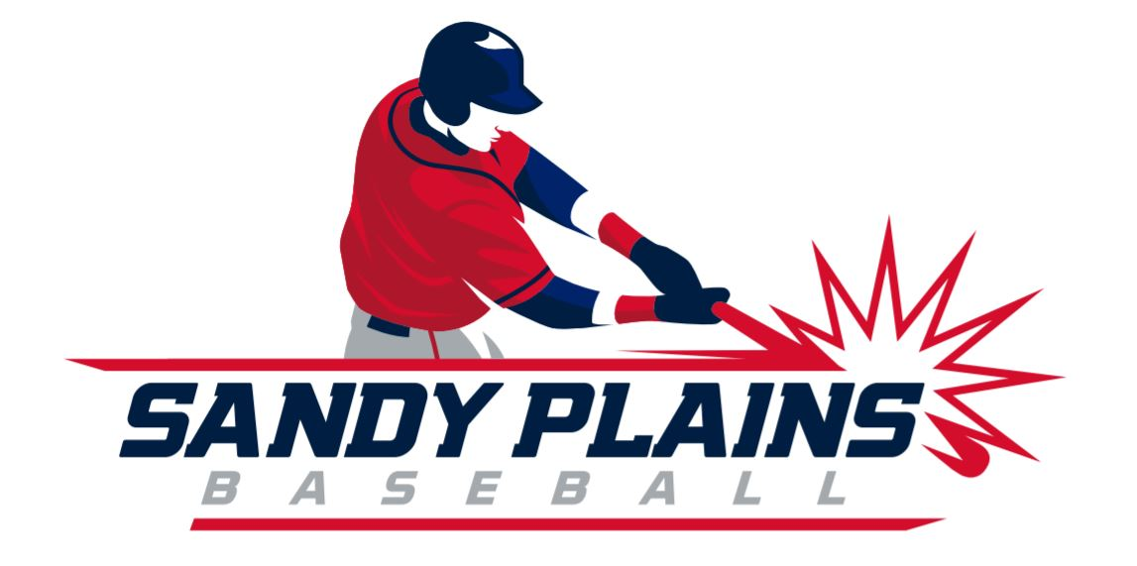

Sandy Plains Baseball Association COVID-19 Policy

- COVID-19 Warning:
  - An inherent risk of exposure to COVID-19 exists in any public place where people are present. When you visit or use the park and facilities at Sweat Mountain Park and Harrison Park, you voluntarily assume all risk related to exposure to COVID-19.
  - If you have a fever or COVID-19 or COVID-19 symptoms you are not allowed in the park.

- Screening Players and Coaches:
  - Coaches are responsible for ensuring players and coaches have a temperature of less than 100.4° before attending practice/games.
    - Parents will take their player’s temperature using their personal thermometer and report it to the manager or coach that the manager has established to monitor temperate information.
    - The manager may request that parents take their player’s temperature and show them the temperate reading at the park.

- Maintain Social Distancing:
  - Spacing between persons in the park should be at least six feet at all times.
    - Spectators are encouraged to bring their own chairs
    - Members of the same household will be allowed to sit within 6ft of each other.
  - Players and teams must maintain social distancing inside the dugouts and throughout practices/games.
  - Not all players may fit in the dugout due to social distancing. Depending on the layout of the field a team can reserve and use the stands for players to ensure that social distancing is maintained.
  - Handshaking and high-fiving is prohibited at all times. Consider lining up outside the dugout and tipping caps to the opposing team as a sign of good sportsmanship after a game.
  - We ask that sunflower seeds, tobacco, and vaping products not be used (no spitting)
  - No team coolers (dispensing type), individual players may bring their own.
  - Social distancing must be maintained at the batting cages
  - Field use will be limited to a maximum of 25 people per State guidelines
  - Each team will dedicate a parent or coach to monitor these guidelines during team practice

- Use of Personal Protective Equipment and Best Practices:
  - Face masks will be encouraged for coaches, players, and spectators but are not mandatory
  - Players and parents will be encouraged to bring hand sanitizer and utilize it before and after practice/games
  - Teams will be encouraged to wipe down the dugouts before their team enters; specifically the bench and the gates.
  - Concessions employees will be screened to ensure temperatures are 100.4° or less
  - Face masks and gloves will be worn by concessions workers

- Gameplay:
  - Pregame plate meeting will be for umpires and head coaches only, while maintaining six-foot social distance
  - If any physical contact should occur between players coaches may call time to have disinfectant used on each player
  - Players and coaches should take measures to prevent all but the essential contact necessary to play the game. This should include refraining from handshakes, high fives, fist/elbow bumps, chest bumps, group celebrations, etc.

- Field transitions:
  - Players and families should vacate the field/facility as soon as possible after the conclusion of their game/practice to minimize contact with players, coaches, and spectators from the next game.
  - If there is a game or practice prior to your event, families and spectators are encouraged to stay in their vehicles or at recommended social distances until the start of their game play to prevent overcrowding of spectator spaces and walkways.

- Player Equipment:
  - Player equipment should be spaced accordingly outside the dugout to prevent direct contact.
  - Players should have their own individual batter’s helmet, glove, and bat.
  - Measures should be enacted to avoid, or minimize, equipment sharing when feasible
  - Some critical equipment may not be able to be obtained by every individual. When it is necessary to share critical or limited equipment, all surfaces of each piece of shared equipment must be cleaned first and then disinfected with a disinfectant against COVID-19. Increased attention should be paid to detailed cleaning of all equipment directly contacting the head and face (catcher’s mask, helmets).

- Player with COVID:
  - If a player/coach contracts COVID, then the team will shut down for two weeks.
  - A good faith effort will be made to reschedule missed game, though it may not be possible to make up all games depending on weather and the end of the season dates.
  - Depending on the weather and need, the county has given permission to play a few days into November for make-ups.

- Refund Policy:
  - Our normal refund policy will be in place: There is a $10.00 cancellation fee that will be assessed for any cancellations made prior to evaluations. There is a $25.00 cancellation fee that will be assessed for any cancellations made after evaluations take place and before games start. There are no refunds once games start.

- Rule Modifications:
  - Catchers:
    - Sweat - since we are coach pitch, we will allow players to use their batting helmet as an option. When wearing batting helmet, the player will need to stand next to the umpire, furthest from the plate.
    - Harrison – we will work with teams to determine if they need additional catcher head gear.

