Activity 4: 6 minutes- 3 minutes clockwise and counter clockwise
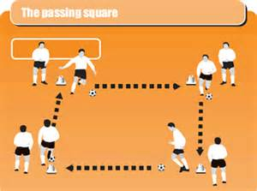
Coaching points: Receive the ball on the back foot/furthest foot away from the ball. Good weight of pass. Open body and hips out when receiving the pass. Belly button should be facing where the pass is going.

Activity 5: Game situation
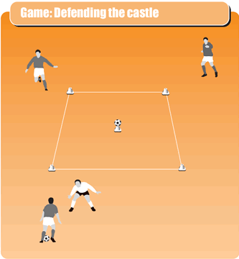
10x10 square. 3v1. Defender is the only one that can go in the square. Three attacking players are not allowed in to the square but the ball can. They have to hit the ball off of the cone to score. 1 minutes games. Everyone is a defender at least once.
Coaching points: Move the ball quickly. Use both feet. Move to create options for the player on the ball.

