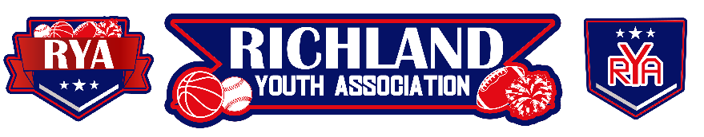
RYA November 2023 BOARD ELECTION Minutes
Meeting Date: November 15, 2023 – 6:30pm
Board Members in Attendance: Mike Cowan, Richard Stutheit, Eric Gomez, Lisa Willis, Emily Standifer,
CJ Bussey, Tammy Treadwell
Board Members Absent: Kevin Vorpahl, Erica Stutheit
Non-Board Member Attendees: Andrew Rivera, Jason Kyle Wright

Board Elections for 2024 RYA Board of Directors
- All board positions were up for election, due to several vacancies for Vice President and Accounting.
- Board Members stepping down from their current board positions include the following:
  - Secretary: Tammy Treadwell
  - Communications: Erica Stutheit
  - Recreational Baseball: Richard Stutheit
  - Cheer: Lisa Willis
- On the ballot for 2024 RYA Board of Directors:
  - * President: Michael “Mike” Cowan (incumbent, uncontested)
  - + Vice President: Lisa Willis (uncontested)
  - + Accounting: Richard Stutheit (interim incumbent, uncontested)
  - * Secretary: No Candidate
  - * Communications: No Candidate
  - Special Events: Emily Standifer (incumbent, uncontested)
  - Recreational Baseball: Andrew Rivera and Jason Kyle Wright
  - Premier Baseball / Tournaments: Kevin Vorpahl (incumbent, uncontested)
  - Basketball: CJ Bussey (incumbent, uncontested)
  - Cheer: Melissa “Missy” Matherly (uncontested)
  - Football: Eric Gomez (incumbent, uncontested)
    - Positions marked with an asterisk (*) are for two-year terms.
    - Positions marked with a plus sign (+) were vacant two-year terms elected in even years. Members nominated for these positions will serve a one-year term and will return to the November 2024 ballot as a two-year term option again.
- Only one position up for election was contested, for Recreational Baseball.
  - Andrew Rivera won the election by a vote of 16-1.
- After the Board Election was closed and certified by the present Board of Directors, Eric Gomez made a motion to add Cassandra “Cassi” Mendoza to the vacancy for the Director of Communications.
  - This nomination was confirmed by a simple majority of the board.
  - Due to this nomination occurring after the open election and board member being appointed, this nomination only qualifies the member for a one-year term. Director of Communications will return to the November 2024 ballot as a one-year term option as well.

Information Regarding RYA Finances
- The following board members will have access to the RYA Financial Accounts, including banking accounts through Wells Fargo, QuickBooks, and any other financial accounts used for RYA business:
  - Michael Cowan (President)
  - Lisa Willis (Vice President)
  - Richard Stutheit (Accounting)
    - This access should include the ability to login to each of RYA’s Financial Accounts and each member should be issued necessary debit cards to the associated bank accounts.
- All board members will have access to review RYA’s Financial Bank Statements during monthly board meetings or as otherwise deemed necessary by the RYA Board President.
- Any member of RYA – including current coach volunteers in good standing and parents of current players – are able to request information from the RYA Board of Directors as to the current state of RYA’s finances. The RYA Board of Directors shall provide the requested information within an appropriate length of time.

RYA Bank Accounts total of $62,360.46 and $6,518.43

Meeting adjourned at 8:09 pm

