Sponsorship Contract
Company/Organization:
Contact Name:
Address:
City: |  |  |  | State: |  | Zip:
Phone: |  | Email:

I approve all the details outlined in this agreement and will meet all the terms as stated.
Sponsor: |  | Date:
SWCRC General Manager: |  | Date:
All copy and content must be approved by the sponsor and the South Wood Country Recreation Center. All artwork must be supplied by the sponsor and be “print ready” in a high-resolution file format. Production will begin after final approval of the design and upon receipt of payment in full.
All sponsorship contracts are for a one-year term and commence on July 1st and expire on June 30th. Sponsorship options are a first-come, first-serve on availability and placement. Existing advertisers have the right of first refusal at the end of their contract. Annual pricing is subject to change and is set by the SWCRC. No results guarantee of product, service, or business with sponsorship.
Sponsorship contracts renew annually unless sponsor notifies SWCRC. Please notify SWCRC if you are not interested in renewal, or your advertising size or design changes are needed.
SWCRC, Attn: Jim Arnold
2711 16th Street South
Wisconsin Rapids, WI 54494

Sponsorship Options: Please check advertising type and size option
Banners
70” by 40” (small/single)  Annual cost $200  Initial production cost $200  130” by 40” (large/double)  Annual cost $300  Initial production cost $250  130” by 84” (oversized)  Annual cost $500  Initial production cost $350 | 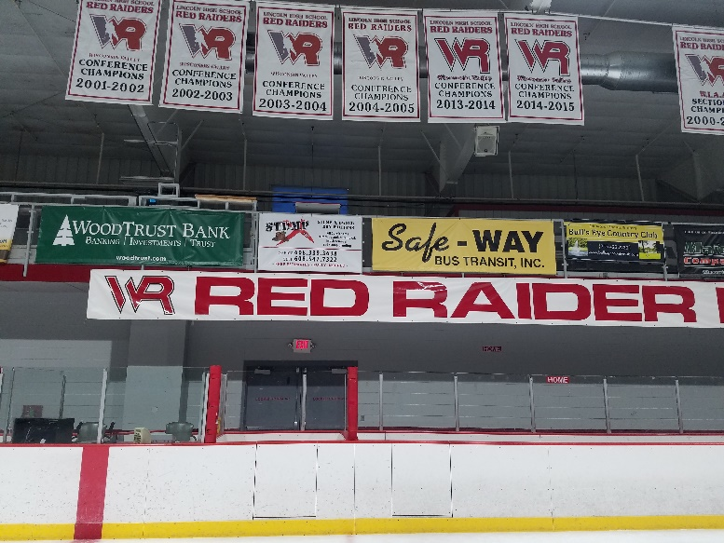

Primary Dasher Board Location
(inside the playing area)
96” by 33”  Annual cost $600  Initial production cost $365 | 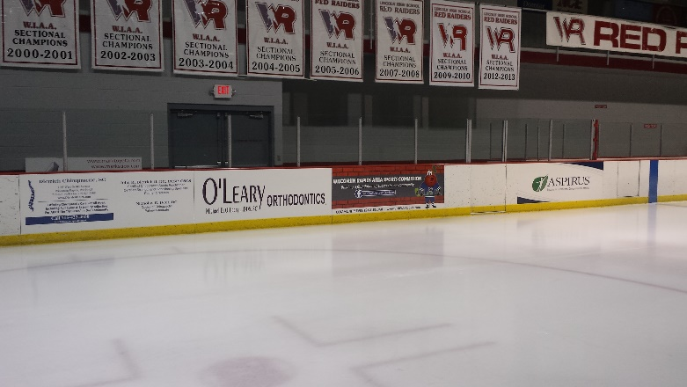
Banner options include full color digitally printed graphics, set-up and installation.
Graphics Printed by Quality Plus Printing 3515 8th Street South, Wis. Rapids, WI 715.423.7440
On board advertisements include full color digitally printed graphics, set up and installation.
Ads On Boards produces advertisements on hockey dasher boards: adsonboards@hotmail.com

