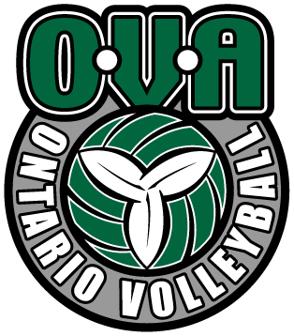

----CLUB----
----TEAM----

2016-17 TRYOUTS

Here is a brief summary of what you can expect if your child is selected on the team:

COACHES
Head Coach (certification): _______________________________________________
Assistant Coach (certification): ____________________________________________
Assistant Coach (certification): ____________________________________________
Assistant Coach (certification): ____________________________________________

TEAM OBJECTIVES
Share your goals for the team this season. Indicate whether your goals are performance or result oriented (Delete highlighted text when done editing)

TRAINING
Number of practice(s) / week: _________

Day of the week | Time | Location

Physical training (Y/N) ________ Day/Time/Location _______________________________
Nutrition training (Y/N) _______ Day/Time/Location ______________________________
Mental Performance (Y/N) _______ Day/Time/Location ______________________________

COMPETITION
Number of age-group OVA tournaments: ________
Number of “play-up” OVA tournaments: ________
Number of tournaments in the USA: ________
Number of other tournaments: ________
Ontario Championships (age groups): ___________________
National Championship (Y/N): _________________

OTHER MANDATORY ACTIVITIES

COST
The cost for the season will be between ____________ and __________
This includes:

The following is not included and will have to be paid by the parents:

OVA SIGNING PEROIDS
There are two signing periods associated with the current OVA Tryout Window Policy:

      - Phase 1: September 18th - 19th – All offers expire September 19th at 11:59pm
- Phase 2: September 24th - 25th –All offers expire September 25th at 11:59pm

*Note: If an athlete and/or parent is given an OVA Offer Form during Phase 1 and does not commit to that club by September 19th at 11:59pm the offer will be considered null and void.

