STMA Girls Basketball Club
April 2018 Agenda

Opening: Meeting called to order 7:00 PM St. Michael Legion by Kathy Alexander

Present: Kathy Alexander, Kent Hamre, Jim Freeland, Bridget McShane, Mike Johnshoy and Ryan Voight

Absent: Kerry Zezza

Approval of Agenda: No formal agenda tonight due to our secretary being gone.

Approval of Minutes: Minutes for March and April will be approved during our May meeting due to the secretary being gone unexpectedly.

New Business: Travel Survey – Kathy will collect data and send out to the board for review.

Financial Update: Need to be cautious with spending.

Travel Tournaments:

April 27 and April 28th and May 4th and 5th:
Discussed parent volunteers. We will stick with 8 hours per player and 10 for more than 1. We will adjust if needed. We will open the opportunities up to everyone.

Message was sent to Parents regarding volunteer hours.

We discussed the duties for the April tournament:
MYAS provides referees, ½ of trainer expense and brackets
STMA will pay MYAS $10 per team, gym time, and 1/2 of trainer.

Parent volunteer shifts will be the same as our home tournament:
- 2 admissions - downstairs
- 2 admissions - upstairs
- 4 concessions
- 2 money takers.

We will also leverage 3 volunteers on Friday night to stock concession stand.

Trainer - Done (Hamre) MYAS pays for half
Food Permit - Done (Hamre)
Concessions - Inventory & make order (Kerry, Kent, Bridgett, Ryan, Jim)
Turn Coolers Down - Jim
Parents' Sign Up Genius - Kathy & Jen - Hamre will contact MYAS to see if times are known.
Board Members – Leads sign up - Kathy
Refs - MYAS takes care of that
Brackets - MYAS takes care of that
Change - Jim
Gym Time & Janitors - Done (Hamre)
Clock Workers – HS Girls will work clocks - Kent
Check for stampers & cash boxes – These should be in our storage.
Awards - MYAS buys, Johnshoy to hand out with helpers
Tape gym floors - Kent or Lahr

Kent will Inventory the concessions inventory this week. Bridget will be lead for concessions. Bridget, Kerry and Kent to finalize the order. Kerry and Bridget to submit the order per the usual plan ahead of Friday the April,27th. A few board members will pick everything up and deliver to the school Friday night.

Volunteer Hours – Next Season: We will mirror how softball does parent hours. See below.

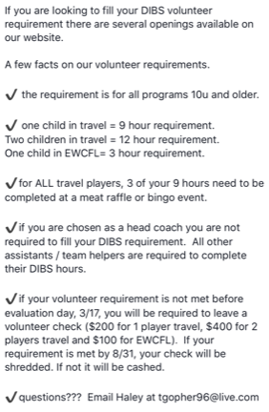

High School:
- Summer schedule has been sent out to players
- Midwest Elite will provide skills for the players if interested.
- Weight lifting for girls through Community Education if interested.
- Banquet next Wednesday.

General Business:
May Meeting
- Determine open board positions
- Finalize May Tournament
- Begin travel season planning for 2018-2019 season.

June Meeting
- New Board Members
- Continue travel season planning and complete required tasks.

Ad for the MYAS Tournament Book – Mike Johnshoy will ensure this is added for our tournament. January 12th and 13th, 2019

Next Meeting:
Wednesday, May 2 at 7:00 PM

