Roll Call: Brooks Savage, Jason Stoffel, Bernadette Schaffer, Terry Johnson, Adam Hoffman, Jesse Viall, Sean McCabe, Tom Johnson, Kristi Woodwick, Josh Colvin, John Klimek, Brooks Savage, Shannon Callahan,
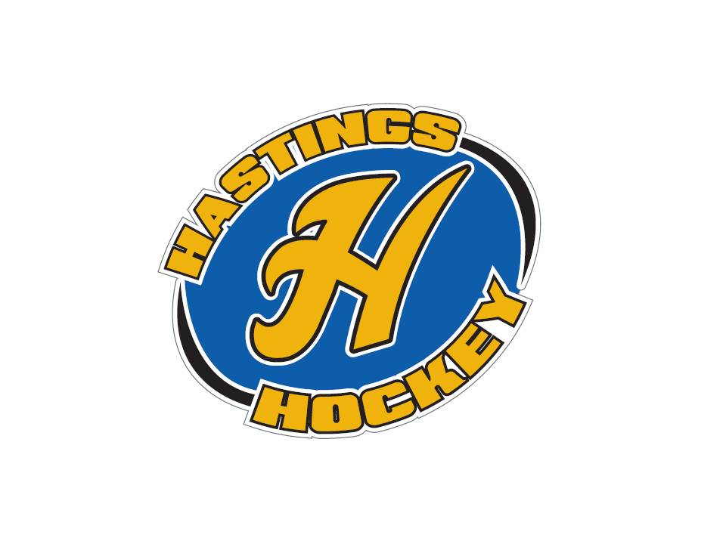
Not in attendance: Adam Welch, Jay Stark, Lisa Zaccardi, Travis Steele, Randy Kruse
- Approval of Agenda
- Approval of Minutes Sean made the motion, Kristi seconded – motion approved

Coordinator Reports
- Referee – John Klimek
Need new refs!! Need new legs, please put the word out to get more help – put on website please
Do not expect perfection from 11th and 12th grade referees, please remember that there is no replay for these young men
- Registrar – Shannon Callahan
Nothing to report
- Technology – Randy Kruse
Not in attendance
- Tournament Director – Lisa Zaccardi
- Sponsorships –
- District 8 – Jay Stark
Not in attendance
- Goalie – Josh Colvin
Nothing to report
- Secretary – Bernadette Schaffer
Nothing to report

Officer Reports:
- President – Terry Johnson-
Thanks to everyone for doing all that they do!!
- Vice President – Jay Stark
Not in attendance
- Treasurer – Jaimie Schuster (Approval of the Financial Statements)
Operating at around $40,000 but there are many things that still need to come out of the budget.
Sean made the motion, Jason seconded – motion to approve financials was passed

Director Reports:
- Volunteers – Shannon Callahan
Bantam B2 - only have 4 volunteers so far. In desperate need of volunteers!!!
- Director of Hockey – Adam Welch
Not in attendance
- Operations – Adam Hoffman
90% of equipment is turned in – get stuff in if you still have it!!
Borders need to be fixed or replaced – maybe swap out the east vs west
- In-House Girls – Kristi Woodwick
Season is wrapping up

- Travel Girls – Travis Steele
Not in attendance
- Ter-Mites – Tom Johnson
Nothing to report
- Mighty/Super Mites – Jesse Viall
Nothing to report
- Squirts – Jason Stoffel
End of the year tournament wrapped up this weekend. – Successful weekend – refs did a nice job
- Peewees – Sean McCabe
AA done, B done – 1 game away from qualifying for regions, B2 and C still playing
In the future – you need to decide back in December if you want to opt out of districts
- Bantams/Jr. Gold/U16 – Brooks Savage
Season winding down…B going to state and B2 and C still playing in districts

Old Business: Discussion of treadmill, meetings are still in the works.

New Business:
Election Approval Jesse Viall made the motion, Sean seconded - motion passed
Director of hockey went vacant – Sean made the motion, Kristi seconded – motion passed

Squirts in House Colvin and Kristi starting discussing the program, practice plans are designed and set for coaches to follow. Trying to figure out how to better the program, better the players, better the coaches. Looking at the bantams – they are successful – why is that?? Do we have a program laid out for what this group of coaches did for these kids. Hoping to develop a future committee to get together and discuss player development.

Plaques to outgoing board members – Thanks to Jaimie, Jason, Jay, and Adam Welch!!

Minutes from 2.26.18 meeting A member and coach was brought up to discuss the conclusion of a hearing with USA hockey on 2/20/18 and the board was informed of the permanent suspension from the program. We are waiting on the appeal process to finalize. Motion was made by Jason, seconded by Jaimie – motion was passed

Collegiate clinics are at the end of the season( March) – high performance – look to USA hockey website for more information.

Board Comment

Membership Comment
10 A girls….. do not have enough players to field a team – is there a forfeit fee? Concerns about teams not being aware of the fact that districts are over spring break.
Adjournment Sean made the motion, Kristi seconded – motion was passed

Next Meeting: April 8th , 2018 (the 1st Sunday is Easter)

