Roll Call: Terry Johnson, Jay Stark, Travis Steele, Tom Johnson, Randy Kruse, Sean McCabe, Bernadette Schaffer, Jaimie Schuster, Brooks Savage, Jason Stoffel, Shannon Callahan, Kristi Woodwick, Adam Welch, Adam Hoffman, Josh Colvin
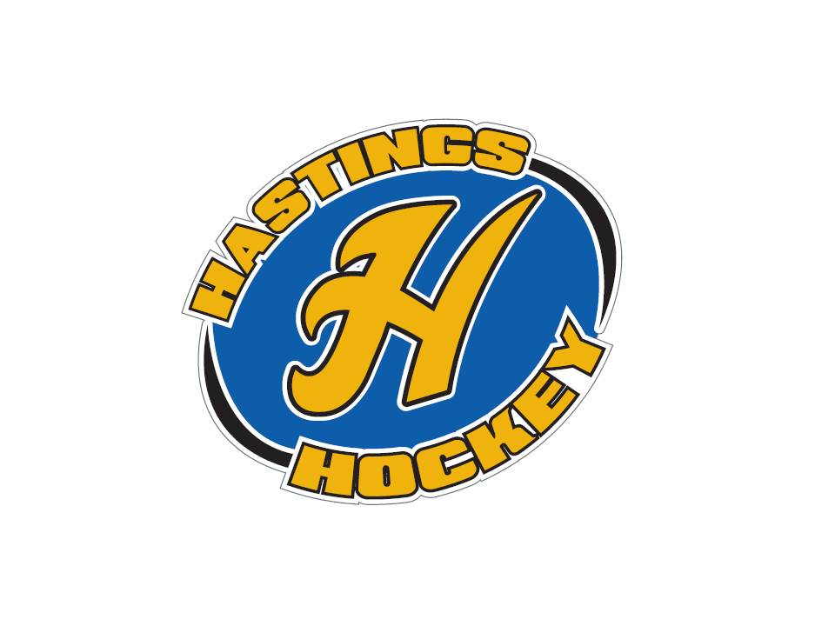

Not in attendance: John Klimek, Lisa Zaccardi

- Approval of Agenda Jason made the motion, Brooks seconded – motion passed
- Approval of Minutes Adam Welch made the motion – Kristi seconded – motion passed

Coordinator Reports
- Referee – John Klimek not in attendance
- Registrar – Shannon Callahan 51 teams approved, 1 team was approved then unapproved because the team was redlined
- Technology – Randy Kruse
Nothing to report
- Tournament Director – Lisa Zaccardi not in attendance but looking for a peewee C team for tournament
- Sponsorships – Terry looking for coordinator still
- District 8 – Jay Stark Refs will not get scheduled if they don’t have chek sent or game reschedule fee – also concussions need to be reported to Terry
No more than 6 full ice hours for mites
- Goalie – Josh Colvin
Middle of break – between goalie clinics – last week was low numbers but it was great the way Jay scheduled it – consistent times etc
- Secretary – Bernadette Schaffer
Discussions about contacting area businesses about tournaments
Brought up needing a new clock

Officer Reports:
- President – Terry Johnson- Hockey Night, Concussions, Positive Coaching Alliance
Will be looking for a communications coordinator
Let Terry know about any concussions!!!!
Hockey Night – coming up!!!
PCA workshop coming up 6:30 – 7:30 Middle School Auditorium – lengthy discussion was made on how to improve the climate of our hockey community
- Vice President – Jay Stark
Sponsorships – Dan Rother looking for
U12 A and B districts here now - possible schedule changes( 15 – 30 minutes) for some levels
B2 Bantam Districts tournaments will be held here

- Treasurer – Jaimie Schuster (Approval of the Financial Statements)
Sean made the motion to pass Approval, Tom seconded motion passed
Jaimie will be combining reimbursements with end of the year checks

Director Reports:
- Volunteers – Shannon Callahan
Big Chill went fine , River Rumble will be next , 3 more tournaments coming up still for DIBS oppurtunties
- Director of Hockey – Adam Welch
See you all Tuesday night!!
- Operations – Adam Hoffman
Missing keys…. Please look for them
- In-House Girls – Kristi Woodwick
Going relatively well….. U8 is confusing – it is mighty and supers combined
- Travel Girls – Travis Steele

- Ter-Mites – Tom Johnson
New skater is starting in termites, and they have another that came back after bring a friend to skate night
- Mighty/Super Mites – Jesse Viall
Carter Hansen is moving up – should be a squirt due to age
- Squirts – Jason Stoffel
Move to shifts on the fly – going well so far…
- Peewees – Sean McCabe

- Bantams/Jr. Gold/U16 – Brooks Savage
Bantams Doing well
Jr Gold and U16 is under way and going well

Old Business:

New Business:
Elections: January 15 – January 31st letters of intent due by 10 pm January 31st election night is Monday the 5th from 5-8 pm
Positions up for Re-election
Vice President
Treasurer
Girls in house Director
Pee Wee Director
Squirt Director
Ter-Mite Director
Director of Hockey

Girls U8 end of year Tournament next year – Hoping to find something next year to wrap things up in a fun way like the boys do

Form a community to meet and discuss possibilities of a treadmill – Jay made the motion and Jesse seconded – motion passed –
Committee is Jason, Sean. Kristi, Jesse and Adam W. Adam H made the motion, Sean seconded – committee is passed

Board Comment
Membership Comment
Adjournment Jaimie made the motion to adjourn at 9:05 and Jay seconded – motion passed

Next Meeting: February 4th, 2018

Side bar for later………..

