AVON

LITTLE LEAGUE

SAFETY MANUAL
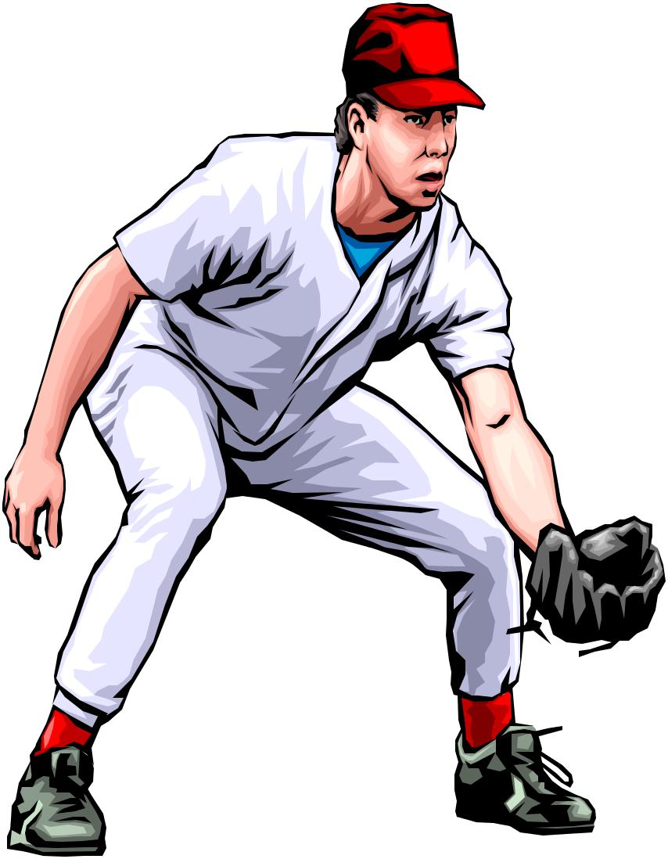

2018 EDITION “Safety Comes First!”

AVON LITTLE LEAGUE

Safety Manual

SAFETY POLICY TITLE – Table Of Contents
POLICY DATE – January 1, 2018

Contents

Introduction ------------------------------------------------------------------------------- 3

Safety Officer ----------------------------------------------------------------------------- 4

Safety Code ------------------------------------------------------------------------------- 5

Telephone Directory, Website Links, Distribution List ----------------------------- 6

Board of Directors ------------------------------------------ ----------------------------- 7

Emergency Procedures, Game Cancellations----------------------------------------- 8

Accident Reporting----------------------------------------------------------------------- 9

Warming up ------------------------------------------------------------------------------- 10

Communicable Disease & Field Safety Checklist ----------------------------------- 11

Fundamentals and Training ------------------------------------------------------------- 12

Lightning, Rain & Hot weather -------------------------------------------------------- 12

Medical Care ----------------------------------------------------------------------------- 13

Violence During Games, Manager/Coaches------------------------------------------ 14

Equipment -------------------------------------------------------------------------------- 16

General Facility, First Aid-------------------------------------------------------------- 17

Field Equipment, Parents & Spectators ---------------------------------------------- 18

Concession Stand------------------------------------------------------------------------ 19

Field & Safety Checklist---------------------------------------------------------------- 20

Ten Commandments of Safety, Injury Treatment Reminder---------------------- 21

Safety Plan Addendum------------------------------------------------------------- 22

Accident Notification Form------------------------------------------------------------ 23

2

AVON LITTLE LEAGUE

Safety Manual

SAFETY POLICY TITLE – Introduction

Welcome to the 2018 season of AVON LITTLE LEAGUE Baseball and Softball. Our league is a Non-Profit organization run solely by volunteers of the community. The purpose of our safety program is to help to prevent injuries from occurring, provide playing fields that are as safe as possible given the resources available. To encourage active participation of not only league officials of all levels, but the parents as well.

Remember, safety is everyone’s job.

Prevention is the key to reducing accidents to a minimum.

Report all hazardous conditions to the Director of

Safety or another Board member immediately.

Don’t play on a field that is not safe or with unsafe playing equipment.

Be sure your players are fully equipped at all times, especially catchers and batters.

And, check your team’s equipment often.

Working together, we all can make Little League Baseball and Softball fun and safe.

3

AVON LITTLE LEAGUE

Safety Manual

SAFETY POLICY TITLE – Safety Officer

The main responsibility of our safety officer is to develop and implement the league’s safety program. A link between the board of directors and its managers, coaches, umpires, players,

spectators and any other third parties on the complex in regards to safety matters, rules and regulations.

The Safety Officer reports to the President of the League and has the following responsibilities:

- Ensure that all Little League rules related to safety are being followed.

- Investigate and handle any insurance related claims.
- Explaining insurance benefits to claimants and assisting them with filing the correct paper work.
- Assisting parents and individuals with insurance claims and will act as the liaison between the insurance company and the parents and individuals.
- Coordinate managers, coaches, umpires, players, and spectators in order to provide the safest environment possible for all.
- Ensure that first aid kits are available and emergency arrangements have been made for medical response, as needed.
- Insuring that each team has an understanding of first aid, where the main first aid kit is stored for emergencies.
- Conduct spot checks of practices and games to be sure reasonable precautions are taken to protect all players and volunteers.
- Identify and control, wherever possible any unsafe conditions that exist at the playing fields. Check existing fire extinguishers.
- Maintain and keep a first aid log. This log will list where accidents and injuries are occurring, to whom, in which divisions, under what supervision and at what time.
- Check fields with the grounds committee listing areas needing attention.
- Schedule a first aid clinic and CPR training class for all managers, coaches, umpires and volunteers.
- Creating and maintaining all signs with field maintenance committee on the Crowley complex including No parking signs, No smoking signs, No pets allowed, cautionary signs, etc.
- Act immediately in resolving unsafe or hazardous conditions once a situation has been brought to his/her attention.

4

AVON LITTLE LEAGUE

Safety Manual
SAFETY POLICY TITLE – Safety Code : Our Goals are Education and Prevention

- Responsibility for safety procedures belongs to every adult member of our local league.

- First Aid training is a recommended requirement for all coaches and managers when medical services cannot be staged at a game. First aid kit should be available at the field.

- No games or practices should be held when weather or field conditions are not good, particularly when field lighting is inadequate.

- Inspect play area frequently for holes, damage, stones, glass or other foreign objects.

- Only players, managers, coaches and umpires are permitted on the playing field during games and practice sessions.

- All equipment should be stored in team dugout or behind screens, & not within any area defined umpires as “in play.”

- All players should be alert and watching the batter on each pitch during practice and games. Establish procedures for retrieving foul balls batted out of the playing area.

- Inspect equipment regularly and make sure it fits properly.

- During warm-up drills players should be spaced so that no one is endangered by wild throws or missed catches.

- All pre-game warm-ups should be performed within the confines of the playing field and not within areas that are frequented by, and thus endanger spectators (i.e., playing catch, pepper, swinging bats, etc.)

- Catchers must wear catcher’s helmet, mask, throat protector, shin guards, long model chest protector and protective supporter (boys) at all times. This applies between innings, in bullpen practice, during games, practices & pitcher warm-ups.

- Batters must wear protective NOCSAE helmets during practice, as well as during games.

- Managers and Coaches may not warm up pitchers before or during a game.

- Head first sliding is prohibited while advancing except at Senior and Big League levels of play.

- During sliding practice, bases should not be strapped down.

- Horseplay and climbing on fences of the dugout is not permitted at any time.

- Parents of players who wear glasses should be encouraged to provide their children with safety glasses.

- Gum chewing is strongly discouraged while on the playing field.

- Metal cleats are not permitted except for the “Big League Division” only.

- Player must not wear watches, rings, pins or metallic items during games and practices.

- Any part of an undershirt exposed to view shall be uniform solid color, not white. Shirts will be tucked.

- Use of mouth guards is strongly encouraged, especially for pitchers and for batters when face shields are not provided.

- Whenever possible, make sure someone at your practice or game has a cellular phone to use in an emergency.

5

AVON LITTLE LEAGUE

Safety Manual

SAFETY POLICY TITLE – Telephone Directory & Websites:

Little League Phone Numbers:

Police – Emergency | 9-1-1
Fire- Emergency | 9-1-1
Good Samaritan Hospital | 508-427-3000
District Safety Officer- Dennis Olszewski | 508-510-3429

Web site:

District 12 |  | www.eteamz.com/massdistrict8
Little League Baseball | www.littleleague.org
Eastern Regional Headquarters |  | www.eastregion.org
Major League Baseball |  | www.mlb.com
AVON LITTLE LEAGUE | www.avon-tlittleleague.com

SAFETY POLICY TITLE – Distribution

In order for any policy to be effective, it must be distributed. This Safety Manual and any subsequent revisions will be distributed as follows:

A – League Officers

B – Managers and Umpires
C – Any parent that requests a copy either verbally or in writing D – District Administrator or Safety Officer E – Copies will be in the:
1 – Concession stand
2 – Equipment Room

6

AVON LITTLE LEAGUE

Safety Manual

SAFETY POLICY TITLE – Board of Directors

LEAGUE OFFICERS:
President |  | Kevin Meany | 617-347-3619 | swingkingbaseball@gmail.com
Vice President |  | Brian Sullivan | 617-699-5497 | sully35@gmail.com
Player Agent |  | Dennis Olszewski | 508-510-3429 | Ski1093@gmail.com
Treasurer |  | Chris Alger | 781-844-9574 | christopheralger@comcast.net
Safety Officer |  | Dennis Olszewski | 508-510-3429 | Ski1093@gmail.com
Secretary |  | Jen Mayo | 508-510-0187 | mayoboys123@yahoo.com
Information Officer |  | Dennis Olszewski | 508-510-3429 | Ski1093@gmail.com
Fundraising Director |  | Mary Beth Sullivan | 617-699-5497 | mbceglie@gmail.com

BOARD OF DIRECTORS:
Kevin Meany | 617-347-3619
Brian Sullivan | 617-699-5497
Chris Alger | 781-844-9574
Jen Mayo | 508-510-0187

7

AVON LITTLE LEAGUE

Safety Manual

SAFETY POLICY TITLE – In Case Of an Emergency

- Give first aid and have someone call 911 immediately if an ambulance is necessary (i.e. severe injury, neck or head injury, no breathing – err on the side of caution).

- Notify parents immediately if they are not at the scene.

- Notify league safety officer by phone within 24 hours.

- Fill out a AVON LITTLE LEAGUE Incident Report form and hand deliver within 24 hours to the AVON LITTLE LEAGUE Secretary. Copies of this form are available from your head coach.

- Talk to your team about the situation if it involves them. Often players are upset and worried when another player is injured. They need to feel safe and understand why the injury occurred.

- Talk to anyone in AVON LITTLE LEAGUE you feel will be helpful (i.e. League Safety Officer, V.P., etc…).

- AVON LITTLE LEAGUE insurance is a supplement to your own insurance policy. Claims must be filed with the League Secretary.

SAFETY POLICY TITLE – Game Cancellations

- Home team league managers are responsible for Tee-Ball, Farm, Instructional, Minor, and Major League cancellations.

- Prior to canceling a game due to weather the league manager/umpire chief should visit the field and evaluate the playing conditions. Keep in mind player safety.

- All decisions to cancel should be made 1 hour or more prior to scheduled start. This will allow adequate time for players to be notified. (Umpire chief will notify managers, the managers would contact all players.)

8

AVON LITTLE LEAGUE

Safety Manual

SAFETY POLICY TITLE – Accident Reporting

What to report - An incident that causes any player, manager, coach, umpire, or volunteer to receive medical treatment and/or first aid must be reported to the Director of Safety. This includes even passive treatments such as the evaluation and diagnosis of the extent of the injury or periods of rest.

When to report - All such incidents described above must be reported to the Director of Safety within 48 hours of the incident. The Director of Safety for 2018 is Dennis Olszewski, and he can be reached at the following:

Phone: 508-510-3429

Ski1093@gmail.com

How to make the report - reporting incidents can come in a variety of ways. Most typically, they are telephone conversations. At a minimum, the following information must be provided:

1 - The name and phone number of the individual involved.

2 - The date, time, and location of the incident. As detailed a

description of the incident as possible.

3 - The preliminary estimation of the extent of any injuries.

4 - The name and phone number of the person reporting the

incident.

Be sure to complete the Insurance Claim Form for ALL injuries and get it to the Director of Safety immediately after reporting the injury. DO NOT SEND THE FORM TO LITTLE LEAGUE.

Director of Safety’s Responsibilities - Within 48 hours of receiving the incident report, the Director of Safety will contact the injured party or the party’s parents and;

- verify the information received;

- obtain any other information deemed necessary;

- check on the status of the injured (i.e., Emergency Room visit, doctor’s visit, etc.);

- will advise the parent or guardian of the League’s insurance coverage’s and the provisions for submitting any claims.

If the extent of the injuries is more than minor in nature, the Director of Safety shall periodically call the injured party’s family to:

- check on the status of any injuries, and;

- check if any other assistance is necessary in areas such as submission of insurance forms, etc. until such time as the incident is considered “closed” (i.e.: no further claims are expected and/or the individual is participating in the league again).

9

AVON LITTLE LEAGUE

Safety Manual

SAFETY POLICY TITLE – Accident Reporting

Insurance Claim Forms

Appendix attached contains detailed instructions on completing the Little League Baseball Accident Notification Form. This form MUST be completed for ALL injuries, whether or not the individual requires additional medical assistance.

DO NOT SEND FORM TO LL INTL - SEND IT TO THE LEAGUE’S SAFETY OFFICER – Dennis Olszewski.

The League needs complete information on the form but it may not necessarily need to be sent in. It may be an informational copy for League use only, but that will be based on the Safety Officer and Director’s review.

If you have any questions on whether or not the form needs to be completed or you have problems in filling it out, contact the League Safety Officer.

SAFETY POLICY TITLE – Warming Up

“WARM UP TO THROW – DON’T THROW TO WARM UP”

This is an old coaches’ saying that still holds true today. Simply having a team show up and throw the ball around prior to a game does not prepare them to play. Baseball is a classic example of short bursts of energy that take maximum effort. All too often, players are injured, not from being struck by a ball or bat, but from muscle pulls, strains or sprains. These are the most preventable injuries by simply doing some pre-game warm-ups.

Each coach or manager is responsible for the safety of each player, and that includes minimizing the risk of injury. To that end, each team will warm up prior to a game or practice using at least 10 to 15 minutes of exercises. See appendix for suggested warm-up drills.

All of these exercises are described in the book and show at https://www.littleleague.org/coaches/.

Additional assistance may be obtained from any school gym teacher or athletic trainer, as needed.

10

AVON LITTLE LEAGUE

Safety Manual

SAFETY POLICY TITLE – Communicable Disease

While risk of one athlete infecting another with HIV/AIDS during competition is close to non-existent, there is a remote risk other blood borne infectious diseases can be transmitted. Procedures for reducing the potential for transmission of infectious agents should include, but not be limited to the following:

1 - Use gloves or other precautions to prevent skin and mucous membrane exposure when contact with blood or other body fluids is anticipated. Bleeding must be stopped, the open wound covered and if there is any excessive amount of blood on the uniform it must be changed before athlete may return.

2 - Immediately wash hands and other skin surfaces if contaminated (in contact) with blood or other body fluids. Wash hands immediately after removing gloves or use hand sanitizer.

3 - Clean all blood contaminated surfaces and equipment with a solution made from a proper dilution of household bleach (CDC recommends a 1 to 100 solution or other disinfectant) before competition resumes.

4 - Although saliva has not been implicated in HIV transmission, to minimize the need for emergency mouth-to-mouth resuscitation, mouthpieces, resuscitation bags or other ventilation devices should be available for use.

5 - Contaminated towels should be disposed of/disinfected properly.

6 - Follow acceptable guidelines in the immediate control of bleeding and when handling bloody dressings, mouth guards and other articles containing body fluids.

7 - Practice proper disposal procedures to prevent injuries caused by needles, scalpels and other sharp instrument or devices.

8 – Athletic trainer/coaches with bleeding or oozing skin should refrain from all direct athletic care until condition resolves.

9 – Bleeding must be stopped, the open wound covered and if there is any excessive amount of blood on the uniform it must be changed before athlete may participate.

SAFETY POLICY TITLE – Field Safety Checklist

All umpires, managers and/or coaches are responsible for checking field safety conditions before each game.

The Field Safety Checklist form should be completed and forwarded to the Leagues Safety Officer within 24 hours whenever any discrepancies are noted. If possible, the inspector should try to correct the condition immediately to ensure a safe playing area.

A sample of the form is attached.

11

AVON LITTLE LEAGUE

Safety Manual

SAFETY POLICY TITLE – Fundamentals and Training

The most basic fundamental that any coach, manager or umpire must master is a working knowledge of the rules of Little League Baseball. Even though many of the rules are similar to other levels of play, there are specific areas that Little League has that must be adhered to.

Each volunteer official will be given a current copy of the Little League rules at the start of the season. Any changes or clarifications will be discussed at the general meetings of the League to ensure uniformity of compliance with those rules. (Just a reminder, by our by-laws, Managers MUST be at or be represented at every meeting) It is expected that all League officials will comply with these rules.

New coaches and managers starting with the League are encouraged to visit https://www.littleleague.org/coaches/. This material provides the basic overview of Little League and how the manager or coach should train their teams in the fundamentals. Additionally, various clinics are available through District 8 on coaching, scorekeeping and injury prevention.

Umpires also have a variety of programs available to them, not only through District 8 but also through Eastern Region Headquarters in Bristol. Numerous clinics and schools are available. Any new umpires in the League must meet with the Umpire-In-Chief to ensure that umpiring fundamentals are reviewed and practiced during early season scrimmages.

All officials must pay special attention to the equipment that the players are using. Most of the team equipment is provided by the League. It is the responsibility of the coach or manager to regularly inspect this equipment to ensure that it is in safe, playable condition. Also, they must ensure that any items that are personal property of a player conform to the rules and specifications set forth by Little League Baseball. All umpires must inspect playing equipment prior to the start of any game (Rule 3.01) . Any item that is found to be defective must be taken out of play. The Equipment Manager will replace league equipment.

Of special concern is the equipment used by the catchers. Any catcher warming up a pitcher MUST have an approved helmet, facemask with dangling throat protector, glove and cup. During a game the catcher will have an approved chest protector and leg protectors when behind the plate (Rule 1.17).

SAFETY POLICY TITLE – Lightning, Rain and Hot Weather

With a thunderstorm, IF YOU CAN HEAR THE THUNDER, YOU CAN BE HIT BY LIGHTNING.

Once the leading edge of a thunderstorm approaches to within 10 miles, you are at immediate risk due to the possibility of lightning strokes coming from the storm’s overhanging anvil cloud.

On the average, thunder can only be heard over a distance of 3 to 4 miles, depending on humidity, terrain, and other factors.

This means that by the time you hear the thunder, you are already in the risk area for lightning strikes.

The ultimate truth about lightning is that it is unpredictable and cannot be prevented. Therefore, a manager, coach or umpire who feels threatened by the approaching storm should stop play and get the kids to safety, regardless of whether or not the lightning can be seen or not, or the 15 second or less time between the flash and the sound has occurred.

12

AVON LITTLE LEAGUE

Safety Manual
For the majority of participants, the best area for them to seek shelter is in a fully enclosed vehicle with the windows rolled up. Avoid high places and open fields, isolated trees, unprotected gazebos, dugouts, flagpoles, light poles, bleachers, metal fences, and water.

When in doubt, the following rule of thumb should be applied:

WHEN YOU HEAR IT – CLEAR IT! WHEN YOU SEE IT – FLEE IT!

Rain:

If it begins to rain:

- Evaluate the strength of the rain. Is it a light drizzle or is it pouring?

- Determine the direction the storm is moving.
- Evaluate the playing field as it becomes more and more saturated.
- Stop practice if the playing conditions become unsafe—use common sense. If playing a game, consult with the other manager and the umpire to formulate a decision.

Hot Weather:

- Precautions must be taken in order to make sure the players on the team do not dehydrate or hyperventilate.

- Suggest players take drinks of water when coming on and going off the field between innings.
- If a player looks distressed while standing in the hot sun, substitute that player and get him/her into the shade of the dugout ASAP.
- If a player should collapse as a result of heat exhaustion, call 9-1-1 immediately. Get the player to drink water and use the instant ice bags supplied in your First –Aid kit to cool him/her down until the emergency medical team arrives.

SAFETY POLICY TITLE – Medical Care

One of the problems that any League official will have to deal with is an injury. It does not matter whether it’s to a player, coach, umpire or spectator. The goal of the League is to ensure that timely care is provided to those who are involved. It is the home team manager’s responsibility to ensure that emergency medical care is provided at each game. This does not mean that the manager must necessarily be the caregiver, but he or she must know some basics. These basics include the following:

DO:

1– Reassure and aid children who are injured, frightened, or lost.

2– Provide, or assist in obtaining, medical attention for those who require it.
3- KNOW YOUR LIMITATIONS.
4- Carry your first-aid kit to all games and practices.
5- Have your players “Medical Clearance Forms” with you at all times.
6- Make arrangements to have a cellular phone available when your game or practice is at a facility that does not have any public phones.

DO NOT:

1- Administer any medications.

2- Provide any food or beverage. Water might be provided if medically safe to do so.
3- Hesitate in giving aid when needed.

13

AVON LITTLE LEAGUE

Safety Manual
4- Be afraid to ask for help if you’re not sure of the proper procedures.
5- Leave an unattended child at a practice or game.
6- Hesitate to report any present or potential safety hazard to the Director of Safety immediately.
7- Transport an injured individual, get an ambulance if needed.

After the incident, be sure to report it to the Director of Safety (see Accident Reporting section of this manual). ALL INCIDENTS MUST BE REPORTED ON THE FORMS IN THAT SECTION.

Various, local agencies provide medical coverage and all are within minutes of any of the League fields. Asking them for assistance is highly recommended.

Managers/coaches are encouraged to attend the annual District 11 seminar on “Prevention & Emergency Management of Little League Baseball & Softball Injuries”. Check the website for dates and times.

SAFETY POLICY TITLE – Violence During Games

Recent events from around the country have indicated that the threat of violence against sports officials, coaches and managers from spectators is an all too real possibility. The League does not condone this type of activity in any manner and the following guidelines are established to try and prevent any unfortunate situations.

If a spectator is becoming excessively loud and unruly or it is felt that they might threaten or act in a violent manner, the umpire of the game will immediately stop play. After play is stopped, the umpire will consult with the team managers to try and determine if the spectator is affiliated with either team. If this is the case, the manager will be asked to speak with the offending individual to try and calm them down. If this does not work, at the umpire’s discretion, the game will be called and the incident referred to the Executive Board of the League for possible action, up to and removal from field.

If the individual cannot be identified with a team or the officials at the game feel that the individual poses a real threat to the safety of any player, official or spectator, the police will be immediately notified to deal with this person. Under no circumstances should any League official attempt to restrain or get into a confrontation with an unruly individual. Our goal is to ensure a safe and enjoyable environment for everyone.

SAFETY POLICY TITLE – Managers and Coaches

The Manager is a person appointed by the president/directors of W.L.L to be responsible for the team’s actions on the field, and to represent the team in communications with the umpire and the opposing team.

a. The manager shall always be responsible for the team’s conduct, observance of the official rules and deference to the umpires.

b. The manager is also responsible for the safety of his players. He / She is also ultimately responsible for the actions of designated coaches.

c. If a manager leaves the field, that manager shall designate a coach as a substitute and such substitute manager shall have the duties, rights and responsibilities of the manager.

d. Managing is not a self-serving recreation. One must be in tune with the best interest of the player’s welfare. Nothing is right unless for their good.

e. Managing involves patience, thoughtful judgement, rational thinking and responsiveness.

14

AVON LITTLE LEAGUE

Safety Manual
Managers will:
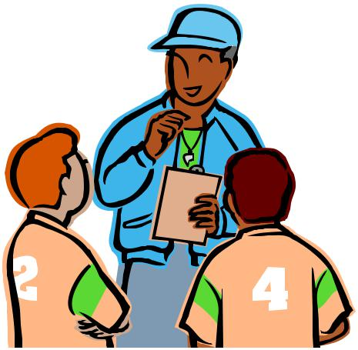

➢  Attend any and all training sessions with his or her designated coaches.

➢  Meet with all parents to discuss Little League philosophy and safety issues.

➢  Cover the basics of safe play with his/her team before starting the first practice.

➢  Teach players the fundamentals of the game while advocating safety.

- Teach players how to slide before the season starts (for appropriate ages).

➢  Encourage players to bring water bottles to practices and games.

- First time managers and coaches are requested to read books or view the video on Little League Baseball mechanics.

- Work closely with equipment officer to make sure equipment is in first-rate working order.

- Make sure that telephone access is available at all activities including practices. It is suggested that cellular phone always be on hand.

- Do not expect more from players than what the players are capable of.

SAFETY POLICY TITLE – Managers and Coaches

- Teach the fundamentals of the game to players: Catching fly balls, Sliding correctly, Proper fielding of ground balls,

Simple pitching motion for balance, Hitting, Base running, Rules of Baseball and team work.

- Encourage players at every opportunity.

- Make sure players are healthy, rested and alert.

- Make sure players are wearing the proper uniform and catchers are wearing a cup.

- Make sure that the equipment is in good working order and is safe.

- Agree with the opposing manager on the fitness of the playing field. In the event that two

managers cannot agree, the president, officer or board member shall make the determination.

- Reflect an understanding of the age group, lead by example.

- Support umpire decisions.

- Make sure players carry all gloves and other equipment off the field and to the dugout when their team is up at bat.

- Keep players alert and in the game, use common sense. Be organized and maintain discipline at all times.

- Keep players and substitutes sitting on the teams bench or in the dugout unless participating

in the game or preparing to enter the game.

15

AVON LITTLE LEAGUE

Safety Manual

- Make sure catchers wear the proper equipment. (Throat guards a must).

- Observe the “No- On-deck” rule for batters and keep players behind the screen at all times. no player should handle a bat in the dugout at any time. (Except Jr. & Sr. League)

- Keep players from climbing fences.

- Get players to drink often so they do not dehydrate. Do not play children that are ill or injured. (Notify the umpire or managers)

- Attend to children that become injured in a game.

- Do not lose focus by engaging in conversation with parents and passerby’s.

- Encourage and teach sportsmanship. Although winning is fun it’s not the most important role.

Equipment is checked when it is issued but it is the managers responsibility to maintain it. Managers should inspect equipment before each game and each practice.

The manager will promptly remove and/or replace damaged and ill-fitting equipment.

Furthermore, kids like to bring their own gear. This equipment can only be used if it meets requirements as outlined in this manual and the official little League rulebook.

At the end of the season, all equipment must be returned to the league for inspection by the Safety Officer.

- Each team, at all times in the dugout, shall have six (6) protective helmets, which must meet NOCSAE specifications and standards. These helmets will be provided by w.L.L at the beginning of the season. If players decide to use their own helmets, they must meet NOCSAE specifications.

- Helmets must have an exterior warning label.

- Use of the helmet by the batter and all base runners is mandatory.

- Use of a helmet by a player/base coach is mandatory.

- All male players must wear athletic supporters.

- Male catchers must wear long model chest protectors, Female catchers must wear long or short model chest protectors.

- All catchers must wear a mask, “dangling” type throat protector and catchers helmet during

practice, pitcher warm-up, and games.

- If the gripping tape on a bat becomes unraveled, the bat must not be used until it is repaired.

- Bats with dents, or that are fractured in any way, must be discarded.

16

AVON LITTLE LEAGUE

Safety Manual

- Only official little League balls will be used during practice and games.

- Make sure the equipment issued is appropriate for the age and size of the kids on your team. If it is not, get replacements from the equipment manager.

SAFETY POLICY TITLE – General Facility

- Located on Crowley, AVON, MA 02322.

- The AVON LITTLE LEAGUE complex consists of (3) three ball fields. (Little League).

- Bleachers are located on first and third base lines on all fields.

- Home plate, batters box, bases and the area around the pitchers mound will be checked periodically for tripping and stumbling hazards.

- Chain link fences will be checked regularly for holes, sharp edges, and loose edges and will be repaired or replaced accordingly.

- Our score booth has an electronic scoreboard on fields 1 and 2.

- Garbage cans are centrally located throughout the complex.

- Porta potty(s) are located at the fields once the season starts.

- No smoking, no dogs/cats are allowed in the complex.

SAFETY POLICY TITLE – First Aid

First-Aid means exactly what the term implies—it is the first care given to a victim. It is usually performed by the first person on the scene and continued until professional medical help arrives, (9-1-1 paramedics). At no time should anyone administering First –Aid go beyond his or her capabilities. Know your Limits!

The average response time on 9-1- 1 calls is 5-7 minutes. En-route paramedics are in constant communication with the local hospital at all time preparing them for whatever emergency action might need to be taken. You cannot do this. Therefore, do not attempt to transport a victim to a hospital. Perform whatever First-Aid you can wait for the paramedics to arrive.

First-Aid kits:

First Aid kits will be available to each team at the beginning of the season.

The first aid kit should become part of the teams equipment package and shall be taken to all practices, batting practices, games and any other little league event where children safety is at risk. To replenish material contact the leagues safety officer.

First Aid kits and this safety manual must be turned in at the end of the season along with your equipment package.

17

AVON LITTLE LEAGUE

Safety Manual

SAFETY POLICY TITLE – Field Equipment

- Be stored appropriately when not in use.

- Never left outside the sheds at end of game.

SAFETY POLICY TITLE – Parents and Spectators

- Must show positive support to all players.

- Must teach all children to play fair and do their best.

- Must positively support all managers, coaches, umpires and players.

- Must respect decisions of umpires.

- Must praise a good effort despite the outcome of the game.

- Are positive in any criticism of the program and willing to volunteer their services to improve it.

- Demonstrate that they recognize the effort expanded by the volunteer personnel by refraining from unsportsmanlike conduct.

- Recognize the little leaguers are children, not professional players, and need encouragement not criticism.

- Applaud good play; encourage the children efforts, initiate and hustle.

- Congratulate the winners, encourage the loser. Enjoy the game for what it is- Fun!

18

AVON LITTLE LEAGUE

Safety Manual

CONCESSION STAND

AVON LITTLE LEAGUE concession stand does not prepare any foods. Stock consists of prepackaged candies, snacks and soft drinks. All products sold need to be wrapped and sealed. All beverages must be in sealed containers with the seal still intact. All products must be purchased from a reputable local dealer for quality reasons. Any package or seal that is broken cannot be sold and should be returned to vender for credit.

Concession stand safety procedures will be posted in the concession stand. These procedures will include the following:

- No children under 16 years of age will be allowed in the concession stand.

- Volunteers must wash hands frequently and wear disposable gloves.
- All volunteers working in the concession stand need to wear a hat or a hair net.
- Anyone who is sick, or has open sores or cuts, should not work in the concession stand.
- All items must be stored a minimum of 12 inches off the floor.
- Items that require refrigeration must be stored in the refrigerators located in the concession stand.
- Trash needs to be disposed of in the trash receptacles. Please be sure that all trash cans have tightly fitting covers.
- Sanitizing wipes will be used to keep the concession stand clean. Wipes should only be used once before disposal.
- There will be no smoking allowed in or outside of the concession stand.
- Concession stand must be cleaned after every event.

The concession manager will be responsible for the training of all those who work the concession stand. Contact information for the concession stand manager will be posted within the concession stand. The minimum age to help in the concession stand is 16 years of age. No one under 16 years of age shall be allowed in the concession area for any reason.

19

AVON LITTLE LEAGUE

Safety Manual

Appendix-A

Field and Safety Checklist

All umpires, managers and coaches are responsible for checking the field and safety conditions before each game
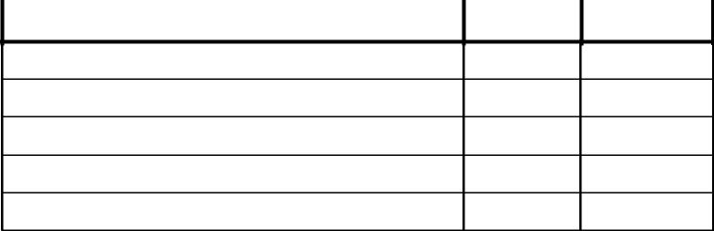

FIELD CONDITION | Good | Repair
Bases-Condition
Bases-Secured in ground
Batters Box Level & Marked
Coaches Box- Square
Fence 3rd Base Side
Fence 1st Base Side
Fence Backstop Area
Fence Outfield Area
Fields Level
Foul Line marked
Foul Poles
Gopher Holes
Grass Infield Surface Even
Grass Outfield Surface Even
Home Plate
In-Field Surface-Dirt Needed
Pitchers Mound
Roto-Till
Dugouts | Good | Repair
Bat rack secure
Bench repair
Ensure no Bee's in fence
Fence condition
Roof
Trash-Clean for play
Press Box | Good | Repair
Roof
Stairs
Benches
Electrical
Scoreboard
Pa System

 | Players | Good Repair
Helmets check for cracks

Bats-No dents, cracks, etc.

Proper Uniform

Athletic Cups

No Jewelry

 | Catchers | Good Repair
Shin Guards, Chest Protectot

Helmet w/Mask, Throat Guard

Athletic Cups, Catchers Mitt

 | Safety | Good Repair
First Aid Kits Available

Ice Available for injuries

Follow Manual Saftey

Fans-Bleachers | Good | Repair
Bleacher Condition
Bleachers Clean
Trash Empty
No Smoking
No Alcohol
No Pets
Misc Info or Remarks | Good | Repair

20

AVON LITTLE LEAGUE

Safety Manual

TEN COMMANDMENTS OF SAFETY

Be Alert
Check Playing Field For Safety Hazards
Wear Proper Equipment
Ensure Equipment Is In Good Shape
Ensure First Aid Is Available
Maintain Control Of The Situation
Maintain Discipline
Safety Is A Team Sport
Be Organized

HAVE FUN!

WHEN TREATING AN INJURY, REMEMBER:

Protection
Rest
Ice
Compression
Elevation
Support
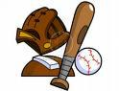

21

AVON LITTLE LEAGUE

Safety Manual

AVON LITTLE LEAGUE 2018 Safety Plan Addendum

- All Volunteers (league officers, coaches, managers, volunteers, or hired workers, who provide regular services to the

league) must fill out a 2018 Volunteer Application Form as well as provide a government- issued photo identification card for ID verification.

- The AVON LITTLE LEAGUE will provide fundamentals training, and require the at least one coach or manager

from each team attend.

  - First aid training will be required for coaches and managers.

      - The safety officer will submit a qualified safety plan registration form with the ASAP plan.

- AVON LITTLE LEAGUE will submit all player rosters, as well as coach and manager data via the Little League

Data Center.

    - The safety officer will complete and submit the 2018 Annual Little League Facility Survey.

22

