volleyball Personal training  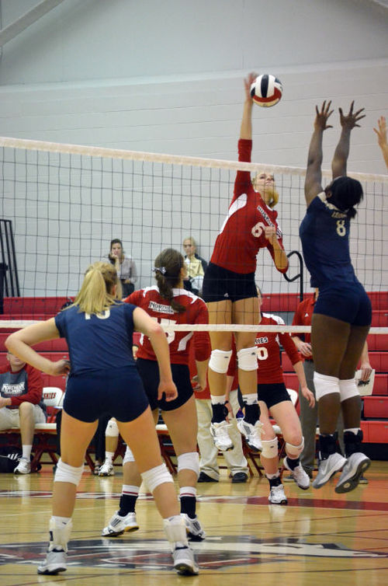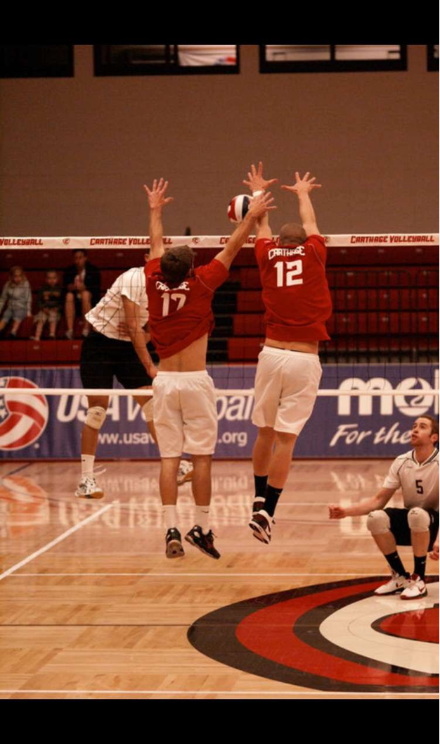  Are you looking to take your game to the next level?  Tyler & Sarah are offering volleyball instruction to all vollebyall athletes from juniors players to adults. for the athlete looking to take their game to the next level or the casual volleyball enthusiast! please do not hesitate to contact us:  tmfrings@outlook.com (414)-530-3842 Sangelos847@gmail.com | 45-60 min sessions  1 on 1 instruction  *Group rates Available upon request  Tyler Frings  -Marian Men’s Volleyball Head Coach  -2012 Carthage grad  -3 NCAA Final 4’s  -1 NCAA Nat. Championship app  -2010 & 2011 NCAA Leader In blocks per set  -AVCA All-American  sarah angelos  -Marian Women’s volleyball asst. coach  -Played Professionally for Brondby Volleyball Club, Denmark  -Danish Cup Champion  -Danish National Championship  -2014 Northern Ill. Grad  -2 time 1st team MAC  -2013 MAC tournament team

