OVYL Field Hockey
2018 marks the 33rd year of OVYL Field Hockey Program flourishing as a recreational league focused on the fundamentals of the game, skill development, teamwork and FUN! We have 3 divisions: Senior (5th &6th Grade), Junior (3rd &4th grade) and Lil’ Lynx (1st & 2nd grade). We practice and play intra-league games at the OVYL (occasionally inter-league games with other local programs), and the Junior and Senior divisions also participate in a few one-day recreational play-days and tournaments (including our own).
FIELD HOCKEY REGISTRATION: Oley Valley School District (OVSD) Girls beginning 1st through 6th grade in fall of 2018 (Current grades KG-5) can register online beginning on April 1, 2018 at www.ovyl.org. Payment can be made online, by mail, or in person. In person fundraising information pickup date and uniform sizing will be held at the OVYL on Tuesday, April 10th from 6pm-8pm. Final uniform sizing and Fundraiser return will be on Thursday, May 3rd from 6-8pm at the OVYL. **Returning Field Hockey players please bring your borrowed OVYL equipment, Field Hockey sticks and balls, to registration for inventory, sizing and repairs.
2018 Field Hockey Registration fees for OVSD residents:
1st and 2nd grade: $40 plus fundraising;
3rd-6th grade: $65 plus fundraising.
After Monday, May 7^{th,} field hockey registration fees will increase $20.
Additional Information
Evaluations: The Field Hockey Evaluation (3rd-6th grade only) date is TBD. Mouth and Shin guards required.
Equipment: Each participant MUST provide and wear their own colored mouth guard (not clear) and shin guards. The OVYL has field hockey sticks for participants to borrow– returnable at the end of the season, or you may use your own. Please have your daughter wear appropriate athletic footwear; spikes are recommended. Uniforms are provided and included with registration fee.
Fall 2018 Season: will begin on Tuesday, August 7th and practices and games held Tuesday and Thursday evenings from 6-7:30 pm. (in beginning of season practices will run closer to 8 pm).
OVYL Field Hockey Tournament: Sunday, September 9th, 2018. Rain date: Sun. Sept 16th, 2018. Please mark it in your calendars! This tournament is our primary fundraiser.
Volunteers: We are always in need of coaches and volunteers! Please volunteer in any capacity you feel comfortable. We also need many volunteers for fundraisers, med kit prep, routine field prep & tournament help (required). The generosity of volunteers is what makes this program possible and successful.
Team Sponsors: We are always looking for TEAM SPONSORS to help defray the cost of the uniforms! As a team sponsor, your business name will be on the back of the uniform tops. Securing a team sponsor fulfills the fundraising requirement!
Camp: The Oley Valley Youth Field Hockey Camp (run by our OVHS Field Hockey Team) is scheduled for June 11-14, 2018. Camp is for girls entering 1st through 8th grade in fall of 2018. (Current grades KG-7)
I look forward to working with you and your daughters for another successful season! If you would like to volunteer with our program or have any questions, concerns or suggestions, please contact me at ovylfieldhockey@gmail.com.
Kelly Williamson, OVYL Field Hockey Commissioner

Baseball
Who’ll stop the rain or snow? Its time for some real spring weather and the start of baseball season at the OVYL!!! As of February 26th, we have 157 kids signed up for baseball for 2018!
Smash Ball: This is where it all begins and last year’s success can only mean more fun in 2018! We have 42 boys and girls signed up for this year, which is a great number and should result in at least 5 teams! Due to the number of teams, we will be playing all of our smashball games at Oley for this year.
Rookie League: We have 37 kids signed up for rookie ball, which will consist of four teams that will play approximately 12-14 games against Oley, Antietam, Birdsboro, Fleetwood, Kutztown and Brandywine. There will also be tournament opportunities for many of the kids, including the Brandywine machine pitch tournament in mid-May.
Minor League: This year we have 46 kids in minors, which will yield four teams playing approximately 14 games against Oley, Brandywine, Kutztown, Birdsboro and Fleetwood; possibly others. In addition, the minor kids can try out for our Jr. Diamond league team as well as our tournament teams. We have completed our Cal Ripken charter for 2018 which only adds the potential for District and State playoffs!
Major League: We have 21 kids signed up for majors this year. We will have two major teams that will play approximately 14 games in the Keystone League against Fleetwood, Brandywine, Muhlenberg and Kutztown. This league will also have a playoff at the end of the season. Our 12U tournament team will participate in both the Oley and other local tournaments this year.
Senior League: We have 11 players signed up for senior ball this year from Oley and Brandywine. With our organization combining forces with Brandywine for American Legion Sr. & Jr. Legion baseball, players at this level have the option of trying out for the Oley/Topton Patriots Post 217 teams at Sr. Legion (16-18 years old), Jr. Legion (13-15 years old) or Jr. Legion prep (14U). The OVYL will field a 15U team in the Southern Berks or Jr. Babe Ruth Keystone League where they will play approximately 12-16 games vs. local Berks teams.

On April 21st, the Youth League will be hosting the annual Scotts Pitch, Hit and Run event. All boys and girls 8 and older are encouraged to register and compete. This event will start at 9:00 a.m. and will end around 10:00 a.m. with opening ceremonies to follow. We will also be having our annual BBQ fundraiser with tickets going on sale soon. Every team, from Smash Ball through the Majors teams will be playing a home game this day. This is a great chance to come out and watch Oley baseball! On April 28-29, we will host the fourth annual Carl Yerger Memorial Tournament at the U12 baseball age level. The third annual Jr. Home Run Derby for kids in the 14U & 12U age groups will also be held during this weekend. Can’t wait to get it started!
Mike Reinert, OVYL Sr. Baseball Commissioner
mlrbaseball20@gmail.com
John Cappellano, OVYL Jr. Baseball Commissioner
jpcappellano@nooter.com
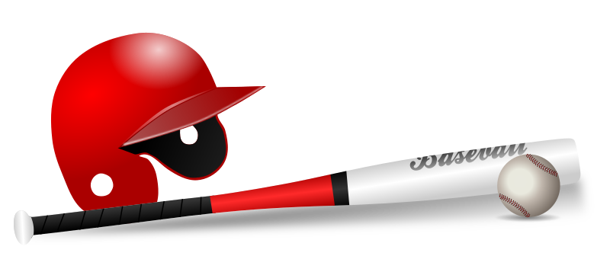

SOFTBALL
It is hard to believe that another softball season is under way! Indoor Practices have begun and we cannot wait to get outside.
We will have four softball teams this season participating in the BCGSL, one U8, two U10, and one U12 levels. It is going to be an exciting season at the OVYL! The softball commissioner position is open and we need your help! Christine Drobek,
Softball Commissioner
Basketball
The Basketball program had a very successful and fun season! Thank you for volunteering your time and supporting your children and the OVYL at all the practices, games, and tournaments!
Enjoy Spring!
Maryann DeBalko & Christi Fegely,
Basketball Commissioners


