Thank you to our Ongoing Billboard Sponsors
- SR Trucking and Excavating
- Fleetwood Footcare
- Graber Letterin’
- Reading Motorcycle Club
- Martin Stone Quarries Inc
- Technicon Enterprises, Inc.
- Watkins Architect. LTD.
- Jenn and Jesse’s Ice Cream
- Classic Era Motors
- Custom Milling
- Security First
- Eastern Industries
- Gasser’s Golf
- Bogia Engineers
- Airgas
- East Penn Manufacturing
- Brook Ledge, Inc
- Lehigh Cement Co.
- Pheasantland Roller Rink, Inc
- Pro Keystone Garage Door Co.
- Puroclean Emergency Restoration Services
- Oley Valley Family Dentistry
- Riverview Tree & Landscaping Inc
- The Soccer Stop
- Spayd’s Landscaping
- Z-Weldco, Inc
- Weidenhammer Systems Corporation
- Walsh Landscaping
- Reinsel Kuntz Lesher
- Tompkins VIST Bank
- Boyle Fencing
- DH Electrical
- Bob Fisher Chevrolet
- N.E. Fisher & Associates/ McCarthy Engineering
- Stitzel Family Funeral Homes
- Mast Roofing
- Smith Law Group
- Mertztown Rod & Gun Club
- Mair’s Continental Motors
Thank you to our Baseball and Softball Team Sponsors for your ongoing support!!

Fall Soccer
Registration is from April 1 through May 31, and can only be completed on-line through the Youth League’s Sports Engine website. Fall soccer is available for children with birth years 2006 through 2014. Birth years 2006 through 2010 will play on travels teams against other youth leagues in the Reading Berks Junior Soccer League (RBJSL). Birth years 2011 through 2014 will play on intramural teams, and will be separated into two divisions: U6 (2013 and 2014) and U8 (2011 and 2012). The registration for U6 will be free for Fall soccer. Please visit the soccer page on the Youth League’s website for additional information regarding the upcoming fall season. The soccer program is organized by a small group of volunteers, and we are in need of additional volunteers to join our soccer committee. If you are interested in helping or if you have any questions regarding the soccer program, please send me an e-mail at madukaitis@gmail.com.
Matt Adukaitis, Soccer Commissioner
OPEN OVYL POSITIONS!
Training/Shadowing Provided
Vice President
Softball Commissioner
Treasurer
Baseball Commissioner
Contact Wendy Serba for more info! wtreading@aol.com

FALL SPORTS REGISTRATION

Field Hockey and Soccer

Online Registration Starts April 1st
Tuesday, April 10th ♦ 6:00 pm– 8:00 pm
(Fundraiser brochure pick up & uniform sizing)

Thursday, May 3rd ♦ 6:00 pm– 8:00 pm
(Final registration, uniform sizing and fundraiser return)

After May 7th-Registration fees will increase by $20.00
Fundraising Options include Joe Corbi’s, Gasser’s Mini-Golf, and Lottery Tickets
If you have any questions about the fall sports programs, contact the commissioners Visit www.ovyl.org for Online Registration
Kelly Williamson, Field Hockey, Matt Adukaitis, Soccer
Baseball Team Sponsors
1) Interflex, Inc.
2) Boyer's Floor Covering, Inc.
3) DWeg's Photography
4) Mertztown Rod & Gun Club
5) Dunkin Donuts
6) Brookledge
7) Liberty Environmental
8) Friedens UCC
9) Reading Motorcycle Club
10) Drs. Schwab & Cambria
11) Gasser's Golf
Softball Team Sponsors
1) Phoenix Rehabilitation and Health Services
2) UGI
3) Anhalt Carpet and Tile Cleaning
4) Habakus Dentistry
5) DH Electrical, Inc.

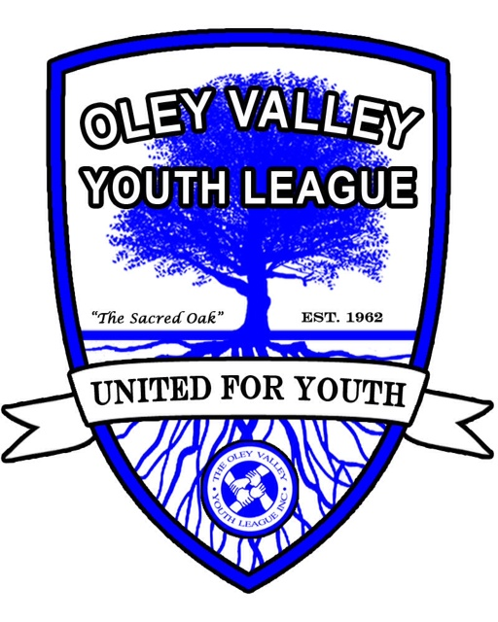

Next Board meeting will be held on the following date
Wednesday, May 2nd
at the Oley Valley Youth League at 7:30pm.
Check our website, www.ovyl.org, for details. Everyone is welcome to attend!

OLEY VALLEY YOUTH LEAGUE

April 2018

