Hitting drill #1:
Young players typically learn to swing the bat with hand drift, also known as "casting of the hands". In the following drills, we begin the process of teaching the hitter a proper swing motion that comes from hands closer to the body. An important feature to this swing comes from the back elbow tight to the body in the swing. Younger hitters will likely begin to step out during the swing, but it is important to teach the hitter to ALWAYS stride toward the pitcher when swinging. Hitter's weight shift and leg drive motion should always be the same, no matter if you are hitting the inside or outside pitch.

Hitting drill 1: Fence Drill 1 - This drill is to have the hitter to focus on NOT drifting their hands out, and having their hands roll out and causing the player to hit weak ground balls. The player will setup by taking their bat handle on their belly button and point their bat end on the fence in front of them. The player should setup their feet in their hitting stance. The player could have a tee in place to give them a object to swing. The player will now swing. If the player hits the fence, he/she should slow down to get the feeling of swinging the right way and then speed up the swing.
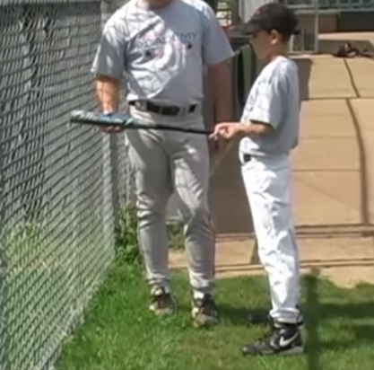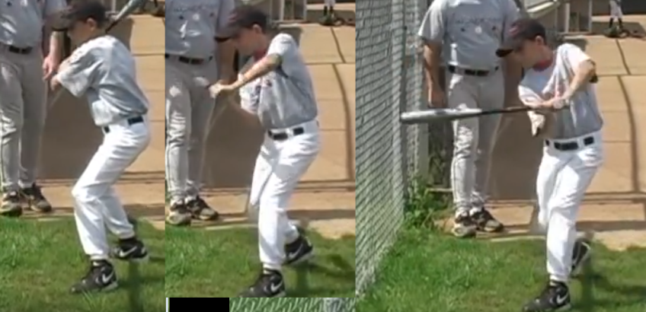

Hitting drill 2: Fence drill 2: This drill is to continue the training of the hitter to keep their hands in and NOT to float outside making the swing long and slow to hit the ball. The player should setup their stance with their plant (back) foot next to the fence. A tee can be used to give the player something to swing at. The player then performs the swing. If the player is long on the swing, they will get immediate feedback from hitting the fence behind them and should be instructed to adjust their swing so they keep the hands in and also shift their weight forward. The back elbow is found in good swings to practically touch the side of the stomach during the swing and a hitting verbal phrase to the hitter can be to imagine the batting the slicing their arm when swinging. It is important to watch the hitter from shifting their weight too far on the front leg, which is a bad way of losing their power on their swing. The hitter should understand that they are hitting the net behind them because their hands are traveling wrong, NOT because their body is too close to the net. If the hitter is having troubles with it, have them slow their swing down to get the understanding how the path of their hands, when done right, will not hit the net.
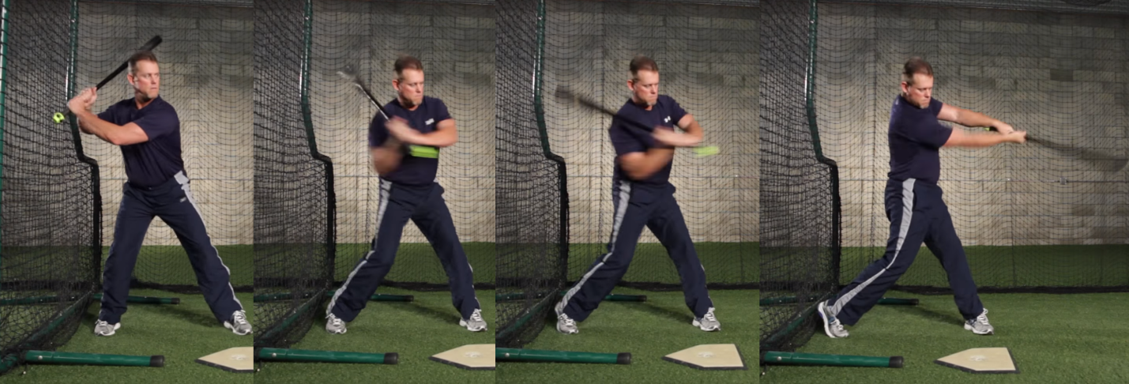

Hitting drill 3: Fence Drill 3 - This drill is to have the hitter focus on NOT drifting their hands out, and having their hands roll out and causing the player to hit weak ground balls. The Hitting Tee plate should be setup close to the fence with the tee a few inches off the fence. The player will setup by taking their bat handle on their belly button and point their bat end on the fence in front of them. The player should setup their feet in their hitting stance. The player will now swing and try to hit the ball straight up the middle. If the player hits the fence too much, he should slow down to get the feeling of swinging the right way and then speed up the swing.
