Catcher drills #1:
Players are to focus on the Mechanics of catching. The following drills are to have catchers practice catching the ball at the location of the catch. Catcher's should focus on not moving their catching hand after catching the ball. This is the beginning of teaching catchers the art of framing pitches, which is basically presenting the pitch to the ump in a solid manner. Catchers who catch the ball and allow the ball to take the glove farther away of where the ball was actually caught, appears to the ump that ball was farther away from the strike zone that it was.
This drill requires:
Tennis balls
Weighted balls

Catching drill 1: Catcher is to setup in their relaxing catcher stance with no glove and the catcher's hand in the catching position. The thrower (can be coach or other catcher) sets up with tennis balls and will rapid underhand throws the tennis balls to the ready catcher with throws from both hands. The thrower should try to go through the balls as quick as possible alternating every other hand.
Reps: 5 sets
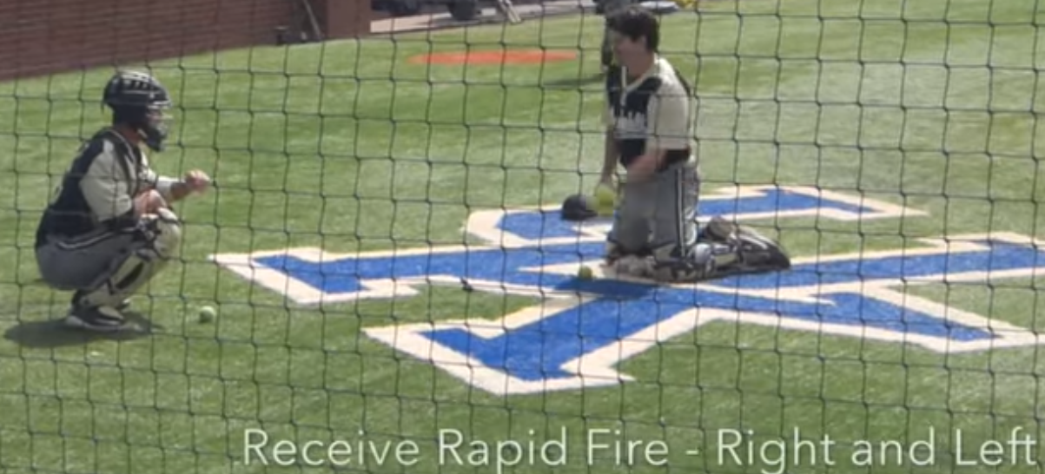

Catching drill 2: Catcher are to setup in their ready catcher stance with no glove and the catcher's hand in the catching position. The thrower (can be coach or other catcher) sets up with weighted balls and will rapid underhand throws the tennis balls to the ready catcher with throws from both hands. The thrower should try to go through all the balls as quick as possible alternating every other hand.
Reps: 5 sets
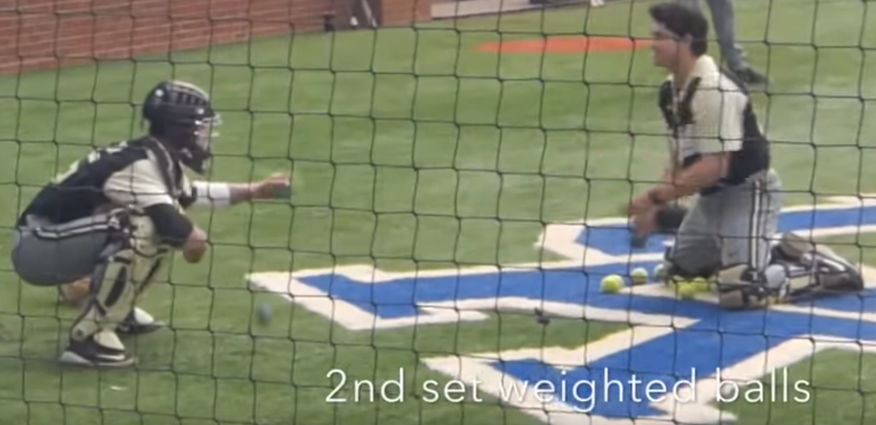

Catching drill 3: Catcher is to setup in their ready catcher stance with no glove and the catcher's hand in the catching position. The thrower (can be coach or other catcher) sets up with tennis balls and weighted balls and will rapid underhand throws the both balls mixed together to the ready catcher with throws from both hands. The thrower should try to go through the balls as quick as possible alternating every other hand.
Reps: 5 sets
