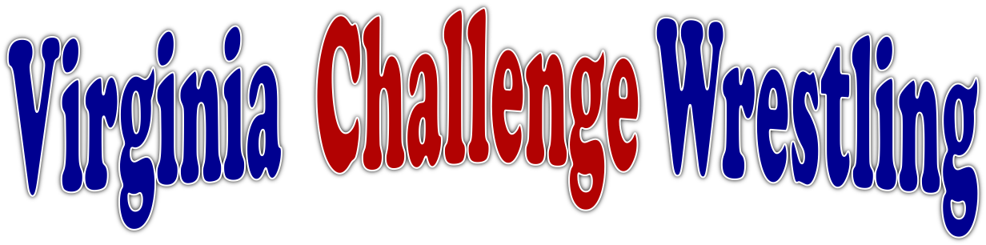

***\*\* PRESENTS \*\****

***The 5th Annual***

**\*\*All Virginia High School Super States Weekend\*\***

Riverbend HS, Fredericksburg

Open to all VHSL and VISAA High school competitors only.

**Details on web site at: www.virginiachallenge.org**

March 3-4, 2018

**USAW Sanctioned Tournament**

All wrestlers must have a current USAW membership; either full membership or a limited Folkstyle Membership is accepted.

**ADMISSION: ADULTS $10, STUDENTS $5, NON-SCHOOL AGE KIDS FREE, CURRENT VHSL OR USAW COACHES CARD FREE**

**Saturday March 3rd, 2018 - $30 – 9:00 am**

**Freshman (must be a freshman) 3 lb. allowance**

98, 106, 113, 120, 126, 132, 138, 145, 152, 160, 170, 182, 195, 220, 285

**Sophomore (must be a sophomore) 3 lb. allowance**

106, 113, 120, 126, 132, 138, 145, 152, 160, 170, 182, 195, 220, 285

**Junior (must be a junior) 3 lb. allowance**

106, 113, 120, 126, 132, 138, 145, 152, 160, 170, 182, 195, 220, 285

***Weigh-Ins/Skin Checks & Check-Ins Friday March 2nd 6-7pm***

***All weigh ins and weight classes have a 3 lb. allowance***

***This weigh in counts for Sunday Super States***

**Sunday March 4th, 2018 - $30 9:00 am**

**Super States (for anyone 9-12 grade) 3 lb. allowance**

106, 113, 120, 126, 132, 138, 145, 152, 160, 170, 182, 195, 220, 285

***Weigh-Ins/Skin Checks & Check-Ins Saturday March 2nd 5-6pm***

***For those who did not weigh in Friday night***

**Awards**

Top 3 Teams Plus

VACW Champion Ring (Super States), VACW Champion Trophy

Top 4 Place winners VACW Custom Medals

Contact: Frank Lipoli: [flipoli12@gmail.com](mailto:flipoli12@gmail.com) or Jack Harcourt: jharcourt@cox.net