Why Female Hockey Players should play Girls Field Lacrosse…

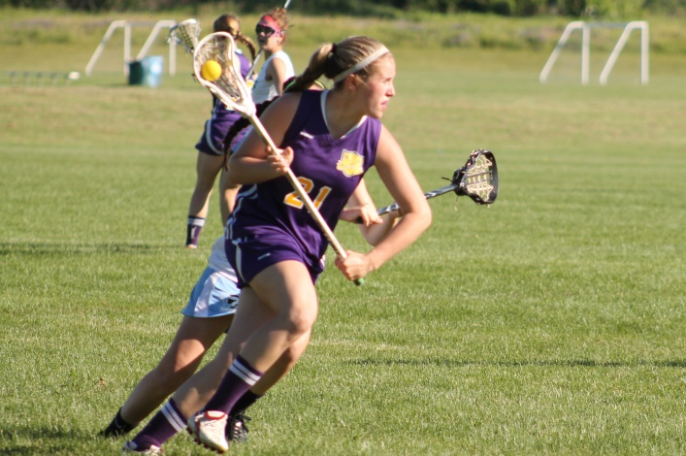

- It helps prevent sport burn-out by playing a new fast paced sport
- Players learn to play both offensive and defensive positions
- Lacrosse increases hand-eye coordination when stick handling
- Lacrosse teaches you to play with your head up and to be aware of your surroundings
- Offensive scoring skills are honed by shooting at smaller targets and picking corners
- Lacrosse teaches the creativity of fakes, back passes and shots
- Players learn to make fast transitions from offense to defense and vice versa
- Lacrosse reinforces the importance of quickness and agility around the net
- Lacrosse reinforces positional play even when the player doesn’t have the ball
- Players learn to be scorers by shooting in traffic and picking corners
- Girls make a whole new set of friends
- Players can choose to play house league (once a week) or rep (twice a week with games on weekends).
- There are a lot of scholarship opportunities for skilled lacrosse players in the OUA and NCAA
- Lacrosse is FUN!
Come to our FREE “try before you buy” event on Family Day, February 19 at Bechtel Park’s indoor Fieldhouse in Waterloo from 2:30-4pm
JOIN ONTARIO’S FASTEST GROWING TEAM SPORT
Girls Field Lacrosse

New players wanted for:
House League and Rep in
U6, U9, U11, U13, U15, U19
Yes! that’s ages 3-19!

House League runs Thursday nights in May and June.
Rep teams practice Tuesday and Thursday evenings with games on Saturday OR Sunday.
Rep tryouts start in April and the season ends with a Provincial Championship tournament at our very own RIM Park in late July.
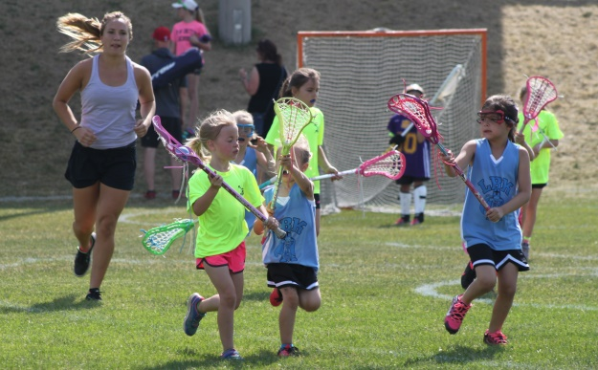

For registration information, click the
Girls Field Lacrosse Registration
tab at www.kwmla.com or go directly to Girls Field Lacrosse registration at
http://www.kwminorlacrosse.com/page/show/3829487-2018-girls-field-registration
Or contact
Ken Lubert at 519-577-4528
Email:
kwgirlsfieldlacrosse@gmail.com

