Rugby for Beginners

Introduction
Rugby Union is a sport played by two teams of fifteen players and eight substitutes controlled by a referee and two touch judges. High School is played in two 30 halves on a grass pitch (100m x 70m). This article is aimed at giving a very basic introduction to the game of Rugby Union. Player photos are courtesy of Steve Zomberg.

The game of rugby is all about continuity (possession, how do we keep the ball) and contest (how do get the ball). There are three areas of contest for the ball, contact, general play, and restarts (kick-off, scrum, line-out, etc.)

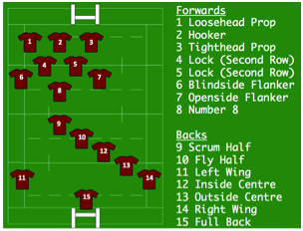
Positions
There are 15 players from each team on the field consisting of 8 forwards and 7 backs each. Players line up in various positions, either in a set piece; kickoff, scurm, line-out, otherwise may be anywhere on the field relative to their basic trained position. There is a Referee (also known as the referee, not “The Sir”), and two Touch Judges.

Playing
Players line up either as a forward or a back. Forwards (sometimes bigger boys) are the players who take part in the scrums and line-outs, backs (sprinters) can be seen lined up when the ball is passed along the line.
Players may run in any direction; however, may only pass backwards, lateral, no forward passing (i.e. towards the opposition’s goal line). Referees will stop the play if the ball is passed forward (called a Knock-On) and award a scrum. A knock-on is where a player loses control of the ball and propels it forward with their hands or arms into another player or into the ground. If it is propelled forward and the player retains control with out it hitting the ground or another player, then it is play on. There is however an exception to this rule, if a kick is charged down, the knock on rule is not applied.

General Offside
In general, a player is off side when they are in front of a teammate who has or was last in possession of the ball. This means that the player is out of the game until they are put back on side. They must not take part in the game in anyway during this time. There is no blocking in rugby.

If a player kicks ahead and a teammate is offside at the moment of the kick and may not advance toward the ball, they can be put on side by the kicker if the kicker runs in front of them or if another on side teammate runs in front of him. They can also be put onside by an opponent if the opponent runs for 5m with the ball, kicks or passes the ball or intentionally touches it but does not hold it – such as tipping or dropping the kick.
There are some other offside lines or zone entry areas; 5m behind the scrum, 10m behind the lineout and at the hindmost foot of a ruck or maul and through the tackle zone. A player who is in an offside position is not likely to be penalized unless they take part in the game before being put on sides.

Advantage (this is the most misunderstood area of the game)
If a team commits an infraction (knock-on, thrown forward, or penalty), the referee judges if the non-offending team has an advantage to play on. In other words, continue playing without stopping the game. The referee will extend an arm toward the non-offending team (indicating the infraction was observed) without immediately blowing the whistle.
If the referee believes that the non-offending team has been allowed to play the ball as they wish (e.g., gaining ground), the referee will announce that advantage is over and play will continue. If the referee decided otherwise, the whistle blown, play is brought back to the original offence and restarted (scrum or penalty is awarded).
So, as a spectator, please recognize this aspect of the game and help others to understand that an advantage may be in process and the referee has observed the infraction.

The Tackle
A tackle is completed when the ball carrier is legally brought to the ground by an opposing player (the tackler). If a player is merely knocked over they are not considered to be tackled and they may get back up and continue playing. Note: Legally brought to the ground means grasping/wrapping arms around the ball carrier below the shoulders (tackling) and briefly holding onto the ball carrier when brought to ground. Grasping an opponent above the shoulders, lifting the ball carrier’s legs above the waist, not wrapping, tripping are examples of a dangerous tackle and susceptible to penalty, or further sanction. When a player is tackled, the tackler or anyone else in contact with the ball carrier MUST release and roll away. The ball carrier MUST make the ball available to be played immediately by a player on their feet of either team (placing, pushing or passing the ball). Holding onto it will result in a penalty to the opposition. The tackler along with any other player coming into the tackle area must be on their feet before playing at the ball and enter the tackle area from behind the tackle (from an angle or the side is illegal). If any player enters the tackle area and does not remain on their feet they may be penalized.

The Ruck
Following a tackle, arriving players (on their feet) may form a ruck (a ruck consists of two opposing players in contact with each other over the ball on the ground). The ball cannot be handled in a ruck, instead the ball must be rucked backwards by players using their feet. Players must join a ruck from behind the hindmost foot of the hindmost player otherwise they will be offside and penalized.

The Maul
A maul is formed when there are three players, all on their feet; the ball carrier and one person from each team in contact. A Maul cannot be tackled (intentionally brought to ground). Players must also join a maul from behind the hindmost foot or
be offside and may be penalized.

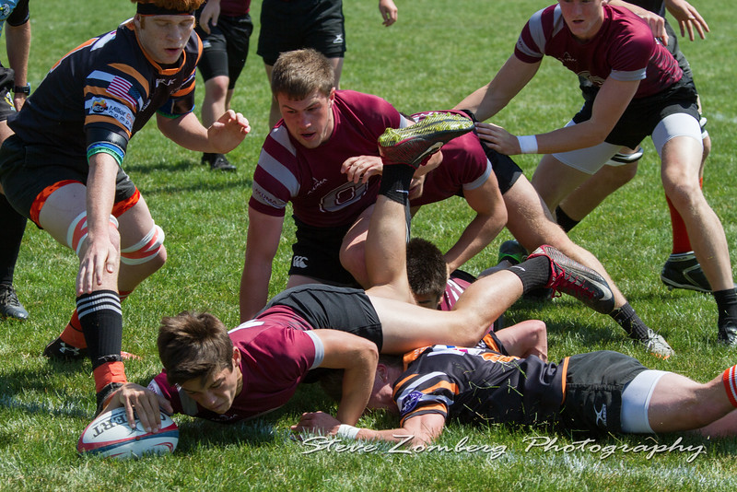
Scoring
The idea of the game is to outscore your opponents by being the first player to ground the ball behind the opposition’s goal line. This is called a “try” (touchdown) and is worth five points.
A “Conversion” (point after) may then be attempted by place kicking the ball over the cross bar and between the posts from a position perpendicular to where the ball was grounded for the try. A Penalty Goal or Drop Goal may also be scored by drop kicking the ball over the bar and between the posts or place kicking a Penalty over the bar between the posts for three points.

The Scrum
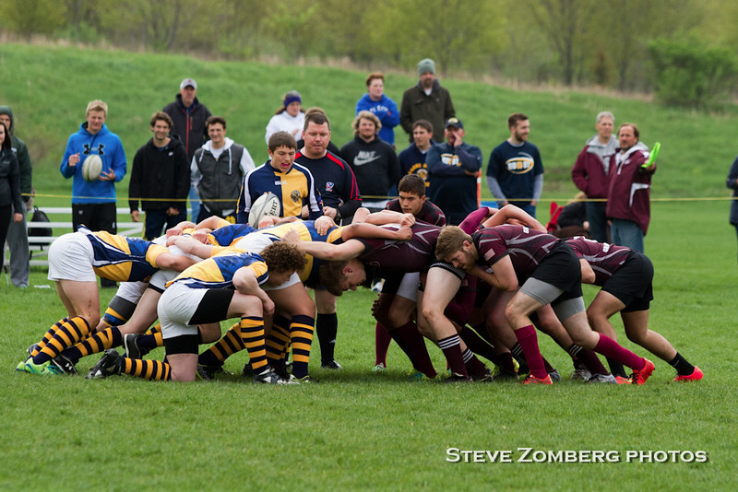
A scrum (a way to restart play after a minor infringement, e.g., Knock-on) consists of eight players from each side who bind on to each other and try to push the other team backwards and off the ball, players cannot push before the ball is in the scrum this will result in a penalty.
Players must remain bound until the ball comes out however if the ball is at the feet of the hindmost player, they may unbind, pick the ball up and continue playing.
The eight players in the scrum are 2 x Props,1 x Hooker 2 x Second Rows and 3 x flankers. The props and hooker comprise the front row. This is a specialist area of the game and only players suitably trained in the prop and hooker positions may play in the front row. The two second rows then places their heads into the spaces between the hooker’s hips and the props hips. The flankers then bind on to the second rows with one flanker on the side of the scrum that has most open field, one on the side with least field and one in the middle – the number 8. The referee instructs both groups of bound forwards to safely engage (interlocking heads). The referee will assess the stability of the Scrum and when determined a safe engagement and all are bound, will signal the scrum-half to roll the ball into the formed tunnel to be hooked.
legs of a prop. Once the ball is out of the scrum, play carries on as normal.

The Line Out
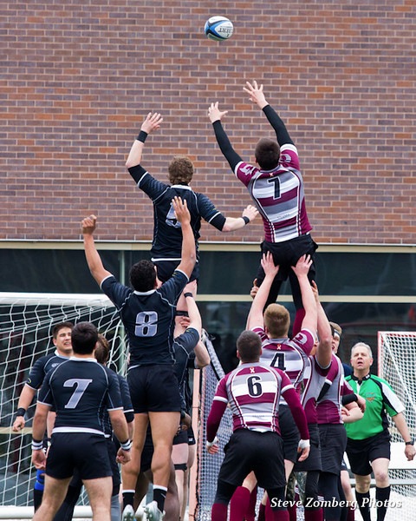
If the ball is run or kicked into touch (out of bounds) from the field of play a line out is awarded. The throw in is awarded to the team not responsible for playing the ball into touch. If a ball is kicked into touch from a penalty kick, the team awarded the penalty has the throw in.

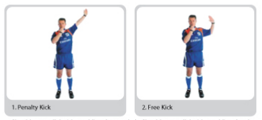
The Penalty If a team are awarded a penalty they may select, to kick to ball to touch to gain field position and hopefully possession from a line out, to kick for goal for a three point score, tap the ball and run or, depending on field position or offence, take a scrum. Some minor offences result in a free kick a bent arm signal from the referee.

Further Reading
This is a very basic over view of the game of Rugby Union. A further understanding of the game may be found in USA Rugby Game Management Guidelines USARR-GMG-01-2017.pdf

