NOTE: If the words “(BRING A COPY)” are shown, you must bring a copy with you and give it to the Credential Committee. We will not keep an entire booklet. We will keep only the items marked “(BRING A COPY)”
1. MAHA DISTRICT/STATE PLAYOFFS: TEAM CREDENTIALS Form (included in this package) complete the top portion of the front side. (BRING A COPY)

2. TEAM CREDENTIALS VERIFICATION SHEET (1‐C) (CVS) (BRING A COPY) Get this form from your association registrar. It has to be the form generated by your association registrar from the USA Hockey Registration Program that your association uses. Make sure you obtain this form after 1/2/2021 so that all information is current on the form. The CVS must include all personnel and players. Coaches correct CEP level must be reflected or an exception hard copy must be presented. CVS form will have the following information pre-entered for players and coaches: names, birthdate, birth certificate verified (@), US or Non-Citizen verification (√), Transfer complete (t)(s), Coach CEP info, Module level, Safesport and background screening completion(√). In the boxes to the right of the players birthdate complete the games played verification to show your team played 24 games and each player played 10 games with game dates across the top and checking the box of the player that played in each game. Leave the columns to the right of citizen verification blank.
3. USA HOCKEY TEAM ROSTER FORM (1‐T) – GENERATED BY THE USAH Registry Program (BRING A COPY). This form must be electronically signed and approved by your USA Hockey Associate Registrar. Only players on this form as of Dec 31, 2020 who have played the required number of games, or has obtained an exception from the state playoff committee, are eligible for Districts/State play. The official 1‐T roster is available from your Association Registrar or through the roster link emailed to your head coach.
The official 1‐T roster is recognizable by the USA Form 1‐t in the upper right corner of the roster.
If you have only one goalie, you may borrow a back‐up. This goalie can only be used in the case of an injury to your rostered goalie. A team may pick up a substitute goalie within its own association or District if it does not already have a spare goalie registered. If a team elects to bring a substitute goalie, the team may only have 19 players registered at any time so as not to exceed the maximum number of players allowed. This goalie must already be signed to an approved U.S.A. Hockey roster and cannot be playing for another team in the same division in the M.A.H.A. Playoffs. All of the same paperwork must be submitted for the back‐up goalie, plus a note of permission from the coach or manager of this goalies’ regular team. (use MAHA form #7 or equivalent)
For non‐national bound divisions, the substitute goalie must be registered in the current season on a team equal or lower age classification and equal or lower team classification. For national bound divisions, the substitute goalie must be registered in the current season on a lower team classification. DO NOT ADD THE BORROWED GOALIE TO YOUR ROSTER
MYRA REMOVED THE TEAM HISTORY REPORTS FROM LIST

4. PLAYER TRANSFER forms for Non‐US citizens approved by the USA Hockey National office
If the USAH registry generated roster does not show verified proof of legal residency and an approved transfer with a circle ‘T’ or ‘S’, Contact your association registrar to process the transfer and have the system updated.
5. FOR NATIONAL BOUND TEAMS ONLY – USA HOCKEY CONSENT TO TREAT FORM – Attached - for each player, coach and manager.

6. MAHA TEAM GAME LOG (BRING A COPY)
This is a list in chronological order of all games played by your team this season. List the game date, arena, opponent and score. NOTE: Game logs will be monitored for both team and individual player game count. (See MAHA Annual Guide for game counts rules.) You also must bring an updated copy of the log to your first MAHA playoff game. A sample of a game log is attached

7. SCORE SHEETS FOR ALL GAMES PLAYED
Please put your scoresheets in chronological order to expedite this review. Sheets will be reviewed for game counts and suspensions served for the entire season.
8. FOR HIGH SCHOOL AND JV TEAMS ONLY: HIGH SCHOOL JV STUDENT PICTURE ID FOR EACH PLAYER
Required to verify Division 1 or Division 2 team classification.

M.A.H.A. DISTRICT / STATE PLAYOFFS: TEAM CREDENTIALS
COMPLETE TOP PORTION OF THIS PAGE DIVISION:
& CREDENTIALS VERIFICATION SHEET
BRING TO CREDENTIALS REVIEW. ASSOCIATION:
PLEASE PRINT

TEAM NAME:
COLORS: HOME:
AWAY:
TEAM CONTACT: NAME:
COACH: ADDRESS:
MANAGER:
CITY:
ZIP:
PH: H: ( )
PH: W: ( )
PH: C: ( )
E-MAIL ADDRESS:
ALT. CONTACT: NAME:
COACH: ADDRESS:
MANAGER:
CITY:
ZIP:
PH: H: ( )
PH: W: ( )
PH: C: ( )
E-MAIL ADDRESS:
HOTEL:
PHONE NO:
ROOM #:
For M.A.H.A. Use Only: CREDENTIALS CHECK: CERTIFIED TEAM (1-T) ROSTER
GAME LOG Total Games: As of:
*** Complete all information on back of this form for each player, coach and manager ***
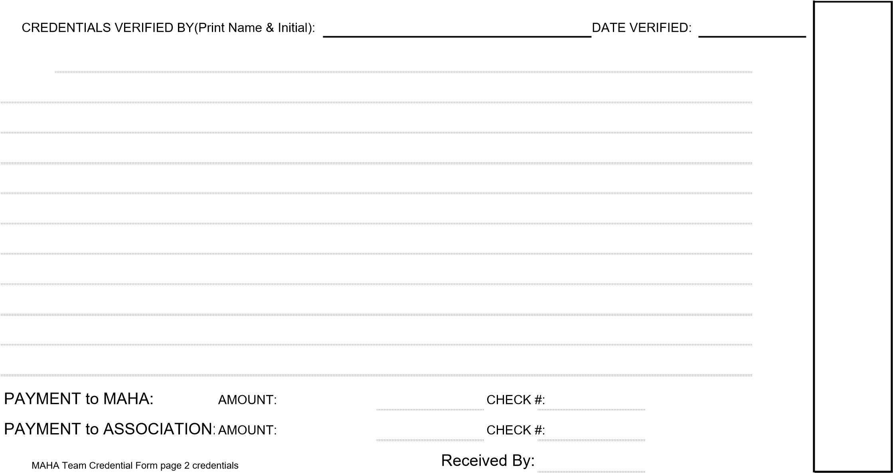NOTES:
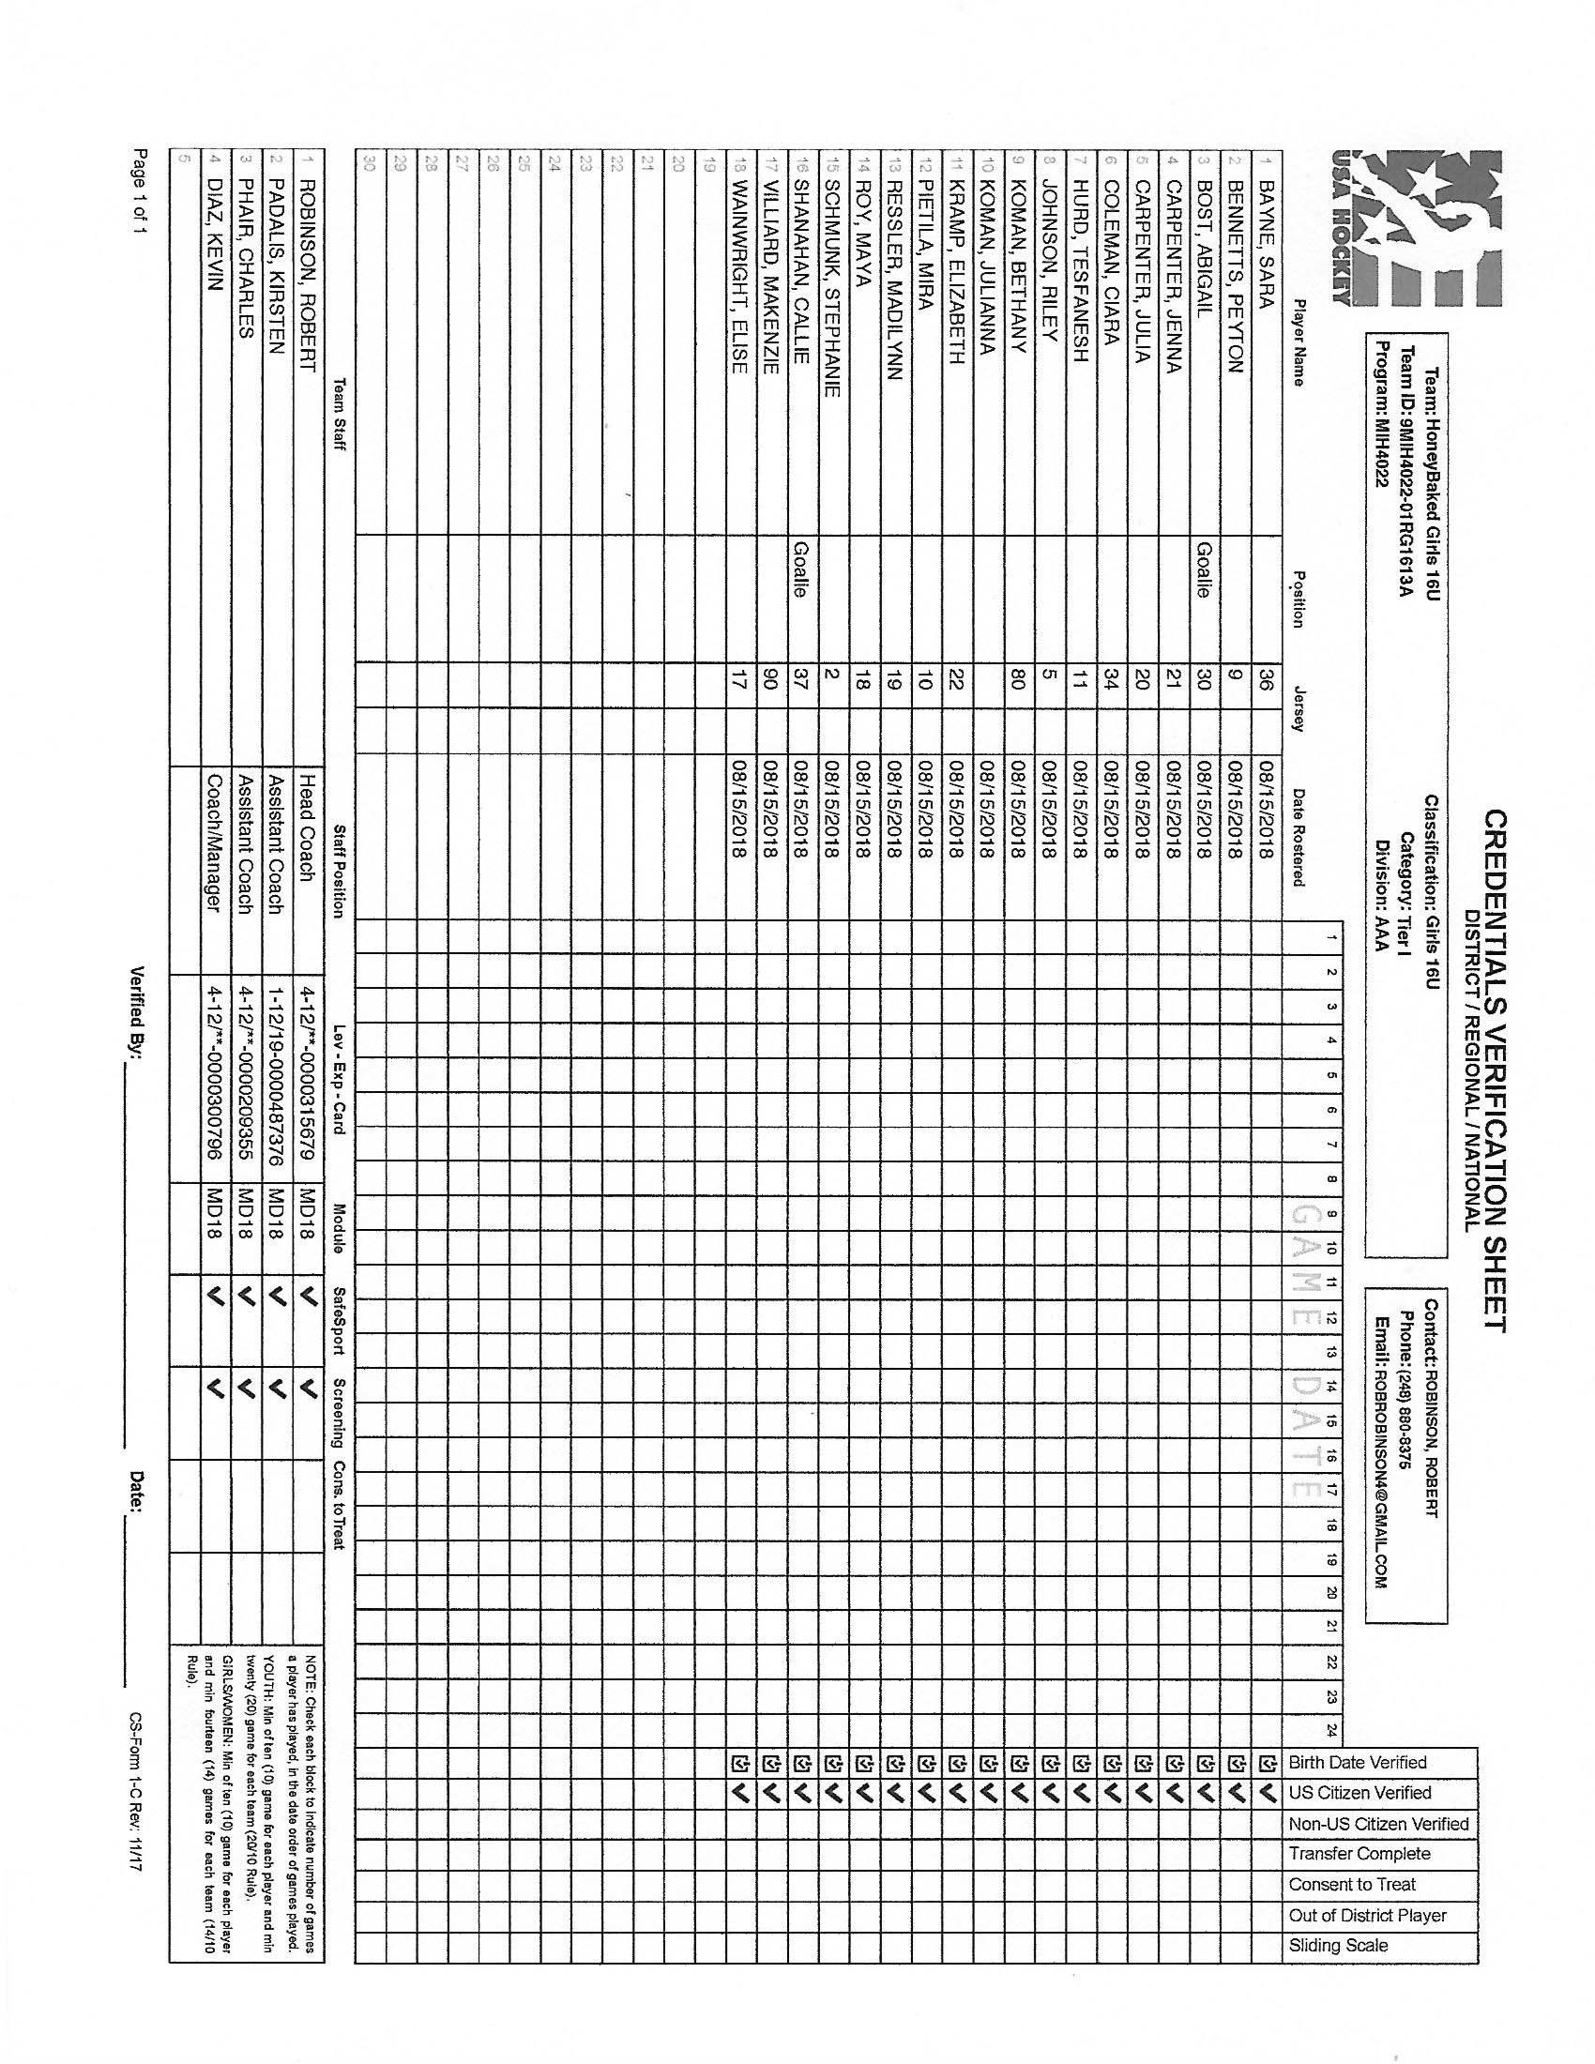
Y
Y
Y
Y
Y
Y
Y
Y
Y
Y
Y
Y
Y
Y
Y
Y
Y
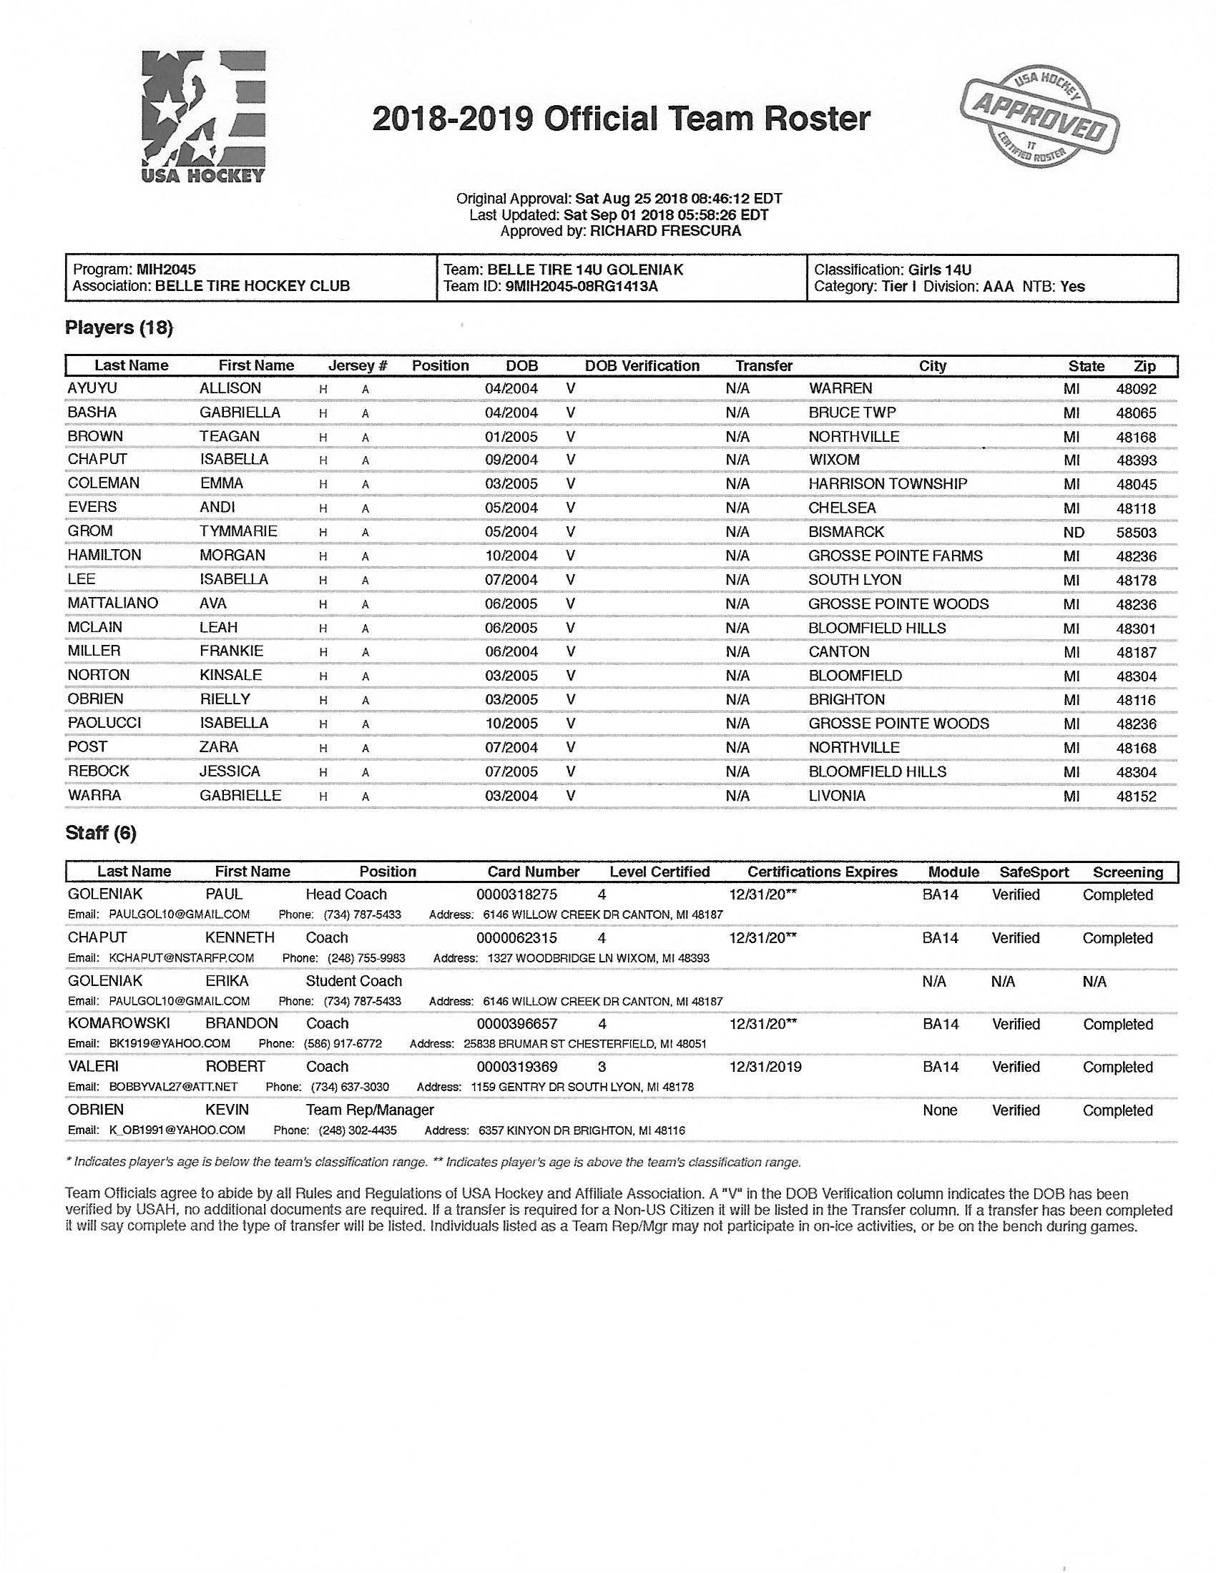
YYYYYY
YYYYYY
YYYYYY
YYYYYY
YYYYYY
YYYYYY
YYYYYY
YYYYY
YYYYYY
YYYYYY
YYYYYY
YYYYYY
YYYYYY
YYYYYYYY
YYYYYYY
YYYYYYY
YYYYYYY
YYYYYYY
Page of
Team Name:
Division:
Association:
Season:
No.Date
Di
v
i
s
i
on
A/AA/AAA/B/BB/
(
House.Rec)
Your
Score
Their
Score
Michigan Amateur Hockey Association
Game Log
Name of Team PlayedGame Played at: City, State
MAHA_Gamelog

