**Skating:**

**A-**Players skate around a designated barrier with no sticks. One player is designated “it”. Players play “TAG”

**B-**Players skate around designated barrier. One player has a “ringette” ring on the stick. The other player skates to steal ringette ring. “Keep Away”

**C-** Players skate around designated barrier. One player has puck on stick. Other player skates to steal puck. “Keep Away”.

**Puckhandling: The Junkyard**

**A-**Players skate around the junkyard any direction they want handling a puck making moves on the obstacles.

**B-**Players make moves on the obstacles then add in that they have to pivot around the obstacles

**C-**Same as 10U but add in passers around the perimeter half way through station.

**Passing/Shooting:**

**A-**First shot is a stationary shot, player picks up puck on side of net for second shot, then picks up puck from other side of net for third shot.

**B-**Fist shot is stationary shot, player next to net passes to shooter for second shot, player on the other side of net passes to shooter for third shot

**C-**Player next to net passes out for first shot, shooter then drives to net for a pass and one timer (second shot), player then backs out to high slot and receives pass for third shot.

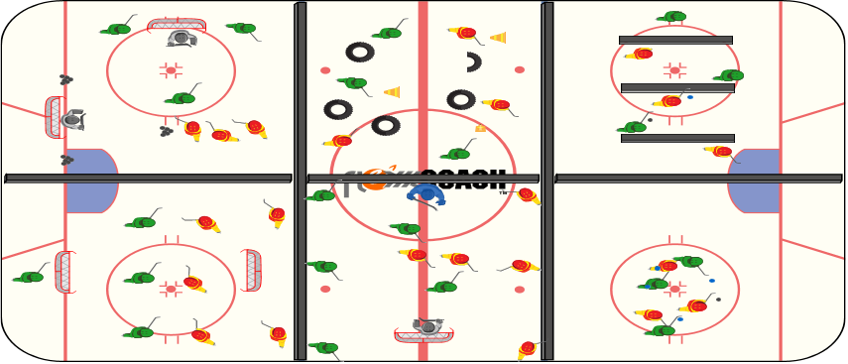

**Small Area Game: Concepts**

**A-** 2v2 or 3v3. Coach designate offensive team and defensive team. Defenive team gets a point for passing to coach. Offense scores goals.

**B-** 2v2 or 3v3. On transition the team must pass to coach before attacking to score.

**C-** 2v2 or 3v3. On transition the team must pass to one of their teammates on the flank before attacking to score.

**A,B,C’s: Concepts & Body Contact – “Lord of the Rings”**

**A-** All players have rings. Each minute remove a ring.

**B-** Half the players have rings, the other half are attempting to steal the ring.

**C-** Half the players have a puck on their stick (offense). Half the players have the ring on their stick (defense).

*Half the players have rings, the other half are attempting to steal the ring. Encourage body contact.

**Small Area Game: Concepts**

**1-**Play to learn. Players play 3v3 or 2v2 in tight area

**B-**Learn to play. Players play 3v3 and have to use player behind offensive net (Kane) or player behind defensive net (Suter) before they can attack.

**C-** Learn to play. Players play 3v3 and have to use one of two players behind offensive net (Kane) or players behind defensive net (Suter) before they can attack.