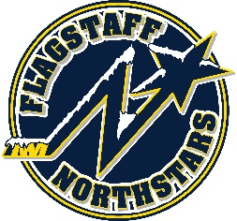
Flagstaff Youth Hockey Association
BOARD OF DIRECTOR’S MONTHLY MEETING AGENDA
January 19, 2022

Topic: FYHA General Board Meeting
Time: January 19, 2022 at 6pm
Location: 215 E Birch Ave or via teams: https://tinyurl.com/FYHA-General-Board-Meeting

GENERAL BOARD MEETING
Topic: FYHA General Board Meeting
Time: 7:00
Approval of Minutes:
Reports:
- President’s Report- Travis Joralmon:
- AAHA Hockey Director- Travis Joralmon:
- ADM Coordinator: Kris Walsh:
- Coaching Coordinator- Travis Johanson:
- Equipment Manager- Greg McLaughlin:
- Fundraising Coordinator-Kyle Palmer:
- Ice Scheduler-Brad Mihalik: Targeting 7/11-7/15 for Northwestern Hockey camp, not confirmed
- COVID Updates and Protocols- Brad Mihalik:
- Registrar-Judy Smith:
- Treasurer-Lauryn Sandoval:
- Webmaster-Courtney Matthews:
- Managers-Courtney Matthews:

UPCOMING EVENTS:
- RMHS 6/20/22-6/24/22
- Dark Sky 7/22/22-7/24/22
- 8U tournament 4/2/22-4/3/22
- Robby Glantz- Easter Weekend

OLD BUSINESS:
- Partnership/sponsorship with N. AZ Healthcare
- Mask & Capacity mandate

NEW BUSINESS:
- Tryout dates (Brad)-selecting teams for reserved time slots (6/7, 6/9, 6/14, & 6/16)
- Annual Meeting-set date/location
- Nominating Committee
- End of season party budget
- Budget committee selection
- Club pictures

