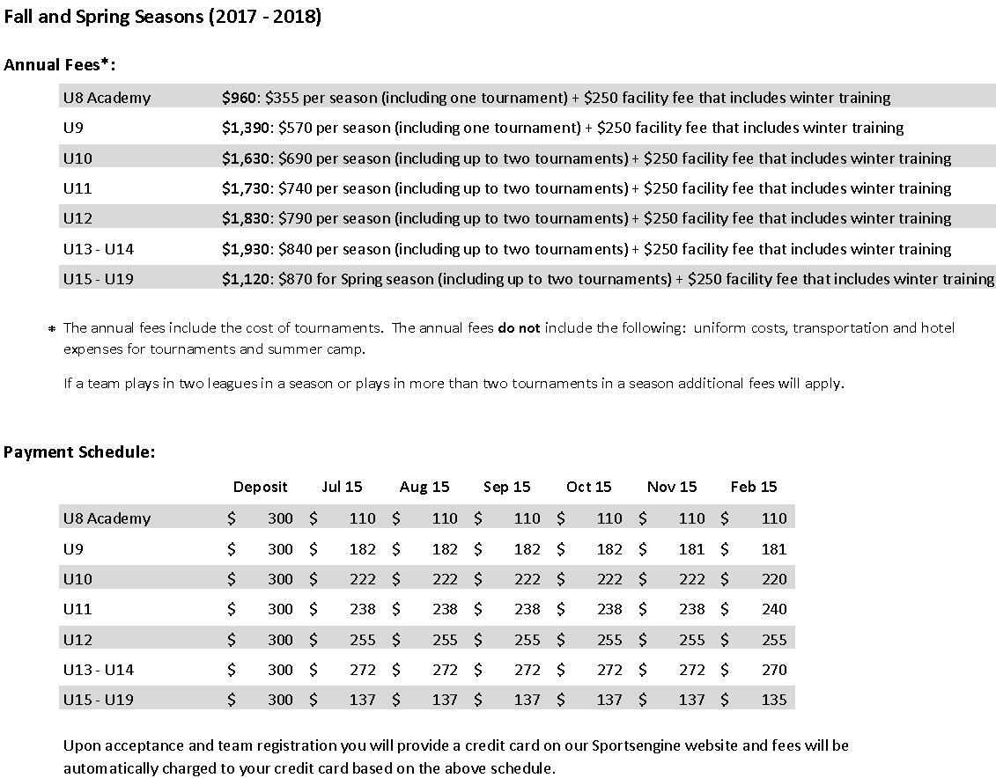

Santos FC is one of the few soccer clubs in Central Ohio to have its own dedicated indoor facility. We have a long-term lease on a warehouse-style building located at 4445 Weaver Court North in Hilliard, just west of the Mill Run area near the corner of Cemetery and Leap Roads. At 12,000 square feet, this facility features 10,000 square feet of turf practice space, a sitting area for parents to wait during training sessions and plenty of parking.

By having full year access to an indoor facility, Santos FC truly distinguishes its commitment to individual and team development within the Central Ohio soccer community. The benefits to this facility are truly endless for club members allowing teams and individuals to continue their development uninterrupted year round. As part of your annual fees every club member is able to participate in three sessions per week of winter indoor training and coaching (November – March). In addition, the facility provides a location for Santos teams to hold in-season practices during inclement weather.

