To Cancel a Dibs:
Start by clicking “My Dibs”
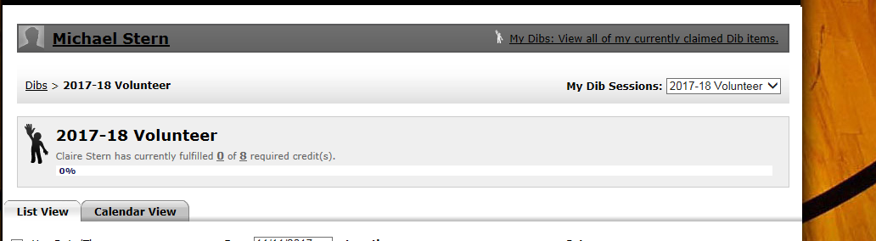

Click on the “Dib Item” (specifically the text that says Admissions, Concessions, Time Keeper, etc). Do not click on the session or date/time or anywhere else.
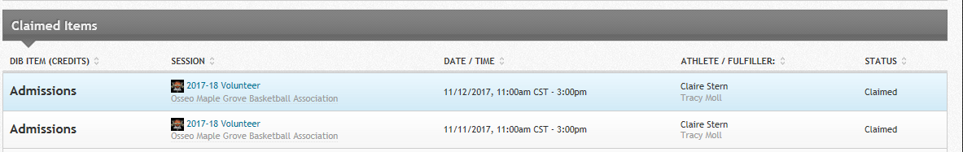

On the lower right hand side, click on “Cancel Claim”
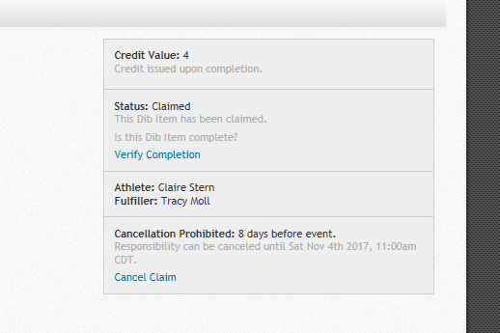

…and follow instructions from there to confirm cancelation.

