2nd Annual Fundraiser Golf Tournament
Friday, August 25, 2017
Proceeds to Benefit the CSB Scholarship Fund
12:00pm Registration, 1:00 Shotgun Start
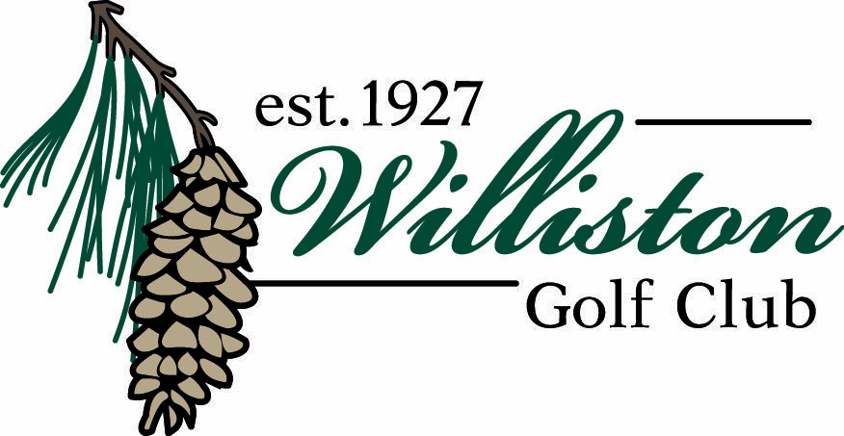
Format:
Four Person Scramble. Ladies - Green Tees, Juniors - Green Tees, Men – White Tees. Prizes Awarded To 1st, 2nd, 3rd & Last Place Teams
Special Events:
50/50 Putting Contest ~ Hole-In-One Prizes ~ Raffle Prizes ~ 50/50 Raffle
Long Drive prizes ~ Closest To The Pin Prizes ~ Mulligan’s
Food and Beverage:
Bag Lunch and After Golf Wings & Things Buffet – GOODWATER Brewery Specials
Entry Form:
$400 Per Team. Includes Golf, Cart, Tee Favor, Food & Prizes
Team Captain Name and Email:_________________________________________
Player #2 Name:_____________________________________________________
Player #3 Name:_____________________________________________________
Player #4 Name:_____________________________________________________
Optional Hole Sponsorship:
$150 per Hole. Promote your business as supporting sponsor of CSB Hockey!
Business Name:____________________________ Jpeg Logo Provided:________

