2017 Seattle Dodgers Off-Season Training Program/Fall Ball
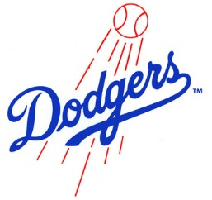
The Seattle Dodgers Baseball Club will be organizing a highly intensive off-season strength/conditioning program, and Fall Ball team(s). Our goal is to introduce our young athletes to baseball specific strength and conditioning workouts, as well as continued baseball instruction.
Age/Team Goals: Our goal is to have 5 teams (13u, 14u, 15u, 16u, 18u), and 12-15 players per team. We will add teams if needed, we will avoid combining teams if at all possible.
Strength/Conditioning Focus: Baseball specific strength program focusing on speed, agility, arm strength, arm maintenance, power throwing, core strength, and increasing bat speed.
Baseball Focus: Swing mechanics, infield mechanics, catching mechanics, and mental approach to offensive/defensive baseball.
Schedule: See Below
Las Vegas Tournament: Each player will have the opportunity to participate in the Las Vegas Desert Fall Classic (Oct 27th thru 29th)- The Seattle Dodgers will combine with other NPA teams for the Las Vegas Tournament, you must try out and make the TRAVEL team to attend this tournament.
Cost: $500 per player (Does not include Las Vegas Tournament)
-Includes jersey, hat, workout shirt
-Off-field training by ex-college and professional players
-8-12 games (weather permitting)
Does Not Include: Airfare to Las Vegas or Lodging in Las Vegas
Las Vegas Rosters:
13u-14u fall teams will carry 12-14 players
15u-18u fall teams will carry 12-15 players
Does Not Include: Airfare to Las Vegas or Lodging in Las Vegas
Schedule:
Begins Wednesday September 13, 2017 and ends Sunday in Las Vegas October 29, 2017
Wednesday: Team training at NPA, or outdoors (weather permitting)
Thursday: Strength and Conditioning
Saturday: Double Header – Lower Woodland and Whitman Middle School (weather permitting)
All other days: Open hitting available at NPA

