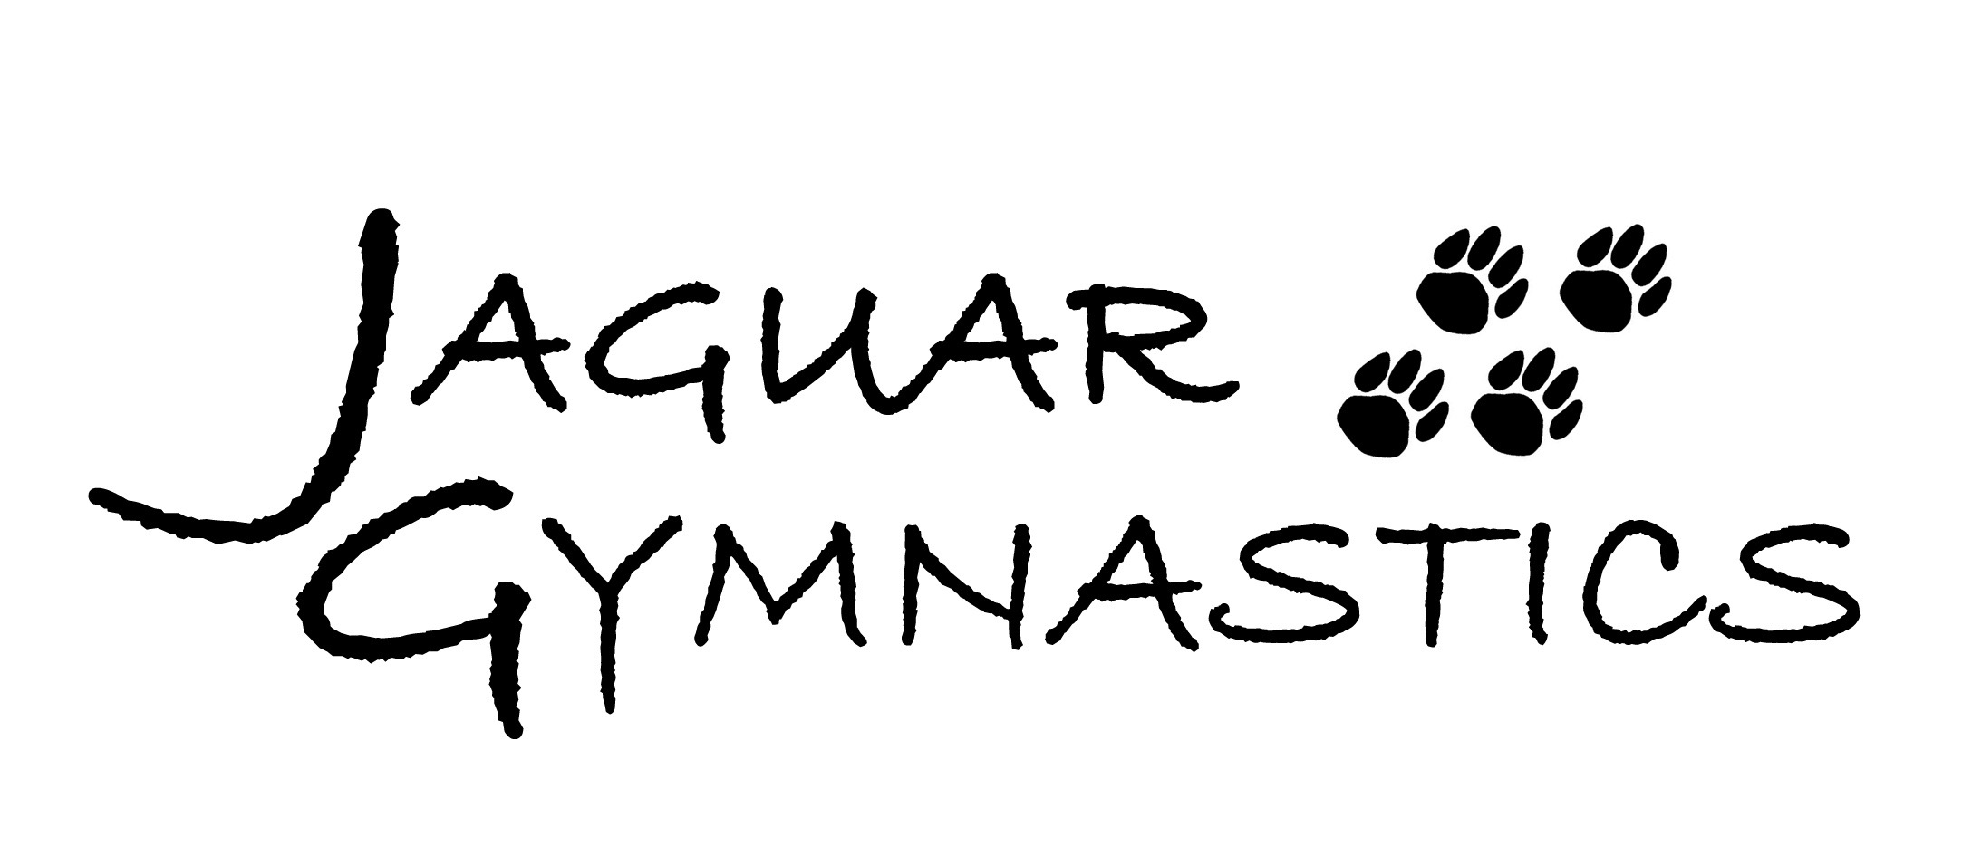

CLASS DESCRIPTIONS:

BEGINNER I:
No experience necessary, must be 5 years old. Main skills include: cartwheels, handstands, walking on beams, landing shapes, front support on bars, and wall walk pullovers on bars.

BEGINNER II:
Must have passed or tested out of Beginner I. Main skills include: back bend, connected cartwheels, handstands on low beam, pullover using 1 leg on wall, and chin hang on bars.

ADVANCED BEGINNER:
Must have passed or tested out of Beginner II. Main skills include: back bend kick over, handstand to bridge, round off, cartwheel on low beam, pull over, and back hip circle.

INTERMEDIATE:
Must be at least 10 years old and/or passed Beginner II. This class is designed to be a smaller class to obtain the skills at a faster rate. Main skills are the same as Advanced Beginner.

ADVANCED:
Must have passed or tested out of Advanced Beginner or Intermediate. Main skills include: connected cartwheel to back bend kick over, back handspring on octagon, full turn on low beam, handstand on high beam, 3 pull ups and 3 leg lifts, and pike dive roll over vault.

TUMBLE I:
No experience necessary, must be 5 years old (girls or boys). Main skills include: cartwheels, handstands, and jumps. Tumble classes also use the mini tramps and tumble trak.

TUMBLE II:
Main skills include: back and front walkovers, roundoffs, back handsprings on octagon and wedge.

TUMBLE III:
Main skills include: back handsprings, back tucks, front handsprings, front tucks, and aerials.

MINI-JAGS, PRE-TEAM, & MAGA:
These levels are by invitation only.

HIGH SCHOOL:
For girls 7th-12th grades that are currently competing or will be competing on a high school team.

