Roll Call: Terry Johnson, Sean McCabe, Jesse Viall, Travis Steele, Randy Kruse, Adam Welch, Bernadette Schaffer,Tom Johnson, Adam Hoffman, Jay Stark
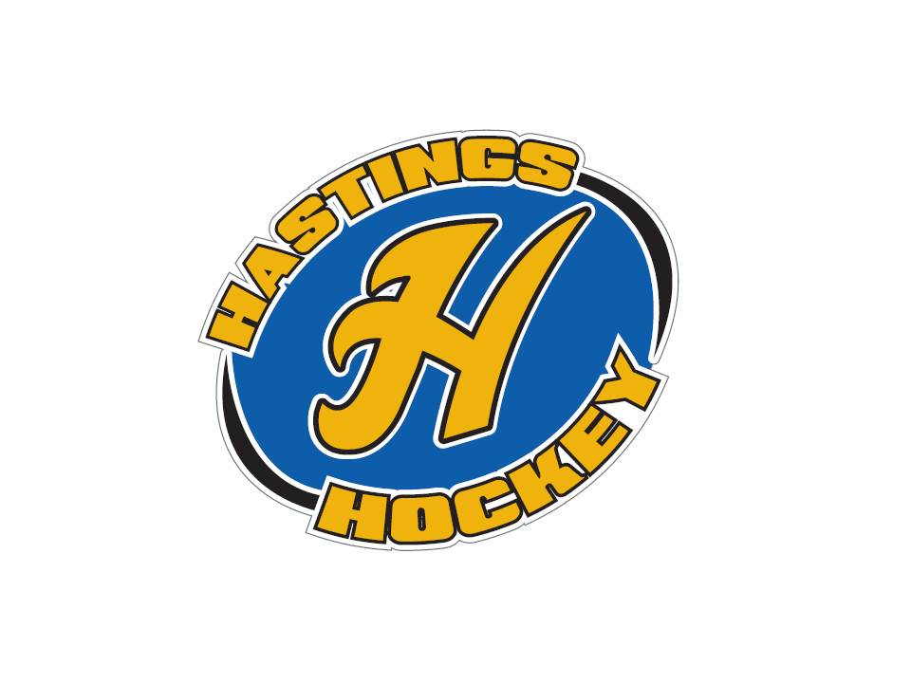

Not in attendance: Jaimie Schuster, Shannon Callahan, John Klimek, Josh Colvin, Shane Lanning, Erik Goettl,

- Approval of Agenda Travis made the motion Adam W seconded it – motion passed
- Approval of Minutes Sean made the motion, Tom seconded it – motion passed

Coordinator Reports
- Referee – John Klimek not in attendance
- Registrar – Shannon Callahan
- Technology – Jay Stark/Randy Kruse
- Tournament Director –
- Sponsorships – Erik Goettl
- District 8 – Jesse Viall
Movement of Red Wing to our district
Coaches clinics need hosts
Preapproval for tournaments before advertising
U15 B U12????
A or B bantam hosting??????
Taking out body checking of C bantams for district 8???– will be voted this year
District 8 is voting to go with stickstats or sport engine
East Ridge wants to form its own association – early discussions
Jesse Viall stepping down as district 8, Jay Stark stepping in – motion made by Jesse, seconded by Tom Johnson – motion passed
- Goalie – Josh Colvin not in attendance
- Secretary – Bernadette Schaffer

Officer Reports:
- President – Terry Johnson
Donny Huemoeller resigned as Bantams director and AA coach
Send bantam issues to Randy
Red Wing wanted to come in, no issues for that
Discussions of apparel for next year, womens apparel was lacking so looking for more options
- Vice President – Jay Stark
Need team counts for traveling teams so that he can work on ice scheduling
- Treasurer – Jaimie Schuster (Approval of the Financial Statements)
Not in attendance

Director Reports:
- Volunteers – Shannon Callahan not in attendance
- Director of Hockey – Adam Welch
Coaching vacancies will be posted today and will be due May 15th We will decide by Memorial Day

Shot club – not too many are signed up so make sure to get that done!!
- Operations – Adam Hoffman
Equipment turn in went well
Junior Gold missing many uniforms
In house equipment – directors will have access to equipment room
Travel team’s equipment – Level directors will hand out and return all team equipment
Free equipment – can be used at any time with a deposit check of $150 – Will start with 3 seasons check out dates, will have 2 equipment check in dates – Termites season end, squirt season end
Would like to remodel the equipment room, change locks
West rink upgrades – banners, signs, flags
In ice players box, coaches tools
Promotions and grants – looking into different opportunities with USA hockey
Girls Hockey Weekend
Gear up Minnesota Grant – 10 sets of equipment
Pass the puck grant - $2500.00

- In-House Girls – Shane Lanning
Not in attendance
- Travel Girls – Travis Steele
Spring skate finishing up – questioning whether to do it again as it interferes with other sports
Discussion of U15 teams
- TerMites – Tom Johnson
nothing
- Mighty/Super Mites – Jesse Viall
nothing
- Squirts – Jason Stoffel
Discussion of how the program will look for coming years
- Peewees – Sean McCabe
nothing
- Bantams/Jr. Gold/U16 – Don Huemoeller
Nothing to report

Old Business:

New Business:
- Tournament coordinator Still need one!!
- Registration Advertising Coordinator Still need one!!
Golf tournament will be Saturday September 9th
- Coaching Positions – applications will be accepted until May 15th at midnight

Board Comment
Directors meeting – We are on the right track for how we are trying to run our squirt program. USA Hockey is supportive of the in house program. Looking to bring in some speakers to explain this to parents. Will try to schedule something during practice times to make it easier for parents to attend. Skill development as well as practice vs games – we are on track with how USA hockey wants to develop players. We will continue working on making practices more fun to make sure that kids do not get bored. Discussion on how smaller ice size is important for kids to develop more.

Membership Comment - none

Adjournment motion made at 8:24 – Adam made the motion and Jason seconded it

Next Meeting: June 4th, 2017

Open positions for coaching

Boys
Peewee AA, B1, B2, C
Bantams AA
U16

Girls
U15 A
U12 A
U12B
U10 A
U10B

