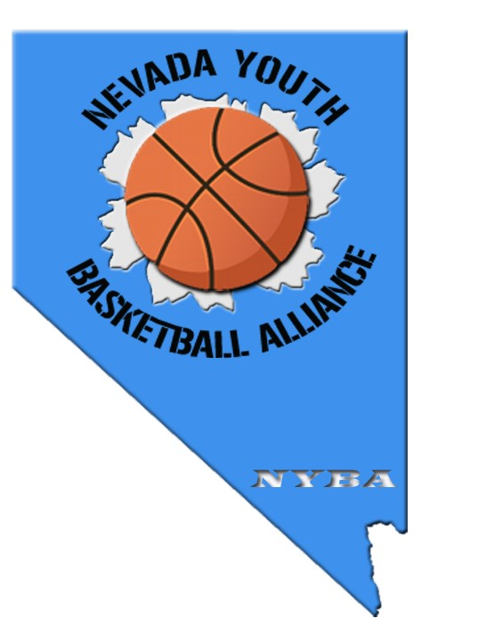

Nevada Youth Basketball Alliance
FALL BASKETBALL REGISTRATION

Recreational 2017 Fall Basketball Registration
Fall season runs from August - November. Games played in Henderson/SE Las Vegas.

Registration Period: May 13 - July 1
*Late registration after July 1 will be placed on a space-available list.

2 Co-ed Divisions
2nd - 3rd Grade
4th - 6th Grade

Cost - $120
_____________________________________________________
Two (2) ways to register:

On-line Registration - Go to www.nybakids.com

Mail-in Registration - Complete the attached registration form and write the check to: NYBA

Mailing Address: NYBA
8114 Tone St.
Las Vegas, NV 89123

Nevada Youth Basketball Alliance
Player Registration Form
www.nybakids.com

PLAYER INFORMATION - Please Print Legibly
Last: First: |  | Phone:
2017 - 2018 Grade: |  | Sex (M or F) :
Address: City: |  | State: Zip Code:
Uniform Size: YS___ YM___ YL___ AS___ AM___ | AL ____
How long has he/she played basketball: Beginner___ 1 - 2 Season___ 2 - 3 Season___ 5 Seasons or More__

Requests: Team/Coach Player/Buddy

Parents
Father/Guardian Name: | Mother/Guardian Name:
Cell Phone: | Cell Phone:
E-mail: | E-mail:

Person to notify in emergency (when parent cannot be reached) ______________________________ Telephone__________________

List any medical condition or allergies______________________________________________________________________________

Doctor to notify in emergency__________________________________________________________ Telephone__________________

Medical/Hospital Insurance Company____________________________________________________ Telephone__________________

Policy Holder Name____________________________________________________ Policy Number____________________________

MEDICAL TREATMENT AUTHORIZATION AND LIABILITY WAIVER: I hereby give my consent to have an athletic trainer, coach, team manager, emergency medical technician, nurse, medical treatment facility, and/or doctor of medicine or dentistry or associated personnel provide the participant with medical assistance and/or treatment and agree to be financially responsible for injury based on information provided herein. I hereby authorize emergency transportation of the applicant to a medical treatment facility should an individual listed above consider it to be warranted. I recognize the possibility of physical injury associated with basketball, and hereby release, discharge, and otherwise indemnify Nevada Youth Basketball Alliance, Jr. NBA, their sponsors and employees and associated personnel of these organizations, against any claim by or on behalf of the basketball player named above as a result of the player's participation in the NYBA basketball program and/or being transported to or from the same, which transportation I hereby authorize.

Signature ___________________________________________________________ Date_______________________________________________

NYBA RELEASE: I, the parent/guardian of the above named child for a position on a Nevada Youth Basketball Alliance team, I agree that the registrant and I will abide by the rules of Nevada Youth Basketball Alliance (NYBA). I hereby agree that NYBA, its members, coaches, staff or officers shall not be held liable for any injury or loss which my child may sustain while participating in activities sponsored by or under the supervision of NYBA, and I agree to indemnify and hold harmless NYBA, its members, coaches, officers and sponsors, their employees and associated personnel, including the owners of the fields and facilities utilized for the programs, against any claim whatsoever.

Signature: ________________________________________________ Date: ____________________________________
NEVADA YOUTH BASKETBALL ALLIANCE - PARENTS CODE OF CONDUCT

As a parent, you play a special role in contributing to the needs and development of youngsters. Through your encouragement and good example, you can help assure that all the boys and girls learn good sportsmanship and self discipline. In the Nevada Youth Basketball Alliance, young people learn to work together, to sacrifice for the good of the team, to enjoy winning and deal appropriately with defeat – all while becoming physically fit and healthy. Best of all, they have fun.

Support your child - Supporting your child by giving encouragement and showing interest in their team is very important. Help your child work toward skill improvement and good sportsmanship in every game. Teach your child that hard work and an honest effort are often more important than victory – that way your child will always be a winner despite the outcome of the game!

Always be positive - Parents serve as role models for their children. Become aware of this and work to be a positive role model. Applaud good plays by your child’s team as well as good plays by the opposing team. Support all efforts to remove verbal and physical abuse from youth sports activities.

Remember that your child wants to have fun - Remember that your child is the one playing basketball, not you. It’s very important to let children establish their own goals – to play the game for themselves. Take care not to impose your own standards and goals on them. Don’t put too heavy a burden on your child to win games. Children play for the fun of playing.

Reinforce Positive behavior - Positive reinforcement is the best way to help your child achieve their goals and their natural fear of failure. Nobody likes to make mistakes. If your child does make one, remember it’s all part of learning, so encourage your child’s efforts and point out the good things your child accomplished.

Don’t be a sideline coach or referee - Coaches and referees are usually parents just like you. They volunteer time to help make your child’s youth basketball experiences a positive one. They need your support too. That means refraining from coaching or refereeing from the sidelines. As a volunteer organization, there’s usually always an opportunity for you to take your interest in coaching or refereeing to the next level and become one yourself.

Parents Pledge

- I shall set an example for sportsmanship for my child to follow. I shall emphasize team play to my child. I shall show by example respect for referees, opposing teams and other fans. I shall not be a grandstand coach. I shall remember that not everyone can play at one time. I shall not be critical unless I’m willing to work to correct the problem. I shall attend my child’s games because, it is important to them, they are not young forever. I shall be supportive when my child is successful or when struggling for success. I shall play and practice the skills of the game with my child. I shall be positive and supportive whether the team wins or loses. I shall remember that all coaches and league officers are volunteers. I shall retain perspective that there are no college/professional scouts in the stands. I shall remember that the game is for the kids.

Remember: good behavior doesn’t cost anything!!! However it does allow the players and other teams to enjoy a
game between kids just for the fun of it.

Parents Signature Players Name Date

______________________________________________________________________________________________________________________

